|  |  |
| --- | --- |
| **Logo_FPT_University_doc** | **MINISTRY OF EDUCATION AND TRAINING** |

|  |
| --- |
| **FPT UNIVERSITY** |
| Capstone Project Document |
| Build a web application for providing information about 3D film café in HCM City |
|  |
| |  |  | | --- | --- | | **Group 7** | | | **Group Members** | Hoang Trung Thien Vuong – Team leader – 60447  Ngo Quoc Nam – Team member – 60475  Nguyen Vinh Hien – Team member – 60339  Pham Ngoc Hoang – Team member – 60263  Nguyen Thanh Trung– Team member – 00753 | | **Supervisor** | Mr. Lam Huu Khanh Phuong | | **Ext Supervisor** | N/A | | **Capstone Project code** | 3D Cafe | |
|  |

|  |
| --- |
| - Ho Chi Minh City, 5/2013 - |

# List of abbreviations and acronyms

|  |  |  |
| --- | --- | --- |
| **No.** | **Abbreviation& Acronym** | **Definition** |
| 1 | Admin | Administrator |
| 2 | SO | Store Owner |
| 3 | VM | View Model |
| 4 | ERD | Entity Relationship Diagram |
| 5 | BA | Business Analyst |
| 6 | DEV | Developer |
| 7 | API | Application Programming Interface |
| 8 | GUI | Graphical User Interface |
| 9 | FAQ | Frequently Asked Questions |
| 10 | DBMS | Database Management System |
| 11 | SDD | Screen Details Design |

# Table of Contents

[List of abbreviations and acronyms 2](#_Toc364415859)

[Table of Contents 2](#_Toc364415860)

[1 Introduction Software 8](#_Toc364415861)

[1.1 Project Title 8](#_Toc364415862)

[1.2 Overview Of Existing Methods 9](#_Toc364415863)

[1.3 Limitations Of Existing Methods 9](#_Toc364415864)

[1.4 Project Objective 9](#_Toc364415865)

[1.5 Scope Definition 9](#_Toc364415866)

[1.6 Approach 10](#_Toc364415867)

[1.7 Customer Functions 10](#_Toc364415868)

[1.8 Store Owner Functions 10](#_Toc364415869)

[1.9 Admin Functions 10](#_Toc364415870)

[1.10 Table Introduction 10](#_Toc364415871)

[2 Project Management Plan 12](#_Toc364415872)

[2.1 Problem Definition 12](#_Toc364415873)

[2.1.1 Name of this Capstone Project 12](#_Toc364415874)

[2.1.2 Problem Abstract 12](#_Toc364415875)

[2.1.3 Project Overview 12](#_Toc364415876)

[2.1.3.1 The Current System 12](#_Toc364415877)

[2.1.3.2 The Proposed System 12](#_Toc364415878)

[2.1.3.3 Boundaries of the System 13](#_Toc364415879)

[2.1.3.4 Development Environment 13](#_Toc364415880)

[2.2 Project Organization 14](#_Toc364415881)

[2.2.1 Software Process Model 14](#_Toc364415882)

[2.2.2 Roles and Responsibility 14](#_Toc364415883)

[2.2.3 Tools and Techniques 15](#_Toc364415884)

[2.3 Project Management Plan 16](#_Toc364415885)

[2.3.1 Tasks 16](#_Toc364415886)

[2.3.2 Task Sheet: Assignment and Timetable 18](#_Toc364415887)

[2.3.3 All Meeting minutes 18](#_Toc364415888)

[2.3.4 Coding Convention 18](#_Toc364415889)

[3 Software Requirement Specification (SRS) 18](#_Toc364415890)

[3.1 User Requirement Specification 18](#_Toc364415891)

[3.1.1 Store Owner Requirements 18](#_Toc364415892)

[3.1.2 Guest Requirements 18](#_Toc364415893)

[3.1.3 Admin Requirements 18](#_Toc364415894)

[3.2 System Requirement Specifications 19](#_Toc364415895)

[3.2.1 External Requirement Specification 19](#_Toc364415896)

[3.2.1.1 User Interfaces 19](#_Toc364415897)

[3.2.1.2 Hardware Interfaces 19](#_Toc364415898)

[3.2.1.3 Software Interfaces 19](#_Toc364415899)

[3.2.1.4 Communication Protocols 19](#_Toc364415900)

[3.2.2 System Features 20](#_Toc364415901)

[3.2.2.1 <UnauthorizedUser>Login 21](#_Toc364415902)

[3.2.2.2 <Guest>Search Film 23](#_Toc364415903)

[3.2.2.3 <Guest>Search Store 26](#_Toc364415904)

[3.2.2.4 <Guest>View Film Information 28](#_Toc364415905)

[3.2.2.5 <Guest>View Store Information 30](#_Toc364415906)

[3.2.2.6 <Guest> Search Schedule 30](#_Toc364415907)

[3.2.2.7 <Admin> Manage Film 35](#_Toc364415908)

[3.2.2.8 <Admin> Manage Store 48](#_Toc364415909)

[3.2.2.9 <Admin> Manage File 54](#_Toc364415910)

[3.2.2.10 <Admin> Manage News 59](#_Toc364415911)

[3.2.2.11 <Admin> Manage Advertising 59](#_Toc364415912)

[3.2.2.12 <Admin> Manage Carousel 65](#_Toc364415913)

[3.2.2.13 <Admin> Manage Category 65](#_Toc364415914)

[3.2.2.14 <Admin> Manage Tag 66](#_Toc364415915)

[3.2.2.15 <Admin> Manage Actor 66](#_Toc364415916)

[3.2.2.16 <Admin> Manage User 67](#_Toc364415917)

[3.2.2.17 <StoreOwner> Manage Store Film 67](#_Toc364415918)

[3.2.2.18 <StoreOwner> Manage Store Profile 73](#_Toc364415919)

[3.2.2.19 <StoreOwner> Manage Schedule 74](#_Toc364415920)

[3.2.2.20 <StoreOwner> Manage News 85](#_Toc364415921)

[3.2.2.21 <StoreOwner> Manage File 85](#_Toc364415922)

[3.2.2.22 <StoreOwner> Manage Store Owner Profile 86](#_Toc364415923)

[3.2.3 Software System Attributes 86](#_Toc364415924)

[3.2.3.1 Reliability 86](#_Toc364415925)

[3.2.3.2 Availability 86](#_Toc364415926)

[3.2.3.3 Security 86](#_Toc364415927)

[3.2.3.4 Maintainability 86](#_Toc364415928)

[3.2.3.5 Portability 87](#_Toc364415929)

[3.2.3.6 Performance 87](#_Toc364415930)

[3.3 Entity Relationship Diagram (ERD) 88](#_Toc364415931)

[4 Software Design Description 89](#_Toc364415932)

[4.1 Design Overview 89](#_Toc364415933)

[4.2 System Architectural Design 89](#_Toc364415934)

[4.2.1 Choice of system Architecture 89](#_Toc364415935)

[4.2.2 MVC Software Architecture 90](#_Toc364415936)

[4.2.3 Discussion of Alternative Designs 91](#_Toc364415937)

[4.2.4 Description of System Interface 91](#_Toc364415938)

[4.2.5 User Interfaces 91](#_Toc364415939)

[4.2.6 Hardware interfaces 91](#_Toc364415940)

[4.2.7 Software Interfaces 91](#_Toc364415941)

[4.3 Database Design 92](#_Toc364415942)

[4.3.1 Table Dictionary 93](#_Toc364415943)

[4.3.2 Actor 93](#_Toc364415944)

[4.3.3 Advertising 93](#_Toc364415945)

[4.3.4 Carousel 94](#_Toc364415946)

[4.3.5 Film 94](#_Toc364415947)

[4.3.6 FilmActorDetail 95](#_Toc364415948)

[4.3.7 FilmCategory 96](#_Toc364415949)

[4.3.8 FilmCategoryDetail 96](#_Toc364415950)

[4.3.9 News 96](#_Toc364415951)

[4.3.10 NewsCategory 97](#_Toc364415952)

[4.3.11 Role 97](#_Toc364415953)

[4.3.12 Room 97](#_Toc364415954)

[4.3.13 Schedule 97](#_Toc364415955)

[4.3.14 Store 98](#_Toc364415956)

[4.3.15 StoreFilmDetail 99](#_Toc364415957)

[4.3.16 TagStore 99](#_Toc364415958)

[4.3.17 TagStoreDetail 99](#_Toc364415959)

[4.3.18 User 99](#_Toc364415960)

[4.4 MVC Package Diagram 100](#_Toc364415961)

[*4.4.1* Model *Package* 101](#_Toc364415962)

[4.4.1.1 HDCafeModel Package 102](#_Toc364415963)

[4.4.1.2 AdminModel Package 103](#_Toc364415964)

[4.4.1.3 StoreOwnerModel Package 123](#_Toc364415965)

[4.4.1.4 HomeModel Package 131](#_Toc364415966)

[4.4.2 Controller Package 138](#_Toc364415967)

[4.4.2.1 Management Website 138](#_Toc364415968)

[4.4.2.2 Management Store Website 141](#_Toc364415969)

[4.4.2.3 HomePage 142](#_Toc364415970)

[4.4.3 View Package 144](#_Toc364415971)

[4.4.3.1 ManagementView 144](#_Toc364415972)

[4.4.3.2 Management StoreView 152](#_Toc364415973)

[4.4.3.3 HomePageView 155](#_Toc364415974)

[4.5 Sequence Diagram 163](#_Toc364415975)

[4.5.1 Scan Film Online 163](#_Toc364415976)

[4.5.2 Edit Store Information 164](#_Toc364415977)

[4.5.3 Change Carousel on Website 165](#_Toc364415978)

[4.5.4 Add New Schedule 166](#_Toc364415979)

[5 Software Test Documentation 167](#_Toc364415980)

[5.1 Introduction 167](#_Toc364415981)

[5.1.1 System Overview 167](#_Toc364415982)

[5.1.2 Test Approach 167](#_Toc364415983)

[5.2 Test Plan 167](#_Toc364415984)

[5.2.1 Feature To Be Tested 167](#_Toc364415985)

[5.2.1.1 <Guest> ViewSchedule 167](#_Toc364415986)

[5.2.1.2 <Guest> SearchFilm 167](#_Toc364415987)

[5.2.1.3 <Guest> SearchStore 168](#_Toc364415988)

[5.2.1.4 <Guest> SearchScheduleByFilm 168](#_Toc364415989)

[5.2.1.5 <Guest> SearchScheduleByStore 168](#_Toc364415990)

[5.2.1.6 <StoreOwner> ViewSchedule 168](#_Toc364415991)

[5.2.1.7 <StoreOwner> AddFilmToStore 168](#_Toc364415992)

[5.2.1.8 <StoreOwner> EditSchedule 168](#_Toc364415993)

[5.2.1.9 <StoreOwner> AddSchedule 168](#_Toc364415994)

[5.2.1.10 <Admin> ViewFile 168](#_Toc364415995)

[5.2.1.11 <Admin> AddUser 168](#_Toc364415996)

[5.2.1.12 <Admin> AddStore 168](#_Toc364415997)

[5.2.1.13 <Admin> AddRoom 169](#_Toc364415998)

[5.2.1.14 <Admin> EditSlideCarousel 169](#_Toc364415999)

[5.2.1.15 <Admin> SearchFilm 169](#_Toc364416000)

[5.2.2 Feature Not To Be Tested 169](#_Toc364416001)

[5.3 Test Case 170](#_Toc364416002)

[5.3.1 <Guest> ViewSchedule 170](#_Toc364416003)

[5.3.2 <Guest> SearchFilm 170](#_Toc364416004)

[5.3.3 <Guest> SearchStore 171](#_Toc364416005)

[5.3.4 <Guest> SearchScheduleByFilm 172](#_Toc364416006)

[5.3.5 <Guest> SearchScheduleByStore 173](#_Toc364416007)

[5.3.6 <StoreOwner> ViewSchedule 174](#_Toc364416008)

[5.3.7 <StoreOwner> AddFilmToStore 175](#_Toc364416009)

[5.3.8 < StoreOwner > EditSchedule 175](#_Toc364416010)

[5.3.9 < StoreOwner > AddSchedule 176](#_Toc364416011)

[5.3.10 < Admin > ViewFile 177](#_Toc364416012)

[5.3.11 < Admin > AddUser 178](#_Toc364416013)

[5.3.12 < Admin > AddStore 181](#_Toc364416014)

[5.3.13 < Admin > AddRoom 183](#_Toc364416015)

[5.3.14 < Admin > EditSlideCarousel 185](#_Toc364416016)

[5.3.15 <Admin> SearchFilm 186](#_Toc364416017)

[5.4 Checklist 187](#_Toc364416018)

[5.4.1 Checklist of Validation 187](#_Toc364416019)

[5.4.2 Submission Checklist 187](#_Toc364416020)

[6 Software User’s Manual 189](#_Toc364416021)

[6.1 Installation Guide 189](#_Toc364416022)

[6.1.1 Hosting and domain 189](#_Toc364416023)

[6.1.2 Upload project and database to web server 189](#_Toc364416024)

[6.1.3 Config Web.config 191](#_Toc364416025)

[6.1.4 Config domain and host 192](#_Toc364416026)

[6.1.5 Wait 48 hours and enter our domain name in browser 193](#_Toc364416027)

[6.1.6 Config website with google analytics 193](#_Toc364416028)

[6.1.7 Config website with Facebook API 193](#_Toc364416029)

[6.1.8 Development in hosting 193](#_Toc364416030)

[Step1: Open your website in Visual Studio 194](#_Toc364416031)

[Step2: Copy your website to remote site. 194](#_Toc364416032)

[Step3: Copy/ Synchronize between your source website and remote website. 195](#_Toc364416033)

[6.2 User’s Guide 196](#_Toc364416034)

[6.2.1 Admin’s Guide 196](#_Toc364416035)

[6.2.1.1 How to add film online 196](#_Toc364416036)

[6.2.1.2 How to scan film online 196](#_Toc364416037)

[6.2.1.3 How to change slide in website 197](#_Toc364416038)

[6.2.1.4 How to change advertising in website 197](#_Toc364416039)

[6.2.1.5 How to manage file on server 197](#_Toc364416040)

[6.2.2 Store Owner’s Guide 197](#_Toc364416041)

[6.2.2.1 How to change information of store 197](#_Toc364416042)

[6.2.2.2 How to add film to store 197](#_Toc364416043)

[6.2.2.3 How to manage schedule 197](#_Toc364416044)

[6.2.2.4 How to add event in schedule 197](#_Toc364416045)

[6.2.2.5 How to manage film on server 199](#_Toc364416046)

[6.2.3 Guest’s Guide 199](#_Toc364416047)

[6.2.3.1 How to view information of a store 199](#_Toc364416048)

[6.2.3.2 How to view information of a film 199](#_Toc364416049)

[6.2.3.3 How to search schedule 199](#_Toc364416050)

# Introduction Software

## Project Title

Build a web application for providing information about 3D film café in HCM City

## Overview Of Existing Methods

Most of coffee shops are using a paper, note to manage the schedule, film … and very few coffee shops have a website. Almost website about 3D and HD coffee don't have enough information that customers seek for (some websites have a news about 3D coffee shop but don't have a schedule about film showing, and almost websites don't have the integration with other coffee shops).

## Limitations Of Existing Methods

* Integration between the stores is not strong.
* Weak and unpopular: Existing methods just give a few information about stores, film and schedule ( some method only give a information about films, some other provide about news, schedule,...etc...)
* So, it is very hard for guest to approach services that they expect.

## Project Objective

We will develop an e-commerce website that:

* First, help guest to find out what coffee shop is suitable for them by many ways, example: they can search films they like, see when that film is showed, view a details of film and store, find coffee shops that are the nearest their place, search schedule of the film or schedule of the store, explore the menu, view panorama pictures about store, customers also can explore and rate for quality of drinks, films, view, infrastructure of the coffee shops and comment, like about stores or news…etc….
* Second, provide an easy, friendly and convenient tool for store owners to manage their store, their film's list, their schedule and their interfaces.
* Third, build a tool for admin to manage system, stores, films, news, data, banner, add film from another popular website easily and effective.

## Scope Definition

* The main scope of our system is to improve traditional 3D and HD Cafe system.
* Focus on main functions:
* Checking schedule of 3D Cafe
* Search film, 3D and HD coffee shop
* Locating place
* Comment, like about stores, news
* Add, update, delete film
* Edit store profile, store interfaces
* Manage schedule

## Approach

* Research more about business rule of 3D and HD cafe at HCM City
* Get comment of some real customers about current 3D Cafe system
* Use some current system of 3D an HD coffee shop and find out how it works, advantages and disadvantages.

## Customer Functions

* Search films
* View a film's detail
* Search 3D and HD coffee shops
* View schedule of films 3D and HD
* View schedule of stores
* Search schedule of films or stores
* Comment, like about store or news
* View the news
* Register to be a member of our website
* Explore the coffee shops
* Seeking the information of coffee shops

## Store Owner Functions

* Manage films
* Manage schedule
* Manage detail of their coffee shop
* View reports

## Admin Functions

* View customer’ information, edit customers information, active (inactive) customers.
* Manage all tables in database.
* Manage detail of films, customers and coffee shops.
* Manage films
* Manage banner
* View report

## Table Introduction

|  |  |  |  |  |  |
| --- | --- | --- | --- | --- | --- |
| **Roles and Responsibility:** | | | | | |
| **No** | **Full name** | | **Role** | **Position** | **Contact** |
| 1 | Lam Huu Khanh Phuong | | Supervisor | Instructor | PhuongLHK@fpt.edu.vn |
| 2 | Hoang Trung Thien Vuong | | Team Leader | Developer | VuongHTT60447@fpt.edu.vn |
| 3 | Ngo Quoc Nam | | Team member | Developer | NamNQ60475@fpt.edu.vn |
| 4 | Nguyen Vinh Hien | | Team member | Developer | HienNV60339@fpt.edu.vn |
| 5 | Pham Ngoc Hoang | | Team member | Developer | HoangPN60263@fpt.edu.vn |
| 6 | Nguyen Thanh Trung | | Team member | Developer | TrungNT00753@fpt.edu.vn |
|  | | | | | |
| **Project Authorization:** | | | | | |
| **Approved by** | | | **Role** | | **Date** |
| Lam Huu Khanh Phuong | | | Supervisor | | May 13th, 2013 |
|  | | | | | |
| **Comments:** | | N/A | | | |

# Project Management Plan

## Problem Definition

### Name of this Capstone Project

* Build a web application for providing information about 3D film café in HCM City

### Problem Abstract

* The authors of this project find out that many people want to go to 3D, HD coffee but they don’t know that what film is showed, address, menu,…etc… of that coffee shop. To know all that thing, they must go to 3D, HD coffee to find out and if film or menu not suitable for them, it is waste of time.
* Beside, traditional system has not yet made use of technology’s strengths such as web application, Goggle API.
* So, the goal of the project is create new system that help store owners to manage their coffee shops, films, store's profile and store's interfaces more efficient, convenience. Admin can manage film, stores, banner, news, and get film's detail from another website then add to the system by the easily, reliable way. Make the guests feel comfortable and satisfaction when experience our website : search for the information about schedule, films, stores easily, reliable and impress with interfaces of the website.

### Project Overview

#### The Current System

* The current 3D,HD coffee management system is still simple
* Current website of coffee shops give a few information about menu, film and schedule (some website does not have a film’s schedule, film's detail)

#### The Proposed System

* Name of proposed system is “HD-3D Café system”
* The aim of this system is to build a website with the following main features:
* Store owner add, delete, update schedule
* Store owner manage the information about their store profile, store's interface, store's films,...etc...
* Customer seek for information (schedule, films, news, address, menu, location, picture,…etc… of the coffee shop )
* Customer explore film’s list and schedule of coffee shop, or schedule of films.
* Calculate and find out the number of view, like, films, stores of website and topic of all coffee shop :
  + - By day
    - By month
    - By year
    - Average

#### Boundaries of the System

* The system under development of this Capstone Project will include:
* The complete website
* All the process involved documents

#### Development Environment

Below is the list of hardware and software requirements needed for development environment:

##### Hardware Requirement

N/A

##### Software Requirement

* Operating system: Windows XP / 7 / 8
* IDE: Visual Studio 2012
* DBMS: SQL Server
* Source Control: Microsoft Team Foundation Server

## Project Organization

### Software Process Model

The process model used for developing this project is SCRUM model

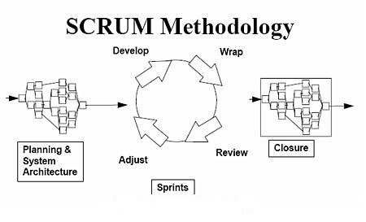

Figure 1 – SCRUM model

All of the phases in the SCRUM models are included in the scope of this project and are the responsibilities of the team.

### Roles and Responsibility

|  |  |  |  |
| --- | --- | --- | --- |
| No | Full name | Role in Group | Responsibilities |
| 1 | Lam Huu Khanh Phuong | Supervisor | * Specify user requirement * Control the development process * Give out technique and business analysis support |
| 2 | Hoang Trung Thien Vuong | Team Leader, BA, DEV, Tester | * Managing process * Business Analysis * Designing database/GUI * Write Documents * Create test plan * Coding * Testing |
| 3 | Ngo Quoc Nam | BA, DEV, Tester | * Business Analysis * Designing database * Write Documents * Coding * Creating test cases * Testing |
| 4 | Nguyen Vinh Hien | BA, DEV, Tester | * Coding * Write Documents * GUI Design * Creating test cases * Testing |
| 5 | Pham Ngoc Hoang | BA, DEV, Tester | * Coding * Write Documents * GUI Design * Creating test cases * Testing |
| 6 | Nguyen Thanh Trung | BA, DEV, Tester | * Coding * Write Documents * GUI Design * Creating test cases * Testing |

### Tools and Techniques

* Front-end technologies: HTML5, CSS, Javascript, jQuery, AJAX
* Tools: Visual Studio 2012, SQL Server 2012
* Architecture and design patterns: MVC4, Entity Framework, ASP.Net

## Project Management Plan

### Tasks

|  |  |  |  |  |  |  |  |
| --- | --- | --- | --- | --- | --- | --- | --- |
|  | Description | Output | Deliverables | | Resources Needed | Dependencies and Constraints | Risks |
| Initiating | Develop tasks, milestone, and assign task for team members | Task list | Deliver task list, project plan document before May 20th, 2013 | | 5 people for 2 days | N/A | Some task may be overloaded, not enough time to success in time |
| Create software project plan | Create software project plan | Software Project Management Plan (SPM) document | Deliver SPM before May 27th, 2013 | | 5 people for 3 days | N/A | The plan is not match with real situation because complicated technique or business. |
| Design layout | Design all layout of Website | Layout of Website | Develop Layout before Jun 3th ,2013 | | 5 people for 10 days | N/A | This layout may be not match all requirement of User. |
| Create Software Requirements Specification | Create software requirement specification | Software Requirement Specification (SRS) document | Delivery before Jun 10th, 2013 | | 5 people for 5 days | N/A | Limited access to subject matter experts .  Lack of experience or bias when defining product requirements. |
| Design Database | Create conceptual, logical, physical database design | Database design and Database script | Deliver with SRS before Jun 17th, 2012 | | 5 people for 5 days | Depends on the completion in SRS | Database lack some field can occur when code or change requirement! Designed Database is too complicated and can't(or hard to) query. |
| Software Design Description | Design the system in an OOP manner | Architecture design, detailed design, diagrams and design specification | SDD before Jun 24th, 2012 | 5 people for 5 days | | Depends on the completion of SRS | SDD is designed not good so that’s make functions hard to implement |
| Coding | Implement the system to reflect SDD | Source code of the project , unit test report | Executable programs and source code before Jul 29th, 2012 | 5 people for 25 days | | Depends on the completion of SRS, SDD, Database design, Coding framework | Many bugs may be hard to be fixed. |
| Testing | Perform system test for the system | System test report | Software test documentation before Aug 12th, 2012 | 5 people for 10 days | | Coding is finished | Test case do not cover all real case can occur when use the software!  Not enough time to test! |
| Deployment | Deploy the System on internet and User Manual | Running website with domain and hosting, user manual | Delivery user manual before Aug 19 th, 2012 | 5 people for 5 days | | Coding and system test are finished, initial data is inputted | Too many connections can overload the system. The user is hard to understand all system and function. |

### Task Sheet: Assignment and Timetable

Refer to Team7\_WBS.mpp file

### All Meeting minutes

Refer to Meeting Minutes folder

### Coding Convention

Refer to C# Convention at page *msdn.microsoft.com\en-us\library\vstudio\ff926074.aspx*

# Software Requirement Specification (SRS)

## User Requirement Specification

The system must satisfy the following defined requirements

### Store Owner Requirements

* Customer can view the information through the Dashboard
* Customer can add new film
* Customer can manage their store : Edit information, menu, map
* Customer can search and edit film
* Customer can add film to schedule
* Customer can manage their schedule: add film, select date and time.
* Customer can view the FAQ

### Guest Requirements

* Guest can view details of 3D and HD coffee shop
* Guest can search the 3D and HD coffee shop by film’s name and time
* Guest can search film by 3D and HD coffee shop and time
* Guest can view the details of film
* Guest can view the map
* Guest can view the news about film or coffee shop

### Admin Requirements

* Admin can view the information through the Dashboard
* Admin can manage the film : search, add, edit, delete film
* Admin can manage the coffee shop : search, add, edit, delete coffee shop
* Admin can view the list of users
* Admin can manage users : add, edit, active/inactive user

## System Requirement Specifications

### External Requirement Specification

#### User Interfaces

The Interface musts be designed to satisfy the following requirement:

N/A

#### Hardware Interfaces

The 3D Cafe websites can only run on the devices which support Internet connection and websites browser with javascript support ability. The system works well when the users’ computers take the configuration satisfying the following conditions:

N/A

#### Software Interfaces

* The product runs on the web application, on the end users’ devices, it needs a browser to run the web application.
* Since between the end users and the system always need some data exchange, thus the database management software is required for the data storing and processing purposes.

|  |  |  |  |
| --- | --- | --- | --- |
| Software Name | Version | Cost | Source |
| Web Browser: N/A |  | Free |  |
| SQL Server | 2012 | Free |  |
| Visual Studio | 2012 | Free |  |

#### Communication Protocols

N/A

### System Features

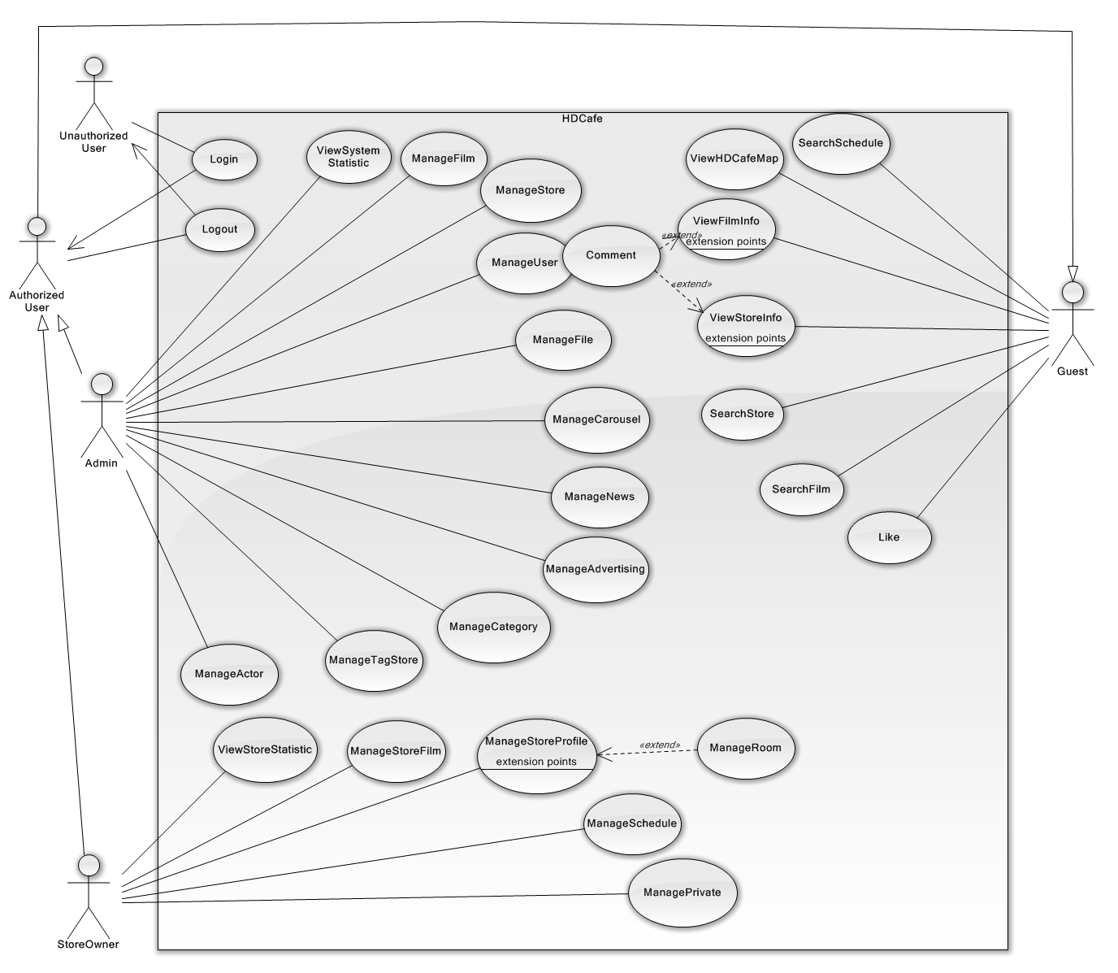

Figure 3.1 - General Use-case Diagram

#### <UnauthorizedUser>Login

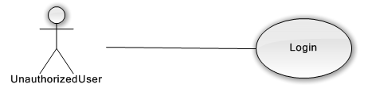

Figure 3.2.1 – Login use-case diagram

|  |  |  |  |  |
| --- | --- | --- | --- | --- |
| **USE CASE-UC01 SPECIFICATION** | | | | |
| **Use-case No.** | UC01 | **Use-case Version** | | v0.1 |
| **Use-case Name** | Login | | | |
| **Author** | Hoang Trung Thien Vuong | | | |
| **Date** | 05/06/2013 | **Priority** | High | |
| **Actor:**  UnauthorizedUser  **Summary:**  UnauthorizedUser login to System to access function based on their role.  **Goal:**  Set role for UnauthorizedUser and redirect to their page  **Triggers:**  UnauthorizedUser want to access their page;  (UnauthorizedUser click “Dang Nhap” button )  **Preconditions:**  The page is fully loaded.  UnauthorizedUser have provided account from Admin.  **PostConditions:**   * Success: * Redirect UnauthorizedUser to their site. * Failure: * System display error message. Content error message will be specified in log files.   **Main Success Scenario:**   |  |  | | --- | --- | | Actor Actions | System Response | | 1. UnauthorizedUser click “Dang nhap” button to Login  3. UnauthorizedUser Enter correct UserName and Password, then click “Dang Nhap” | 2. System displays a form that have two input for Username and Password.  4. System check Username and Password. If true, set user to their Role and redirect them to approach page. |   **Alternative Scenario:**   |  |  | | --- | --- | | Ator Actions | System Response | | [Alternative1]  1. UnauthorizedUser enter wrong UserName and Password, then click “Dang Nhap”  [Alternative2]  1. UnauthorizedUser click to “Quen Mat Khau”  3. UnauthorizedUser enter correct email to the textbox, then click “ Gui”.  5. UnauthorizedUser click to Register | 2. System check UserName and Password. If false, display a message “ Ban nhap sai ten dang nhap hoac mat khau”  2. System display a form that require Email of UserName  4. System send a email that contain a new password to email  6. Display a message “ He thong hien chua cho dang ky account, xin lien he Admin de biet them chi tiet”. |   **Exceptions:**   |  |  | | --- | --- | |  |  | | Actor Actions | System Response | | [Exception1]  1.“UserName” textbox is empty  [Exception2]  1.”Password” textbox is empty | 2.Display message “Ban chua nhap UserName”  2.Display message “ Ban chua nhap Password” |   **Relationships:** N/A.  **Business Rules:** N/A. | | | | |

#### <Guest>Search Film

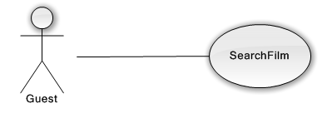

Figure 3.2.2 – Guest Search Film use-case diagram

|  |  |  |  |  |
| --- | --- | --- | --- | --- |
| **USE CASE-UC02 SPECIFICATION** | | | | |
| **Use-case No.** | UC02 | **Use-case Version** | | v0.1 |
| **Use-case Name** | Search Film | | | |
| **Author** | Nguyen Vinh Hien | | | |
| **Date** | 05/06/2013 | **Priority** | High | |
| **Actor:**  Guest  **Summary:**  Guest can search film of the system  **Goal:**  Helps guest to search film of system more easy  **Triggers:**  guest want to see the film’s list of the system  (guest inputs key words on textbox then clicks “Tìm kiếm” icon at the right corner of frame to search follow key words inputted)  **Preconditions:**  The page is fully loaded.  **PostConditions:**   * Success: * Films of the system are displayed as thumbnails. * Films are displayed correctly corresponding to optional inputted * Failure: N/A   **Main Success Scenario:**   |  |  | | --- | --- | | Actor Actions | System Response | | 1. Guest input key words into textbox  [Alternative1] [Alternative2][Alternative3] [Alternative4].  2. Guest click "Search" icon | 3. Display films matches key words or options that user selected in step 1 in thumbnails icon. |   **Alternative Scenario:**   |  |  | | --- | --- | | Ator Actions | System Response | | [Alternative 1]  1. Guest click on " A->Z" button  [Alternative 2]  1. Guest check in category check box  [Alternative 3]  1. Guest click on ">>" icon  [Alternative 4]  1. Guest click on "IMDB Rating" button | 2. List film is displayed with the name of films is ordered by name (A to Z)  2. Filter film that matches with category that user selected.  2. The last page of films is displayed  2. List film is displayed with the IMDB rating of the films is ordered by increasing |   **Exceptions:**   |  |  | | --- | --- | |  |  | | Actor Actions | System Response | | N/A | N/A |   **Relationships:** N/A  **Business Rules:**  Guest can search film with many options selected  Inputted key words have to match at least one film or meaning words | | | | |

#### <Guest>Search Store

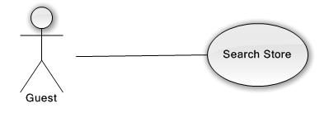

Figure 3.2.3 – Guest Search Store use-case diagram

|  |  |  |  |  |
| --- | --- | --- | --- | --- |
| **USE CASE-UC03 SPECIFICATION** | | | | |
| **Use-case No.** | UC03 | **Use-case Version** | | v0.1 |
| **Use-case Name** | Search Store | | | |
| **Author** | Nguyen Vinh Hien | | | |
| **Date** | 05/06/2013 | **Priority** | High | |
| **Actor:**  Guest  **Summary:**  Guest can search store of the system  **Goal:**  Helps guest to search store of system more easy  **Triggers:**  Guest want to see the store's list of the system  (Guest inputs key words on textbox then clicks “Search” icon at the right corner of frame to search follow key words inputted)  **Preconditions:**  The page is fully loaded.  **PostConditions:**   * Success: * Stores of the system are displayed as thumbnails. * Stores are displayed correctly corresponding to the optional inputted * Failure: N/A   **Main Success Scenario:**   |  |  | | --- | --- | | Actor Actions | System Response | | 1. Guest input key words into textbox  [Alternative1] [Alternative2][Alternative3] .  2. Guest click "Search" icon | 3. Display stores matches key words or options that guest selected in step 1 in thumbnails icon |   **Alternative Scenario:**   |  |  | | --- | --- | | Ator Actions | System Response | | [Alternative 1]  1. Guest click on "2" icon  [Alternative 2]  1. Guest check in tag check box  [Alternative 3]  1. Guest click on ">>" icon | 2. The second page of stores is displayed  2. Filter stores that matches with tag that user selected.  2. The last page of stores is displayed |   **Exceptions:**   |  |  | | --- | --- | |  |  | | Actor Actions | System Response | | N/A | N/A |   **Relationships:** N/A  **Business Rules:** Guest can search store with many options selected. Inputted key words have to match at least one store or meaning words | | | | |

#### <Guest>View Film Information

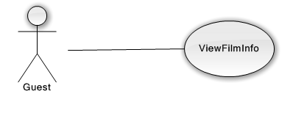

Figure 3.2.4 – Guest View Film Information use-case diagram

|  |  |  |  |  |
| --- | --- | --- | --- | --- |
| **USE CASE-UC04 SPECIFICATION** | | | | |
| **Use-case No.** | UC04 | **Use-case Version** | | v0.1 |
| **Use-case Name** | View Film Info | | | |
| **Author** | Nguyen Vinh Hien | | | |
| **Date** | 05/06/2013 | **Priority** | High | |
| **Actor:**  Guest  **Summary:**  Guest can view the film's info of any active film  **Goal:**  Helps guest to get the information of the film quickly  **Triggers:**  Guest want to view the film's info  (Guest clicks on “Film” item at the "Film" page)  **Preconditions:**   * The page is fully loaded * The film’s list of the system is fully loaded   **PostConditions:**   * Success: * The film's info is displayed correctly and successfully * Failure: N/A   **Main Success Scenario:**   |  |  | | --- | --- | | Actor Actions | System Response | | 1. Guest click on “Film” item at the "Film" page.  3. Guest click on "Lịch chiếu" tab [Alternative 1] | 2. The film's info screen is displayed  4. The schedule of that film is displayed. |   **Alternative Scenario:**   |  |  | | --- | --- | | Ator Actions | System Response | | [Alternative 1]  1. Guest click on " Hình ảnh" tab | 2. The pictures of that film is displayed |   **Exceptions:**   |  |  | | --- | --- | |  |  | | Actor Actions | System Response | | N/A | N/A |   **Relationships:** N/A  **Business Rules:** Guest can view the film's info of any active film | | | | |

#### <Guest>View Store Information

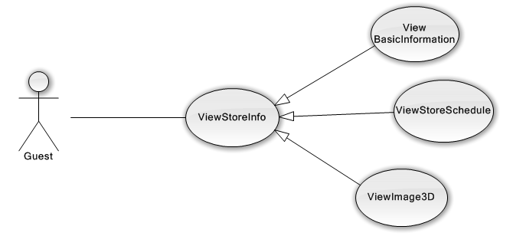

Figure 3.2.5 – Guest View Store Information use-case diagram overview

Guest can view store information include:

***View basic Information, View Store’ Film Schedule, View Image 3D of Store***

#### <Guest> Search Schedule

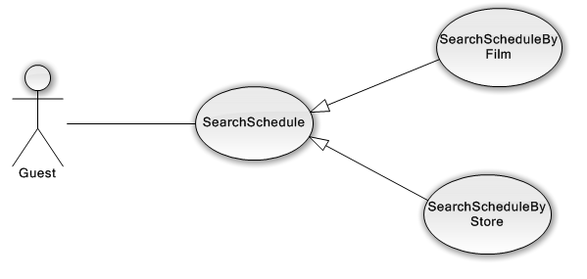

Figure 3.2.6 – Guest Search Schedule use-case diagram

Guest can search film’ schedule of store by two ways: **By Film** and **By Store**

##### <Guest> Search Schedule By Film

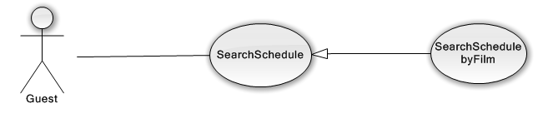

Figure 3.2.6.1 – Guest Search Schedule By Film use-case diagram

|  |  |  |  |  |
| --- | --- | --- | --- | --- |
| **USE CASE-UC05 SPECIFICATION** | | | | |
| **Use-case No.** | UC05 | **Use-case Version** | | v0.1 |
| **Use-case Name** | Search Schedule By Film | | | |
| **Author** | Hoang Trung Thien Vuong | | | |
| **Date** | 05/06/2013 | **Priority** | High | |
| **Actor:**  Guest  **Summary:**  Guest can view information of a schedule by film.  **Goal:**  Helps guest get schedule based on a film.  **Triggers:**  Guest wants to view schedule about the film.  (Guest choose film, choose store )  **Preconditions:**  The page is fully loaded.  **PostConditions:**   * Success: * Display the correct information about the schedule of film. * Failure: * System display error message. Content error message will be specified in log files.   **Main Success Scenario:**   |  |  | | --- | --- | | Actor Actions | System Response | | 1. Guest type keyword to search film in “Chon phim” region.  3. Guest click to a film in list result.  5. Guest click to a store in “Chon quan” region | 2. System returns a list of film that match with keyword. The film result will display : [Name] [VnName] [Image]  4. System finds all the store that have that film and have schedule for that film in one week. The Store result will display with format: [StoreName] [Image]  6. Display the schedule of that film in that store with date-time in seven day with format [Room] [Type] [datetime]. |   **Alternative Scenario:**   |  |  | | --- | --- | | Ator Actions | System Response | | [Alternative 1]  1.Guest hover the film  [Alternative2]  1.Guest hover the store | 2. Display short information of the film: Name, content, actor, imdb rating.  2. Display the basic information of the store: Name, address |   **Exceptions:**   |  |  | | --- | --- | |  |  | | Actor Actions | System Response | | [Exception 1]  1.The film do not in any schedule of all store | 2. Display a message “ Phim khong co lich chieu o quan nao” in “Chon Quan” region. |   **Relationships:** SearchSchedule  **Business Rules:** N/A. | | | | |

##### <Guest> Search Schedule By Store

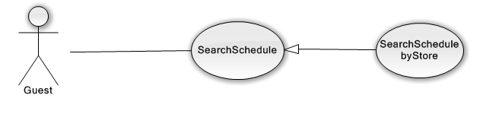

Figure 3.2.6.2 – Search Schedule By Store use-case diagram

|  |  |  |  |  |
| --- | --- | --- | --- | --- |
| **USE CASE-UC06 SPECIFICATION** | | | | |
| **Use-case No.** | UC06 | **Use-case Version** | | v0.1 |
| **Use-case Name** | Search Schedule By Store | | | |
| **Author** | Hoang Trung Thien Vuong | | | |
| **Date** | 05/06/2013 | **Priority** | High | |
| **Actor:**  Guest  **Summary:**  Guest can view information of a schedule by store.  **Goal:**  Helps guest get schedule based on the store.  **Triggers:**  Guest wants to view schedule of the store.  (Guest choose store, choose film )  **Preconditions:**  The page is fully loaded.  **PostConditions:**   * Success: * Display the correct information about the schedule of store. * Failure: * System display error message. Content error message will be specified in log files.   **Main Success Scenario:**   |  |  | | --- | --- | | Actor Actions | System Response | | 1.Guest type keyword to search store in “Chon quan” region.  3. Guest click to a store in list result.  5. Guest click to a film in “Chon phim” region | 2. System return a list of store that match with keyword with format result: [StoreName] [Image]  4. System finds all the film in store’s schedule and datetime from now to seven day.  6. Display the schedule of that film with format [Room] [datime]. |   **Alternative Scenario:**   |  |  | | --- | --- | | Ator Actions | System Response | | [Alternative 1]  1. Guest hover the film  [Alternative2]  1. Guest hover the store | 2. Display short information of the film: Name, content, actor, imdb rating.  2. Display the basic information of the store: Name, address |   **Exceptions:**   |  |  | | --- | --- | |  |  | | Actor Actions | System Response | | [Exception 1]  1.The film do not in any schedule of all store | 2. Display a message “ Phim khong co lich chieu o quan nao” in “Chon Quan” region. |   **Relationships:** SearchSchedule  **Business Rules:** N/A. | | | | |

#### <Admin> Manage Film

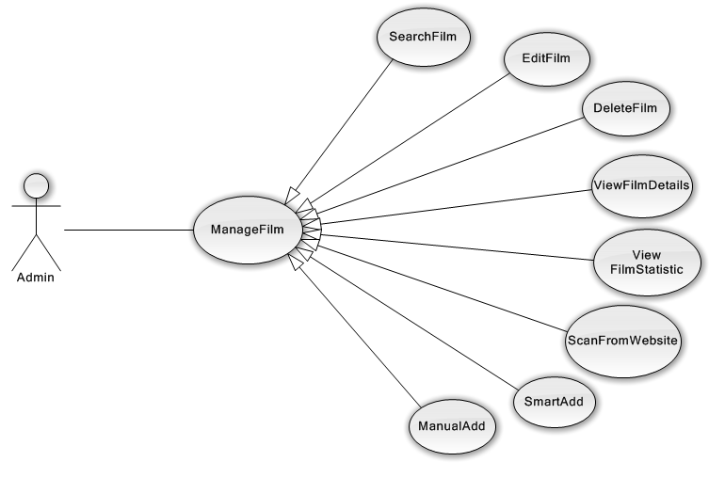

Figure 3.2.7 – Admin Manage Film use-case diagram overview

Admin can manage film of the system follow 6 main features:

**Search Film, Add Film, Edit Film, Delete Film, View Film Details, View Film Statistic.**

##### <Admin> View Film Statistic

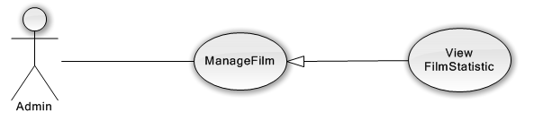

Figure 3.2.7.1 – Admin View Film Statistic use-case diagram

##### <Admin> View Film Details

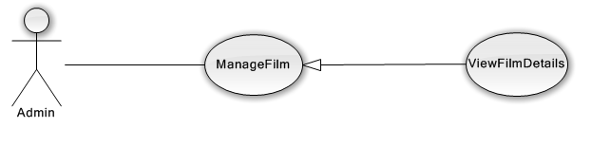

Figure 3.2.7.2 – Admin View Film Details use-case diagram

##### <Admin> Search Film

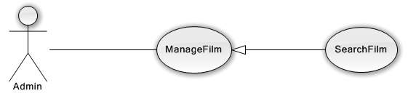

Figure 3.2.7.3 – Admin Search Film use-case diagram

|  |  |  |  |  |
| --- | --- | --- | --- | --- |
| **USE CASE-UC07 SPECIFICATION** | | | | |
| **Use-case No.** | UC07 | **Use-case Version** | | v0.1 |
| **Use-case Name** | Search Film | | | |
| **Author** | Nguyen Vinh Hien | | | |
| **Date** | 05/06/2013 | **Priority** | High | |
| **Actor:**  Admin  **Summary:**  Admin can search film of the system  **Goal:**  Helps admin to search film of system more easy  **Triggers:**  Admin want to see the film’s list of the system  (Admin inputs key words on textbox then clicks “Tìm kiếm” at the right corner of frame to search follow key words inputted)  **Preconditions:**  The page is fully loaded.  **PostConditions:**   * Success: * Films of the system are displayed as thumbnails. * Films are displayed correctly corresponding to key words inputted * Failure: N/A   **Main Success Scenario:**   |  |  | | --- | --- | | Actor Actions | System Response | | 1. Admin input key words into textbox  [Alternative1] [Alternative2][Alternative3].  2. Admin click "Search" icon | 3. Display films matches key words or options that admin selected in step 1 in thumbnails icon with ability to Deactivate and Edit |   **Alternative Scenario:**   |  |  | | --- | --- | | Ator Actions | System Response | | [Alternative 1]  1. Admin check in " Inactive Film" check box  [Alternative 2]  1. Admin check in category check box  [Alternative 3]  1. Admin click on ">>" icon | 2. Filter film that is inactive  2. Filter film that matches with category that user selected.  2. The last page of films is displayed |   **Exceptions:**   |  |  | | --- | --- | |  |  | | Actor Actions | System Response | | N/A | N/A |   **Relationships:** ManageFilm  **Business Rules:** Admin can search film with many options selected. Inputted key words have to match at least one film or meaning words | | | | |

##### <Admin> Manual Add Film

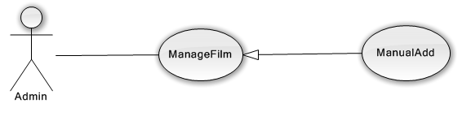

Figure 3.2.7.4 – Admin Manual Add Film use-case diagram

|  |  |  |  |  |
| --- | --- | --- | --- | --- |
| **USE CASE-UC08 SPECIFICATION** | | | | |
| **Use-case No.** | UC08 | **Use-case Version** | | v0.1 |
| **Use-case Name** | Manual Add film | | | |
| **Author** | Ngo Quoc Nam | | | |
| **Date** | 05/06/2013 | **Priority** | High | |
| **Actor:**  Admin  **Summary:**  Admin can add a film by input data on form modal  **Goal:**  Helps admin input their own information of a film when they add new one  **Triggers:**  Admin wants to add a film in his/her own information.  (Admin clicks “Thêm phim” tab on “Phim ảnh” page)  **Preconditions:**  Log-in successful with role admin  Go to “Phim ảnh” page  **PostConditions:**   * Success: * Add new film successful and update list film on page immediately   Failure:   * Add film unsuccessful * System display error message. Content error message will be specified in log files   **Main Success Scenario:**   |  |  | | --- | --- | | Actor Actions | System Response | | 1.Admin click on “Thêm phim” tab on “Phim ảnh” page  3.Admin input corresponding information in form then click “Lưu” button [Exception1] | 2. Add Film form content displayed with fields for admin input information of new film.  4. Modal popup is hidden, new film is displayed on top of list active film on “Phim ảnh” page. |   **Alternative Scenario:**   |  |  | | --- | --- | | Ator Actions | System Response | | N/A | N/A |   **Exceptions:**   |  |  | | --- | --- | |  |  | | Actor Actions | System Response | | [Exception1]  1. Admin leave all empty fields then click on “Lưu” button | 2. Modal popup display validation for needed to input field. |   **Relationships:** ManageFilm  **Business Rules:** N/A. | | | | |

##### <Admin> Smart Add

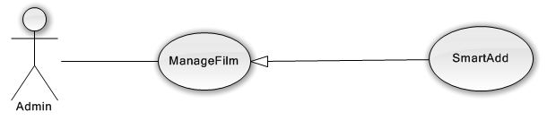

Figure 3.2.7.5 – Admin Smart Add use-case diagram

|  |  |  |  |  |
| --- | --- | --- | --- | --- |
| **USE CASE-UC09 SPECIFICATION** | | | | |
| **Use-case No.** | UC09 | **Use-case Version** | | v0.1 |
| **Use-case Name** | Smart Add | | | |
| **Author** | Hoang Trung Thien Vuong | | | |
| **Date** | 01/08/2013 | **Priority** | High | |
| **Actor:**  Admin  **Summary:**  Admin can add film from Internet.  **Goal:**  Helps Admin easy to add a film with minimum information.  **Triggers:**  Admin want to add a film on internet without fill information step by step.  (Admin click on “ Them phim thong minh” tab of ManageFilm page)  **Preconditions:**  The page is fully loaded.  Admin is in ManageFilm Page.  Admin have key active of TMDB API.  **PostConditions:**   * Success: * Add a complete information about film in to Database * Failure: * System display error message. Content error message will be specified in log files.   **Main Success Scenario:**   |  |  | | --- | --- | | Actor Actions | System Response | | 1. Admin click on “Them phim thong minh” tab  3. Admin enters any string to “Ten Phim” textbox and year to “Nam” input and click “Tim kiem phim online” button.  5. Admin use mouse to hover to images of film want to add.  7. Admin click to the “Them phim vao du lieu” button. | 2. Display the form with two fields: [Name] [Year].  4. The System search film online and return list of result that matching with query. The result will check if that film is in Database or not.  + If film is in Database, it will have background color yellow and do not have any function.  + If film is new, it will have background blue and have function add.  6. System display “add” button.  8. System displays a loader bar and start gets full information of film in Internet (Themoviedb.org and IMDB.com). When it complete, the loader bar will hidden and the background of film will change to yellow, disable all function of this film on this Page. |   **Alternative Scenario:**   |  |  | | --- | --- | | Ator Actions | System Response | | [Alternative 1]  1. Admin choose “Down hinh anh ve may” and click “Them” button on film.  [Alternative 2]  1. Admin click “Lam moi log”  [Alternative 3]  1. Admin click “Tu dong hien thi log”. | 2. System displays a loader bar and start gets full information of film in Internet (Themoviedb.org and IMDB.com). When it complete, the loader bar will hidden and the background of film will change to yellow, disable all function of this film on this Page.  Then it will create a folder to include all images of that Film with structure [Name] ([FilmID)]/ backdropxx.jpg, folderxx.jpg and create a folder thumbs to hold thumbs of backdrop. Each action will be specified to log files.  2. System refreshes the datatable with new data.  2. System auto refreshes data each 3 second. |   **Exceptions:**   |  |  | | --- | --- | |  |  | | Actor Actions | System Response | | [Exception1]  1. Logs can not be load  [Exception2]  1.Cannot connect to TMDB | 2.Display message “ load du lieu that bai”  2. System writes logfile and still add film to DB without tmdbId. |   **Relationships:** ManageFilm  **Business Rules:** N/A | | | | |

##### <Admin> Scan From Website

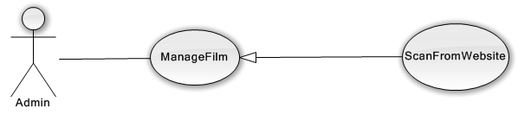

Figure 3.2.7.6 – Admin scan film from website use-case diagram

|  |  |  |  |  |
| --- | --- | --- | --- | --- |
| **USE CASE-UC10 SPECIFICATION** | | | | |
| **Use-case No.** | UC10 | **Use-case Version** | | v0.1 |
| **Use-case Name** | Scan From Website | | | |
| **Author** | Hoang Trung Thien Vuong | | | |
| **Date** | 01/08/2013 | **Priority** | High | |
| **Actor:**  Admin  **Summary:**  Admin can scan information about film from other website  **Goal:**  Helps Admin easy to add amount of film with Vietnamese information.  **Triggers:**  Admin want to scan a website and get Vietnamese information.  (Admin click on “ Quet phim online” tab of ManageFilm page)  **Preconditions:**  The page is fully loaded.  Admin is in ManageFilm Page.  Admin is right to scan specific website.  Admin have key active of TMDB API.  **PostConditions:**   * Success: * Scan successful information with amount films. * Failure: * System display error message. Content error message will be specified in log files.   **Main Success Scenario:**   |  |  | | --- | --- | | Actor Actions | System Response | | 1. Admin click on “Quet phim online” tab  3. Admin enters the number page want to scans, then click “Quet” button.  5. Admin use mouse to hover to images of film want to add.  7. Admin click to the “Them phim vao du lieu” button. | 2. Display the form “Quet Phim Le” with two fields: [PageFrom] [PageTo].  4. The System scans film on specific website and return list of result. Then it will use SearchFilmOnline function to check film is in database or not.  + If film is in Database, it will have background color yellow and do not have any function.  + If film is new, it will have background blue and have function add.  The system display report after scan: Total film scan, total film is in database, total film is new.  6. System display “add” button.  8. System displays a loader bar and start gets full information of film in Internet (Themoviedb.org and IMDB.com). When it complete, the loader bar will hidden and the background of film will change to yellow, disable all function of this film on this Page. |   **Alternative Scenario:**   |  |  | | --- | --- | | Ator Actions | System Response | | [Alternative 1]  1. Admin choose “Down hinh anh ve may” and click “Them” button on film.  [Alternative 2]  1. Admin click “Lam moi log”  [Alternative 3]  1. Admin click “Tu dong hien thi log” | 2. System displays a loader bar and start gets full information of film in Internet (Themoviedb.org and IMDB.com). When it complete, the loader bar will hidden and the background of film will change to yellow, disable all function of this film on this Page.  Then it will create a folder to include all images of that Film with structure [Name] ([FilmID)]/ backdropxx.jpg, folderxx.jpg and create a folder thumbs to hold thumbs of backdrop. Each action will be specified to log files.  2. System refreshes the datatable with new data.  2. System auto refreshes after 3 second . |   **Exceptions:**   |  |  | | --- | --- | |  |  | | Actor Actions | System Response | | [Exception1]  1. Logs cannot be load  [Exception2]  1.Cannot connect to website  [Exception3]  1.Cannot connect to TMDB | 2.Display message “ load du lieu that bai”  2. Display message “Khong ket noi duoc voi HHT” and write to logfile.  2. System writes to logfile and still adds film to DB without TMDBId. |   **Relationships:** SmartAdd, ManageFilm  **Business Rules:** Free TMDBId key api cannot send more than 30 requests/ second. | | | | |

##### <Admin> Edit Film

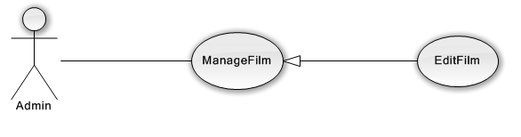

Figure 3.2.7.7 – Admin Edit Film use-case diagram

##### <Admin> Delete Film

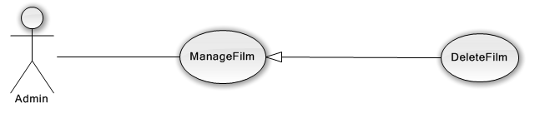

Figure 3.2.7.8 – Admin Delete Film use-case diagram

#### <Admin> Manage Store

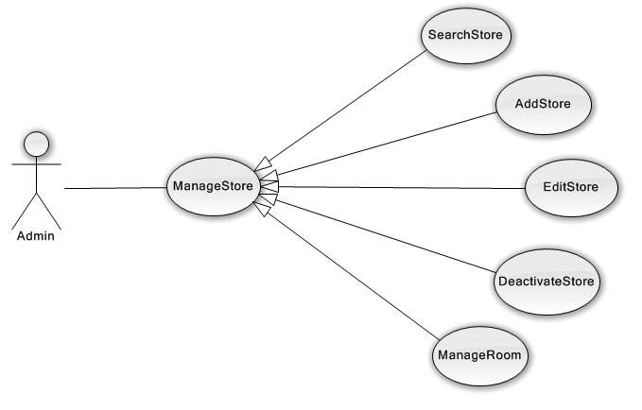

Figure 3.2.8 – Admin Manage Store use-case diagram overview

Admin can manage store of the system follow 6 main features:

Search Store, Add Store, Edit Store, Deactivate Store / Activate Store, Manage Room

##### <Admin> Search Store

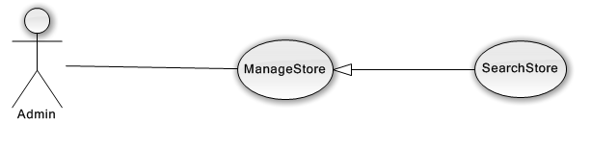

Figure 3.2.8.1 – Admin Search Store use-case diagram

|  |  |  |  |  |
| --- | --- | --- | --- | --- |
| **USE CASE-UC11 SPECIFICATION** | | | | |
| **Use-case No.** | UC11 | **Use-case Version** | | v0.1 |
| **Use-case Name** | Search Store | | | |
| **Author** | Nguyen Vinh Hien | | | |
| **Date** | 05/06/2013 | **Priority** | High | |
| **Actor:**  Admin  **Summary:**  Admin can search store of the system  **Goal:**  Helps admin to search store of system more easy  **Triggers:**  Admin want to see the store's list of the system  (Admin inputs key words on textbox then clicks “Search” icon at the right corner of frame to search follow key words inputted)  **Preconditions:**  The page is fully loaded.  **PostConditions:**   * Success: * Stores of the system are displayed as thumbnails. * Stores are displayed correctly corresponding to key words inputted * Failure: N/A   **Main Success Scenario:**   |  |  | | --- | --- | | Actor Actions | System Response | | 1. Admin input key words into textbox  [Alternative1] [Alternative2][Alternative3] .  2. Admin click "Search" icon | 3. Display stores matches key words or options that admin selected in step 1 in thumbnails icon with ability to Deactivate and Edit |   **Alternative Scenario:**   |  |  | | --- | --- | | Ator Actions | System Response | | [Alternative 1]  1. Admin check in " Inactive Store" check box  [Alternative 2]  1. Admin check in tag check box  [Alternative 3]  1. Admin click on ">>" icon | 2. Filter stores that is inactive  2. Filter stores that matches with tag that user selected.  2. The last page of stores is displayed |   **Exceptions:**   |  |  | | --- | --- | |  |  | | Actor Actions | System Response | | N/A | N/A |   **Relationships:** ManageStore  **Business Rules:** Admin can search store with many options selected. Inputted key words have to match at least one store or meaning words | | | | |

##### <Admin> Add Store

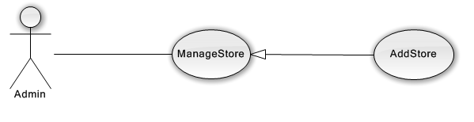

Figure 3.2.8.2 – Admin Add Store use-case diagram

|  |  |  |  |  |
| --- | --- | --- | --- | --- |
| **USE CASE-UC12 SPECIFICATION** | | | | |
| **Use-case No.** | UC12 | **Use-case Version** | | v0.1 |
| **Use-case Name** | Add Store | | | |
| **Author** | Ngo Quoc Nam | | | |
| **Date** | 05/06/2013 | **Priority** | High | |
| **Actor:**  Admin  **Summary:**  Admin can add a store by input data on form modal  **Goal:**  Helps admin input information of a store when they add new one  **Triggers:**  Admin wants to add a store’s information.  (Admin clicks “Thêm quán mới” button on “Cửa hàng” page)  **Preconditions:**  Log-in successful with role admin  Go to “Cửa hàng” page  **PostConditions:**   * Success: * Add new store successful and update list store on page immediately   Failure:   * Add store unsuccessful * System display error message. Content error message will be specified in log files   **Main Success Scenario:**   |  |  | | --- | --- | | Actor Actions | System Response | | 1.Admin click on “Thêm quán” button on “Cửa hàng” page  3.Admin input corresponding information in form then click “Lưu” button [Exception1] | 2. Modal popup is displayed with fields for admin input information of new store.  4. Modal popup is hidden, new store is displayed on top of list active store on “Cửa hàng” page. |   **Alternative Scenario:**   |  |  | | --- | --- | | Ator Actions | System Response | | N/A | N/A |   **Exceptions:**   |  |  | | --- | --- | |  |  | | Actor Actions | System Response | | [Exception1]  1. Admin leave all empty fields then click on “Lưu” button | 2. Modal popup display validation for needed to input field. |   **Relationships:** ManageStore  **Business Rules:** N/A. | | | | |

##### <Admin> Edit Store

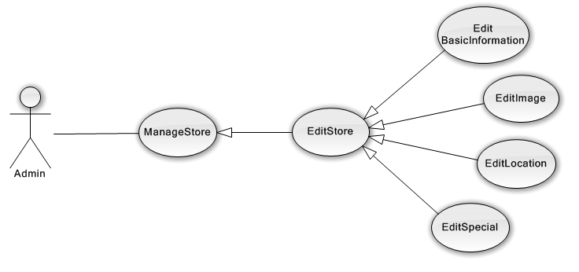

Figure 3.2.8.3 – Admin Edit Store use-case diagram overview

Admin can edit store of the system follow 4 main features:

**Edit Basic Information, Edit Image, Edit Location on map, Edit Special Information**

##### <Admin> Deactivate Store

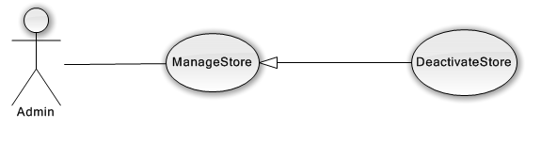

Figure 3.2.8.4 – Admin Deactivate Store use-case diagram

##### <Admin> Manage Room

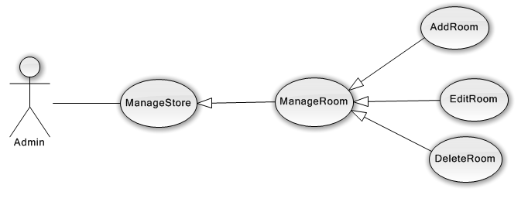

Figure 3.2.8.5 – Admin Manage Room use-case diagram overview

Admin can manage room of the store follow 3 main features:

**Add Room, Edit Room, Delete Room**

#### <Admin> Manage File

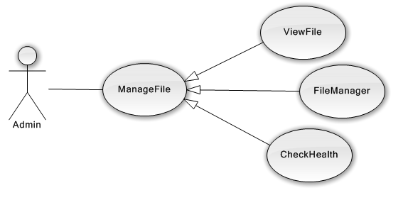

Figure 3.2.9 – Admin Manage File use-case diagram overview

Admin can manage file of the system follow 3 main features:

**View File, File Manager, Check Health**

##### <Admin> View File

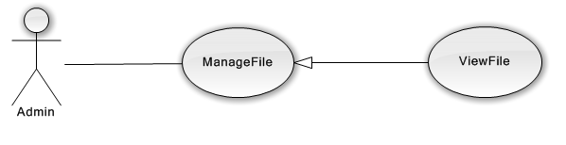

Figure 3.2.9.1 – Admin View File use-case diagram

##### <Admin> File Manager

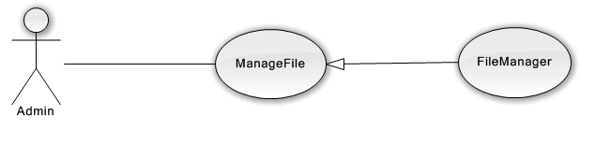

Figure 3.2.9.2 – Admin Manage Film use-case diagram

|  |  |  |  |  |
| --- | --- | --- | --- | --- |
| **USE CASE-UC13 SPECIFICATION** | | | | |
| **Use-case No.** | UC13 | **Use-case Version** | | v0.1 |
| **Use-case Name** | File Manager | | | |
| **Author** | Hoang Trung Thien Vuong | | | |
| **Date** | 01/08/2013 | **Priority** | High | |
| **Actor:**  Admin  **Summary:**  Admin have a tool support manage files on server.  **Goal:**  Helps Admin easy to manipulate files like windows explorer.  **Triggers:**  Admin want to view, change, and upload files.  (Admin choose button on “Menubar” at ManageFile Page)  **Preconditions:**  The page is fully loaded.  Admin is in ManageFile page.  **PostConditions:**   * Success: * File Manager support any operation that Admin choose * Failure: * System display error message. Content error message will be specified in log files.   **Main Success Scenario:**   |  |  | | --- | --- | | Actor Actions | System Response | | 1. Admin click on any button on menubar. The menubar support below function:   * Back * Forward * Reload * Home * Go to parent directory * New folder * New text file * Upload files * Open * Download * Get Info * Preview * Coppy * Cut * Paste * Delete * Duplicate * Rename * Edit file * Resize & Rotate * ListView * Sort | 2. The file manager receive the command the process it. Then display the result based on command. |   **Alternative Scenario:**   |  |  | | --- | --- | | Ator Actions | System Response | | [Alternative 2]  1. Admin right click on white space  3. Admin choose the command :   * Reload * Back * Upload files * New folder * New text file * Sort * GetInfo   [Alternative 2]  1. Admin right click on file  3. Admin choose the command:   * Open * Preview * Coppy * Cut * Duplicate * Delete * Rename * Resize & rotate * GetInfo | 2. File Manager display approach command for right menu context.  4. File Manager receive the command and process it. Then display the result baed on command.  2. File Manager display approach command for right menu context.  4. File Manager receive the command and process it. Then display the result baed on command. |   **Exceptions:**   |  |  | | --- | --- | |  |  | | Actor Actions | System Response | | [Exception1]  1. System cannot connect to Controller | 2. Display message “Cannot connect to backend”. User should F5 or try again. |   **Relationships:** ViewFile, ManageFile  **Business Rules:** N/A | | | | |

##### <Admin> Check Health

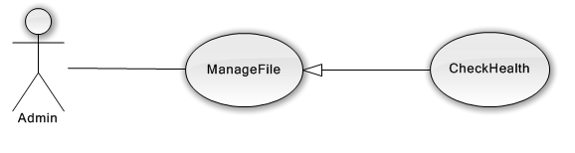

Figure 3.2.9.3 – Admin Check Health use-case diagram

#### <Admin> Manage News

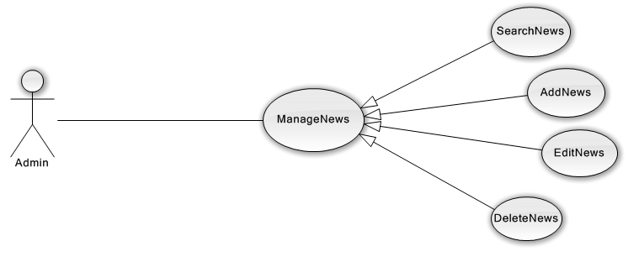

Figure 3.2.10 – Admin Manage News use-case diagram overview

Admin can manage news of multimedia follow 4 main features:

**Search News, Add News, Edit News, Delete News**

#### <Admin> Manage Advertising

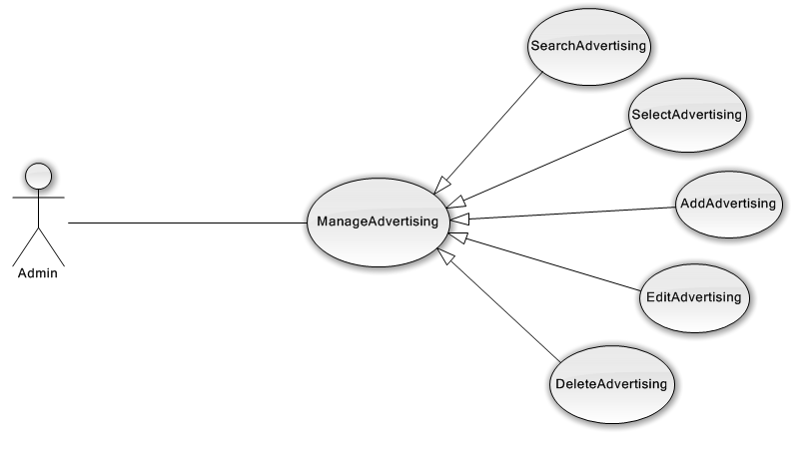

Figure 3.2.11 – Admin Manage Advertising use-case diagram overview

Admin can manage advertising of multimedia follow 5 main features:

***Search Advertising, Select Advertising, Add Advertising, Edit Advertising, Delete Advertising***

##### <Admin> Search Advertising

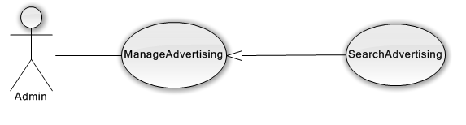

Figure 3.2.11.1 – Admin Search Advertising use-case diagram

|  |  |  |  |  |
| --- | --- | --- | --- | --- |
| **USE CASE-UC14 SPECIFICATION** | | | | |
| **Use-case No.** | UC14 | **Use-case Version** | | v0.1 |
| **Use-case Name** | Search Advertising | | | |
| **Author** | Pham Ngoc Hoang | | | |
| **Date** | 05/06/2013 | **Priority** | High | |
| **Actor:**  Admin  **Summary:**  Admin can search advertising on home page.  **Goal:**  Helps admin find the advertising that they need.  **Triggers:**  Admin want to search advertising.  (Admin type keyword to search bar on “Quảng cáo” tab )  **Preconditions:**  The page is fully loaded.  Admin is in “Quảng cáo” tab on “Truyền thông” page that have search bar  **PostConditions:**  Success:   * Display the correct information about the advertising.   Failure:   * Website can not find the advertising, result wrong.   **Main Success Scenario:**   |  |  | | --- | --- | | Actor Actions | System Response | | 1. Admin type keywork to the search bar. [Alternative1]  3. Admin sees the result and clicks on one advertising on the result list. | 2. System finds and return a list of advertising that matching with the keyword in Json and display result below the Search bar.  4. System redirect to news information. |   **Alternative Scenario:**   |  |  | | --- | --- | | Ator Actions | System Response | | [Alternative1]  1. Admin type keywork on Search bar. | 2. Display full result. If empty, show message “Không tìm thấy quảng cáo bạn cần” |   **Exceptions:**   |  |  | | --- | --- | |  |  | | Actor Actions | System Response | | N/A | N/A |   **Relationships:** ManageAdvertising  **Business Rules:** N/A | | | | |

##### <Admin> Select Advertising

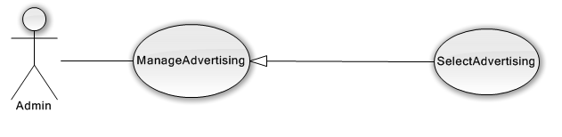

Figure 3.2.11.2 – Admin Select Advertising use-case diagram

|  |  |  |  |  |
| --- | --- | --- | --- | --- |
| **USE CASE-UC15 SPECIFICATION** | | | | |
| **Use-case No.** | UC15 | **Use-case Version** | | v0.1 |
| **Use-case Name** | Select Advertising | | | |
| **Author** | Ngo Quoc Nam | | | |
| **Date** | 05/06/2013 | **Priority** | High | |
| **Actor:**  Admin  **Summary:**  Admin can select a advertising from list advertise set on a definite page  **Goal:**  Helps admin select advertising will be display on page  **Triggers:**  Admin wants to select advertising.    **Preconditions:**  Log-in successful with role admin  Go to “Multimedia” page  **PostConditions:**   * Success: * Select advertising and update list advertising on page immediately   Failure:   * Add advertising unsuccessful * System display error message. Content error message will be specified in log files   **Main Success Scenario:**   |  |  | | --- | --- | | Actor Actions | System Response | | 1.Admin click on “Chỉnh sửa” button on “Quảng cáo” tab  3.Admin change (search/delete/select new) advertising in select2 box then click “Lưu lại” button | 2. Select2 box is enable for admin select advertising and edit list advertising  4. New list advertising is updated and saved on select2 box in current page. Alert saved is displayed |   **Alternative Scenario:**   |  |  | | --- | --- | | Ator Actions | System Response | | N/A | N/A |   **Exceptions:**   |  |  | | --- | --- | |  |  | | Actor Actions | System Response | | N/A | N/A |   **Relationships:** ManageAdvertising  **Business Rules:** N/A. | | | | |

##### <Admin> Add Advertising

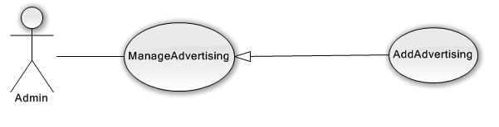

Figure 3.2.11.3 – Admin Add Advertising use-case diagram

##### <Admin> Edit Advertising

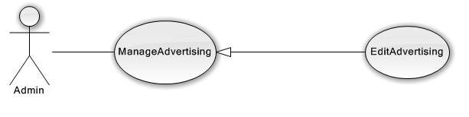

Figure 3.2.11.4 – Admin Edit Advertising use-case diagram

##### <Admin> Delete Advertising

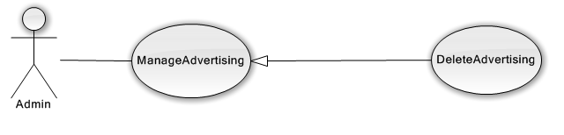

Figure 3.2.11.5 – Admin Delete Advertising use-case diagram

#### <Admin> Manage Carousel

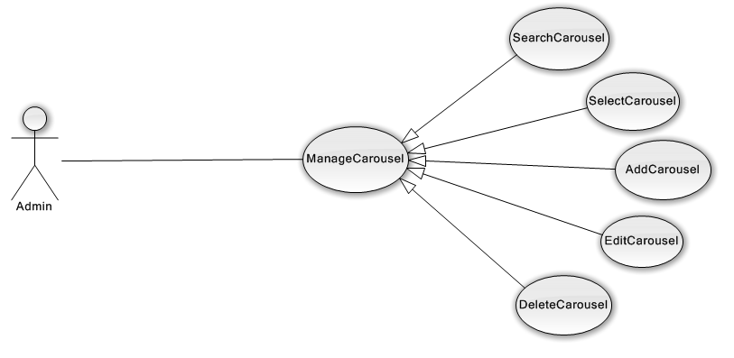

Figure 3.2.12 – Admin Manage Carousel use-case diagram overview

Admin can manage carousel of multimedia follow 5 main features:

***Search Carousel, Select Carousel, Add Carousel, Edit Carousel, Delete Carousel***

(Feature use-cases are similar to Manage Advertising)

#### <Admin> Manage Category

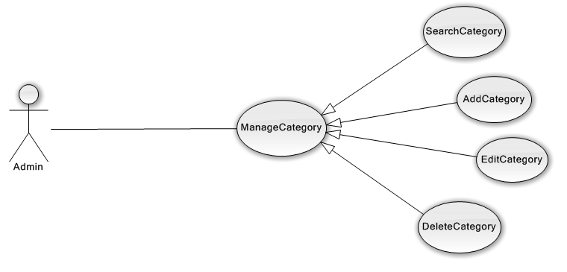

Figure 3.2.13 – Admin Manage Category use-case diagram overview

Admin can manage category of data follow 4 main features:

***Search Category, Add Category, Edit Category, Delete Category***

#### <Admin> Manage Tag

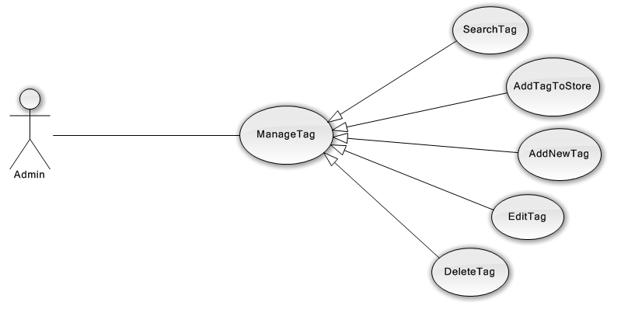

Figure 3.2.14 – Admin Manage Tag use-case diagram overview

Admin can manage tag of data follow 4 main features:

***Search Tag, Add New Tag, Edit Tag, Delete Tag, Add Tag to Store***

#### <Admin> Manage Actor

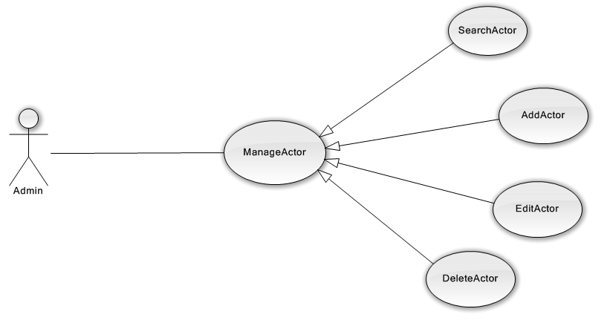

Figure 3.2.15 – Admin Manage Actor use-case diagram overview

Admin can manage category of data follow 4 main features:

***Search Actor, Add Actor, Edit Actor, Delete Actor***

#### <Admin> Manage User

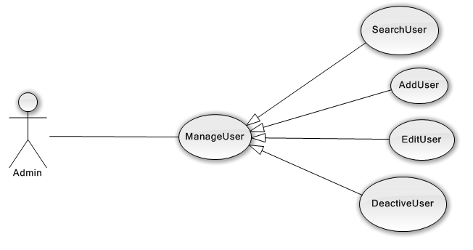

Figure 3.2.16 – Admin Manage User use-case diagram overview

Admin can manage user of the system follow 4 main features:

***Search User, Add User, Edit User, Deactivate User***

#### <StoreOwner> Manage Store Film

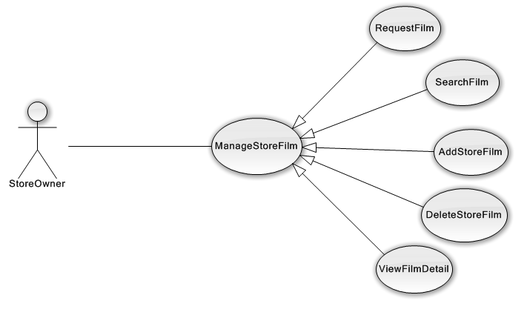

Figure 3.2.17 – Admin Manage Store’ Film use-case diagram overview

Store Owner can manage store’s film of the current store follow 5 main features:

***Search Film, Add Film to store, Delete Film from store, View Film Details, Request Film***

##### <StoreOwner> Request Film

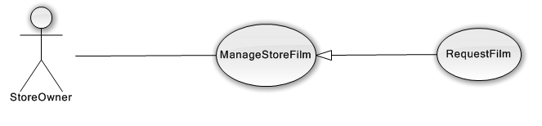

Figure 3.2.17.1 – Store Owner Request Film use-case diagram

|  |  |  |  |  |
| --- | --- | --- | --- | --- |
| **USE CASE-UC16 SPECIFICATION** | | | | |
| **Use-case No.** | UC16 | **Use-case Version** | | v0.1 |
| **Use-case Name** | View Store Staticstic | | | |
| **Author** | Hoang Trung Thien Vuong | | | |
| **Date** | 05/06/2013 | **Priority** | High | |
| **Actor:**  StoreOwner  **Summary:**  StoreOwner can request a film that does not in database.  **Goal:**  Helps StoreOwner send request and help Admin update database.  **Triggers:**  StoreOwner want request a film does not in database.  (StoreOwner click on “ Gui yeu cau” button of ManageFilmStore page)  **Preconditions:**  The page is fully loaded.  StoreOwner is in ManageFilmStore Page.  **PostConditions:**   * Success: * The message is sent to Admin. * Failure: * System display error message. Content error message will be specified in log files.   **Main Success Scenario:**   |  |  | | --- | --- | | Actor Actions | System Response | | 1. StoreOwner click on “gui yeu cau” tab  3. StoreOwner fill request to field [Content] and click send button. | 2. The system display a form with field [Content]  4. The system will send message to Admin and display message alert send successfuly |   **Alternative Scenario:**   |  |  | | --- | --- | | Ator Actions | System Response | | N/A | N/A |   **Exceptions:**   |  |  | | --- | --- | |  |  | | Actor Actions | System Response | | N/A | N/A |   **Relationships:** ManageStoreFilm  **Business Rules:** N/A | | | | |

##### <StoreOwner> Search Film

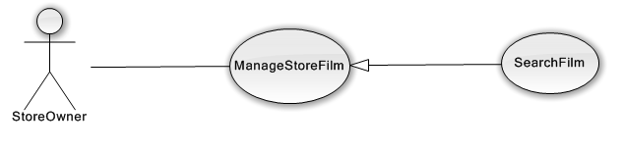

Figure 3.2.17.2 – Store Owner Search Film use-case diagram

(Use-case specification is similar to Admin Search Film)

##### <StoreOwner> Add Film to Store

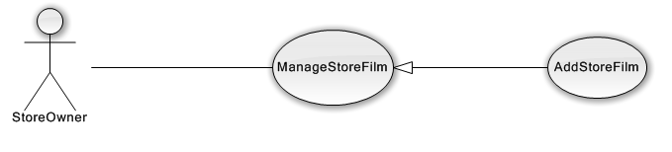

Figure 3.2.17.3 – Store Owner Add Film to Store use-case diagram

|  |  |  |  |  |
| --- | --- | --- | --- | --- |
| **USE CASE-UC17 SPECIFICATION** | | | | |
| **Use-case No.** | UC17 | **Use-case Version** | | v0.1 |
| **Use-case Name** | Add Store Film | | | |
| **Author** | Nguyen Vinh Hien | | | |
| **Date** | 05/06/2013 | **Priority** | High | |
| **Actor:**  Store Owner  **Summary:**  Store owner can add films to their store’s list of films  **Goal:**  Helps store owner add film to their store easily  **Triggers:**  Store owner want to add new film to their store’s list of films  (Store owner clicks “Thêm phim vào quán” icon at the bottom of film’s icon which they want to add)  **Preconditions:**  The page is fully loaded  The film’s list of system is fully loaded  **PostConditions:**   * Success: * The film is added to store’s film list successfully * The film is added have a blue background color * Failure: N/A   **Main Success Scenario:**   |  |  | | --- | --- | | Actor Actions | System Response | | 1. [Alternative 1] [Alternative 2].Store Owner click “Thêm phim mới “ icon [Exceptions 1]. | 2. The film is added to store’s film list. |   **Alternative Scenario:**   |  |  | | --- | --- | | Ator Actions | System Response | | [Alternative 1]  1. Store owner check in " Ngoài Quán" check box  .  [Alternative 2]  1. Store owner check in category check box | 2. Filter film that is not in store of store owner  2. Filter FIlm that matches options that user selected. |   **Exceptions:**   |  |  | | --- | --- | |  |  | | Actor Actions | System Response | | [Exceptions 1]  1. Store owner click on "Thêm phim mới" icon at the bottom of the film that already inactive | 2. The film is added to store’s film list and the picture of that film will not display, the "sorry, that film is deactive by the admin" picture will be displayed. |   **Relationships:** ManageStoreFilm  **Business Rules:** Admin can add any film showed in the system's film list with no background color. Film added must not already exist at store’s film list | | | | |

##### <StoreOwner> View Film Detail

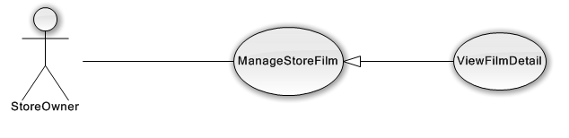

Figure 3.2.17.4 – Store Owner View Film Details use-case diagram

(Use-case specification is similar to Admin View Film details)

##### <StoreOwner> Delete Store Film

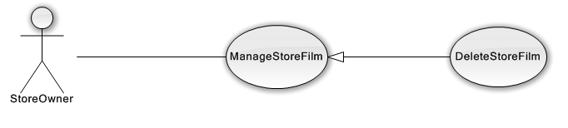

Figure 3.2.17.5 – Store Owner Delete Store Film use-case diagram

#### <StoreOwner> Manage Store Profile

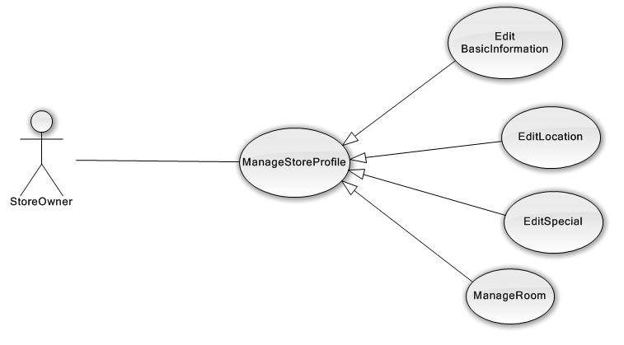

Figure 3.2.18 – Manage Store Profile use-case diagram overiew

Store Owner can manage current store’s profile follow 4 main features:

***Edit Basic Information, Edit Location, Edit Special, Manage Room***

(Use-cases specification is similar to Admin Edit Store)

#### <StoreOwner> Manage Schedule

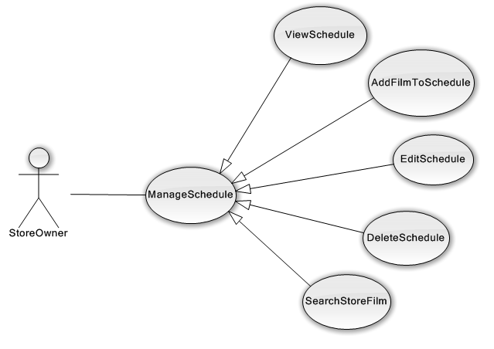

Figure 3.2.19 – Admin Manage Schedule use-case diagram overview

Store Owner can manage current store’s schedule follow 5 main features:

***View Schedule, Add film to schedule, Edit Schedule, Delete schedule, Search Film of store***

##### <StoreOwner> View Schedule

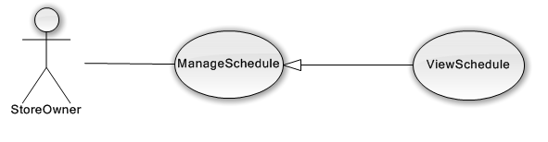

Figure 3.2.19.1 – Store Owner View Schedule use-case diagram

|  |  |  |  |  |
| --- | --- | --- | --- | --- |
| **USE CASE-UC18 SPECIFICATION** | | | | |
| **Use-case No.** | UC18 | **Use-case Version** | | v0.1 |
| **Use-case Name** | View Schedule | | | |
| **Author** | Hoang Trung Thien Vuong | | | |
| **Date** | 01/08/2013 | **Priority** | High | |
| **Actor:**  StoreOwner  **Summary:**  StoreOwner can view all schedule in calendar.  **Goal:**  Helps StoreOwner overall the schedule in any time.  **Triggers:**  StoreOwner want view Schedule in Store.  (StoreOwner click on “ Lich chieu” button on Menubar)  **Preconditions:**  The page is fully loaded.  **PostConditions:**   * Success: * All schedule in the specific time is loaded fully. * Failure: * System display error message. Content error message will be specified in log files.   **Main Success Scenario:**   |  |  | | --- | --- | | Actor Actions | System Response | | 1. StoreOwner click on “Lich chieu” button  3. StoreOwner click any date on small calendar    5. StoreOwner check to any room on list room | 2. The system display interface:   * Left: a button “Create” and a small calendar. * Right: Display all room and a big calendar present the schedule for each room   4. The system display exactly the date that StoreOwner clicks and presents the schedule on that date/week/month.  6. The system will remove or display room that checked and render schedule again. |   **Alternative Scenario:**   |  |  | | --- | --- | | Ator Actions | System Response | | [Alternative1]  1. StoreOwner hover any event on schedule | 2.System displays a tooltip that have:   * Image of event * BeginTime and EndTime * OwnerOfEvent * Name Event |   **Exceptions:**   |  |  | | --- | --- | |  |  | | Actor Actions | System Response | | [Exception1]  1. StoreOwner scrollbar schedule to end. Then click on small schedule to change another day. | 2. The schedule will be render wrong pixel. The System need to be refreshes the Calendar. |   **Relationships:** N/A  **Business Rules:** The Time display on schedule is from 8h00 – 23h00. | | | | |

##### <StoreOwner> Add Film to Schedule

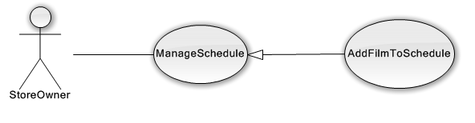

Figure 3.2.19.2 – StoreOwner Add Film to Schedule use-case diagram

|  |  |  |  |  |
| --- | --- | --- | --- | --- |
| **USE CASE-UC19 SPECIFICATION** | | | | |
| **Use-case No.** | UC19 | **Use-case Version** | | v0.1 |
| **Use-case Name** | Add Schedule | | | |
| **Author** | Hoang Trung Thien Vuong | | | |
| **Date** | 01/08/2013 | **Priority** | High | |
| **Actor:**  StoreOwner  **Summary:**  StoreOwner can add new event to schedule.  **Goal:**  Helps StoreOwner easy to add event to schedule  **Triggers:**  StoreOwner want add new event.  (StoreOwner click on “ Tao” button on left panel or any whitespace in big calendar)  **Preconditions:**  The page is fully loaded.  StoreOwner is in ManageSchedule Page.  **PostConditions:**   * Success: * The new event is added to Calendar. * Failure: * System display error message. Content error message will be specified in log files.   **Main Success Scenario:**   |  |  | | --- | --- | | Actor Actions | System Response | | 1. StoreOwner click on “Tao su kien” button  3. StoreOwner fill correct information and click “Tao” | 2. The system display a form:   * Room * Film * BeginTime * EndTime * A small calendar. * isBooks   4. System checks validation of event. Sytem close the form if true and display result on big Calendar with notifies. |   **Alternative Scenario:**   |  |  | | --- | --- | | Ator Actions | System Response | | [Alternative1]  1. StoreOwner choose multi date by click on small calendar | 2. System check validation of multi event.Sytem close the form if true and display result on big Calendar with notifies. |   **Exceptions:**   |  |  | | --- | --- | |  |  | | Actor Actions | System Response | | [Exception1]  1. The EndTime is early than BeginTime  [Exception2]  1. The EndTime is same as BeginTime  [Exception3]  1. The BeginTime and EndTime conflict with other event when the same room and overload time. | 2. Form display message “ Khong the ket thuc su kien truoc khi no dien ra” and disable “Tao” button  2. Form display message “ Khong the ket thuc su kien ngay khi no bat dau” and disable “Tao” button  2. Form display message “Su kien trung voi lich chieu cua phim xx bat dau luc HH:mm den HH:mm ngay mm/dd/yyy” and disable “Tao” button. |   **Relationships:** ViewSchedule  **Business Rules:** The Time to create event is from 8h00-23h00. | | | | |

##### <StoreOwner> Edit Schedule

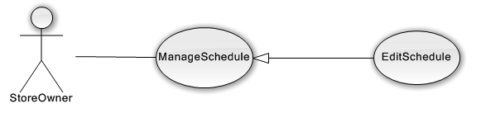

Figure 3.2.19.3 – Store Owner Edit Schedule use-case diagram

|  |  |  |  |  |
| --- | --- | --- | --- | --- |
| **USE CASE-UC20 SPECIFICATION** | | | | |
| **Use-case No.** | UC20 | **Use-case Version** | | v0.1 |
| **Use-case Name** | Edit Schedule | | | |
| **Author** | Hoang Trung Thien Vuong | | | |
| **Date** | 01/08/2013 | **Priority** | High | |
| **Actor:**  StoreOwner  **Summary:**  StoreOwner can edit event in schedule.  **Goal:**  Helps StoreOwner easy to edit event in schedule.  **Triggers:**  StoreOwner want edit event.  (StoreOwner click on event in big Calendar.)  **Preconditions:**  The page is fully loaded.  StoreOwner is in ManageSchedule Page.  **PostConditions:**   * Success: * The event will be updated. * Failure: * System display error message. Content error message will be specified in log files.   **Main Success Scenario:**   |  |  | | --- | --- | | Actor Actions | System Response | | 1. StoreOwner click event in big calendar  3. StoreOwner update the new information and click “Cap nhat”. | 2. The system display a form with information of that film.   * Room * Film * BeginTime * EndTime * A small calendar. * isBooks   4. System checks validation of event. Sytem close the form if true and display result on big Calendar and alert successfully. |   **Alternative Scenario:**   |  |  | | --- | --- | | Ator Actions | System Response | | N/A | N/A |   **Exceptions:**   |  |  | | --- | --- | |  |  | | Actor Actions | System Response | | [Exception1]  1. The EndTime is early than BeginTime  [Exception2]  1. The EndTime is same as BeginTime  [Exception3]  1. The BeginTime and EndTime conflict with other event when the same room and overload time. | 2. Form display message “ Khong the ket thuc su kien truoc khi no dien ra” and disable “Tao” button  2. Form display message “ Khong the ket thuc su kien ngay khi no bat dau” and disable “Tao” button  2. Form display message “Su kien trung voi lich chieu cua phim xx bat dau luc HH:mm den HH:mm ngay mm/dd/yyy” and disable “Tao” button. |   **Relationships:** ViewSchedule, DeleteFilm  **Business Rules:** The Time to edit event is from 8h00-23h00. | | | | |

##### <StoreOwner> Delete Schedule

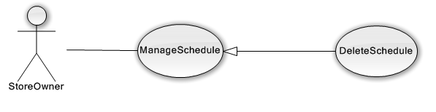

Figure 3.2.19.4 – Store Owner Delete Schedule use-case diagram

##### <StoreOwner> Search Film of Store

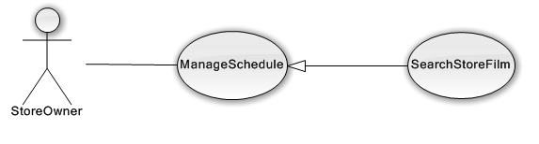

Figure 3.2.19.5 – Store Owner Search Film of Store use-case diagram

|  |  |  |  |  |
| --- | --- | --- | --- | --- |
| **USE CASE-UC21 SPECIFICATION** | | | | |
| **Use-case No.** | UC21 | **Use-case Version** | | v0.1 |
| **Use-case Name** | Search Store Film | | | |
| **Author** | Hoang Trung Thien Vuong | | | |
| **Date** | 01/08/2013 | **Priority** | High | |
| **Actor:**  StoreOwner  **Summary:**  StoreOwner view film suggest from system  **Goal:**  Let StoreOwner know the film that user select most or high ranking film.  **Triggers:**  StoreOwner want to delete event.  (StoreOwner click on event in big Calendar.)  **Preconditions:**  The page is fully loaded.  StoreOwner is in ManageSchedule Page.  **PostConditions:**   * Success: * Load the useful information into table * Failure: * System display error message. Content error message will be specified in log files.   **Main Success Scenario:**   |  |  | | --- | --- | | Actor Actions | System Response | | 1. StoreOwner click “xem goi y” button | 2. The system display tables:   * Film popular * Film high scrore * New Film |   **Alternative Scenario:**   |  |  | | --- | --- | | Ator Actions | System Response | | [Alternative1]  1.StoreOwner click “Them vao lich chieu” button | 2. (AddSchedule usecase). |   **Exceptions:**   |  |  | | --- | --- | |  |  | | Actor Actions | System Response | | N/A | N/A |   **Relationships:** AddSchedule  **Business Rules:** N/A | | | | |

#### <StoreOwner> Manage News

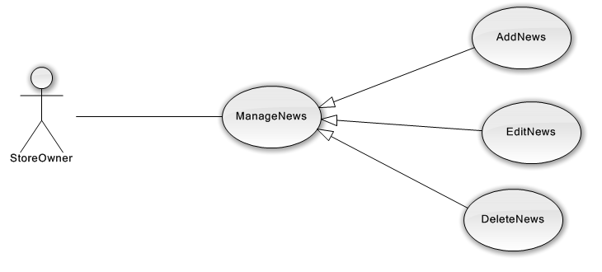

Figure 3.2.20 – Store Owner Manage News use-case diagram overview

Store Owner can manage news follow 3 main features:

***Add News, Edit News, Delete News***

(Use-case specification is similar to Admin Manage News)

#### <StoreOwner> Manage File

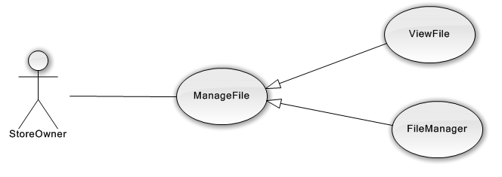

Figure 3.2.21 – Store Owner Manage File use-case diagram

Store Owner can manage file of the system follow 3 main features:

***View File, File Manager***

(Use-case specification is similar to Admin ManageFile)

#### <StoreOwner> Manage Store Owner Profile

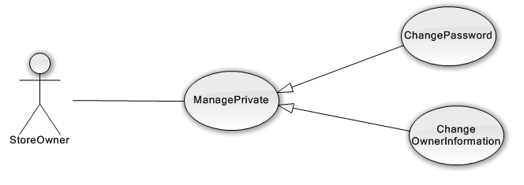

Figure 3.2.22 – Manage Store Owner Profile (Manage Private) use-case diagram

Store Owner can manage their profile follow 2 main features:

***Change Password, Change Personal Information***

### Software System Attributes

#### Reliability

* Mean Time Between Failures (MTBF): The acceptable failure is once a year.
* Mean Time To Repair (MTTR): The acceptable mean time for a particular failure must be least than 12 hours.
* Maximum Bugs or Defect Rate: 10 – 15 bugs /KLOC

#### Availability

* The server shall be working 24/7. When the system go in under-maintenance, the page will display that “The website is not available that that moment. Pleased come back in some hours.”

#### Security

* Our system always checks authenticated of all method that needs permission. Anonymous cannot access method of Admin and StoreOwner in controller.

#### Maintainability

* Our system uses Entity framework and MVC 4 framework, so it easy to work around if database/requirement change.
* Module of Admin, StoreOwner and Guest is modular to permit future modifications.

#### Portability

* System can run anywhere on Web platform exception function view3D store need browser support WebGL. WebGL is widely supported in modern browsers and this function is run best on google chrome 25 or above.

#### Performance

N/A

## Entity Relationship Diagram (ERD)

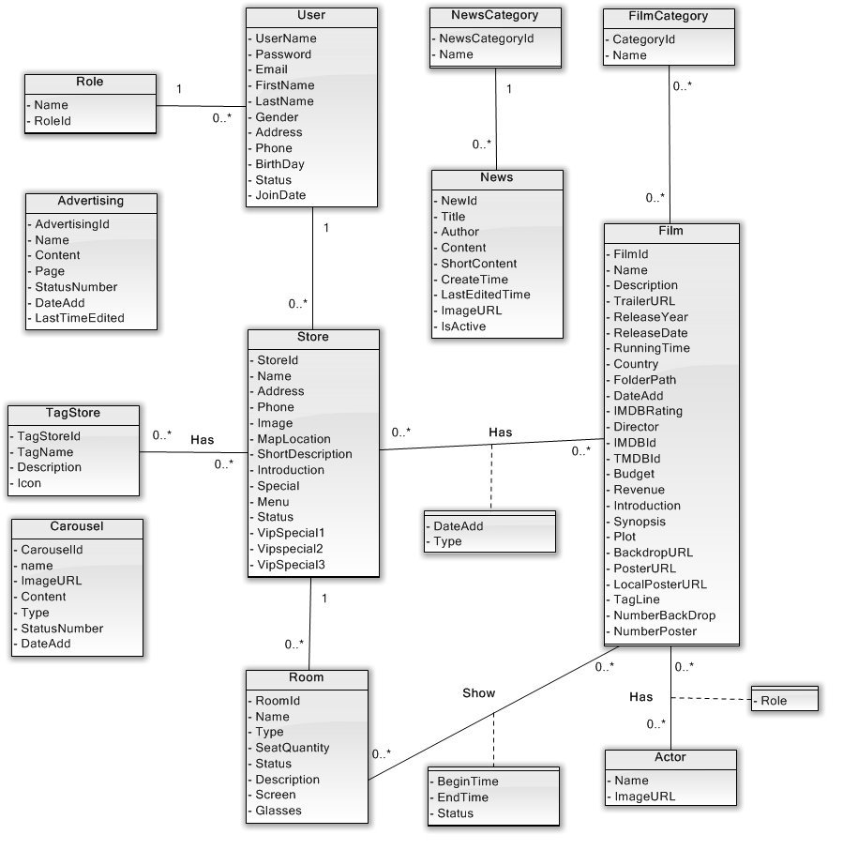

Figure 3.3 Entity Relationship Diagram

# Software Design Description

## Design Overview

* This document describes the technical and UI design of the FFDS system. It includes the architectural design and the detailed design of common functions and business functions. It also includes the design of database model.
* The architectural design describes the overall architecture of the system, and the architecture of each main component and subsystem. It will describe the patterns being used, the role of each component and the role of the system in the working environment.
* The detailed design describes static and dynamic structure for each component and function. It includes class diagrams, class explanations, and sequence diagrams of the main use cases. The detailed design uses notations of .NET framework 4.3 and C#, as they are the framework and language for developing the system.
* The database design describes the relationship between entities, and details of each entity. It uses notations of SQL Server 2012 as it is the database server for developing the system.
* The user interface design describes the layout of the system, and some design for the screens

## System Architectural Design

### Choice of system Architecture



Figure 4.1 – System Architecture (Distributed)

The main entities of the above diagram are described as following:

* **Database**: this is the central daa storage for the system. It contains data: user, films, stores, film’s category, films of store and room.
* **Management site**: this is the website to manage film, store, schedule, category and room. It is developed using ASP.NET MVC 4 framework.

### MVC Software Architecture

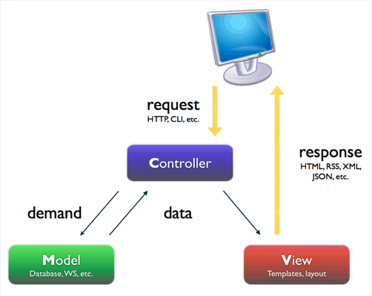

**Firgue 4.2 - MVC software architecture**

* **Models:** Model objects are the parts of the application that implement the logic for the application's data domain. Often, model objects retrieve and store model state in a database. For example, a Product object might retrieve information from a database, operate on it, and then write updated information back to a Products table in a SQL Server database.
* **Views:** are the components that display the application's user interface (UI). Typically, this UI is created from the model data. An example would be an edit view of a Products table that displays text boxes, drop-down lists, and check boxes based on the current state of a Product object.
* **Controllers:** are the components that handle user interaction, work with the model, and ultimately select a view to render that displays UI. In an MVC application, the view only displays information; the controller handles and responds to user input and interaction. For example, the controller handles query-string values, and passes these values to the model, which in turn might use these values to query the database.

### Discussion of Alternative Designs

N/A

### Description of System Interface

N/A

### User Interfaces

* UI should be simple, model and easy to use.
* Support drag & drop easy for change any in website.

### Hardware interfaces

* The site should be deployed online and available to a wide range of hardware devices.

### Software Interfaces

* Any service exposed by the system should be accessible using HTTP protocol.
* Run best on Chrome browser.

## Database Design

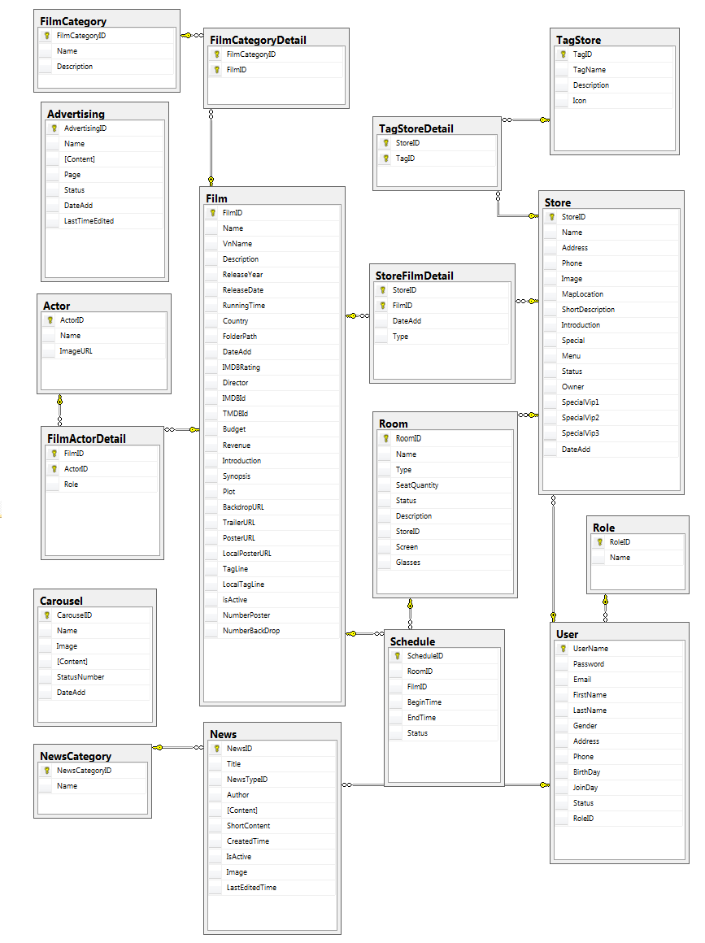

### Table Dictionary

|  |  |  |
| --- | --- | --- |
| **No.** | **Table Name** | **Description** |
| 1 | Actor | Storing information about all actors in system |
| 2 | Advertising | Storing information about all advertising in system |
| 3 | Carousel | Storing information about slide, banner displayed in homepage of system |
| 4 | Film | Storing information about all film in system |
| 5 | FilmActorDetail | Storing information about actors(role) in a film |
| 6 | FilmCategory | Storing all categories in a film |
| 7 | FilmCategoryDetail | Storing information category of a film in system |
| 8 | Log | Storing information about logfile in system |
| 9 | News | Storing information about News |
| 10 | NewsCategory | Storing category of News in system |
| 11 | Role | Storing all role in system |
| 12 | Room | Storing information about a room in system |
| 13 | Schedule | Storing information (timebegin, timeend) of a room when showing film. |
| 14 | Store | Storing information ( name, address, description… ) about a store. |
| 15 | StoreFilmDetail | Storing information about all film of store. |
| 16 | TagStore | Storing information about all tag in system |
| 17 | TagStoreDetail | Storing information about tags in a store. |
| 18 | User | Storing information about user in system |

### Actor

|  |  |  |  |  |  |  |
| --- | --- | --- | --- | --- | --- | --- |
| Field Name | Type | Null | Unique | P/F Key | Default | Description |
| ActorID | int |  |  | PK |  | The ID of the actor |
| Name | varchar(30) |  |  |  |  | The name of the actor |
| ImageURL | varchar(120) |  |  |  |  | Image of actor |

### Advertising

|  |  |  |  |  |  |  |
| --- | --- | --- | --- | --- | --- | --- |
| Field Name | Type | Null | Unique | P/F Key | Default | Description |
| AdvertisingID | int |  |  | PK |  | The ID of the adverting |
| Name | varchar(30) |  |  |  |  | The name of the adverting |
| Content | nvarchar (2000) |  |  |  |  | The content of the adverting. |
| Page | nvarchar(30) |  |  |  |  | The name of page wants to display advertising. |
| Status | int |  |  |  |  | The status of this advertising. |
| DateAdd | date |  |  |  |  | The date that add this advertising. |
| LastTimeEdited | datetime | true |  |  |  | The last time edited this advertising. |

### Carousel

|  |  |  |  |  |  |  |
| --- | --- | --- | --- | --- | --- | --- |
| Field Name | Type | Null | Unique | P/F Key | Default | Description |
| CarouselID | int |  |  | PK |  | The ID of the carousel |
| Name | nvarchar(30) |  |  |  |  | The name of the carousel |
| Image | varchar(120) |  |  |  |  | The image of the carousel |
| Content | nvarchar (2000) | true |  |  |  | The content of the carousel |
| StatusNumber | int |  |  |  |  | The status of this carousel. |
| DateAdd | date |  |  |  |  | The date that add this carousel. |

### Film

|  |  |  |  |  |  |  |
| --- | --- | --- | --- | --- | --- | --- |
| Field Name | Type | Null | Unique | P/F Key | Default | Description |
| FilmID | int |  |  | PK |  | The ID of the carousel |
| Name | nvarchar(75) |  |  |  |  | The name of the carousel |
| VnName | nvarchar(75) | true |  |  |  | The image of the carousel |
| Description | nvarchar (2000) |  |  |  |  | The content of the carousel |
| ReleaseYear | int |  |  |  |  | The status of this carousel. |
| ReleaseDate | date | true |  |  |  | The date that add this carousel. |
| RunningTime | int |  |  |  |  | The length of time that a film or television program takes to run from beginning to end. |
| Country | nvarchar(60) | true |  |  |  | The country that produce the film |
| FolderPath | varchar(120) |  |  |  |  | Folder that hold all image of a film |
| DateAdd | date |  |  |  |  | The date add this film to System |
| IMDBRating | float | true |  |  |  | Rating of IMDB.com |
| Director | varchar(30) | true |  |  |  | The person who gives instructions to the actors and other people |
| IMDBId | nvarchar(15) | true |  |  |  | ID film of IMDB.com |
| TMDBId | int | true |  |  |  | ID film of Themoviedb |
| Budget | int |  |  |  |  | The money use to produce the film |
| Revenue | int |  |  |  |  | The revenue of film after release. |
| Introduction | nvarchar (MAX) | true |  |  |  | Introduction of the film in system. |
| Synopsis | nvarchar (MAX) | true |  |  |  | A short description of the main events or ideas in a film |
| Plot | nvarchar (1000) | true |  |  |  | The events that form the main story of a book, film, or play: |
| BackdropURL | varchar(120) | true |  |  |  | ImageURL of backdrop. Using backdrop in themovie.org |
| TrailerURL | varchar(120) | true |  |  |  | The trailer of film in this system |
| PosterURL | varchar(120) | true |  |  |  | The image URL of poster. Using poster in themovie.org |
| LocalPosterURL | varchar(120) | true |  |  |  | Poster with local languages |
| TagLine | nvarchar(200) | true |  |  |  | Tagline is a slogan of a film. |
| LocalTagLine | nvarchar(200) | true |  |  |  | Tagline with local languages |
| isActive | bit |  |  |  |  | Status of the film in system |
| NumberPoster | int | true |  |  |  | Total poster after download images. |
| NumberBackDrop | int | true |  |  |  | Total backdrop after download images. |

### FilmActorDetail

|  |  |  |  |  |  |  |
| --- | --- | --- | --- | --- | --- | --- |
| Field Name | Type | Null | Unique | P/F Key | Default | Description |
| FilmID | int |  |  | PK |  | The ID of the film |
| ActorID | int |  |  | PK |  | The ID of the actor |
| Role | nvarchar(40) | true |  |  |  | The role of that actor act in this film |

### FilmCategory

|  |  |  |  |  |  |  |
| --- | --- | --- | --- | --- | --- | --- |
| Field Name | Type | Null | Unique | P/F Key | Default | Description |
| FilmCategoryID | int |  |  | PK |  | The ID of the category |
| Name | nvarchar(25) |  |  |  |  | The name of the category |
| Description | nvarchar (256) |  |  |  |  | The description about category. |

### FilmCategoryDetail

|  |  |  |  |  |  |  |
| --- | --- | --- | --- | --- | --- | --- |
| Field Name | Type | Null | Unique | P/F Key | Default | Description |
| FilmCategoryID | int |  |  | PK |  | The ID of the category |
| FilmID | int |  |  | PK |  | The ID of the film |

### News

|  |  |  |  |  |  |  |
| --- | --- | --- | --- | --- | --- | --- |
| Field Name | Type | Null | Unique | P/F Key | Default | Description |
| NewsID | int |  |  | PK |  | The ID of the category |
| Title | nvarchar (200) |  |  |  |  | The name of the category |
| NewsTypeID | int |  |  | FK |  | The description about category. |
| Author | varchar(40) |  |  | FK |  | The person who write this news. FK : User\_UserName |
| Content | nvarchar (MAX) |  |  |  |  | The detail of this news |
| ShortContent | nvarchar (1000) |  |  |  |  | The short content display before people read detail. |
| CreatedTime | datetime |  |  |  |  | The time this news is written |
| IsActive | bit |  |  |  |  | Status of this news |
| Image | varchar(120) |  |  |  |  | Image that display in overview. |
| LastEditedTime | datetime | true |  |  |  | The last time when someone edit this news. |

### NewsCategory

|  |  |  |  |  |  |  |
| --- | --- | --- | --- | --- | --- | --- |
| Field Name | Type | Null | Unique | P/F Key | Default | Description |
| NewsCategoryID | int |  |  | PK |  | The ID of the news’s category |
| Name | nvarchar(20) |  |  |  |  | The name of the news’s category |

### Role

|  |  |  |  |  |  |  |
| --- | --- | --- | --- | --- | --- | --- |
| Field Name | Type | Null | Unique | P/F Key | Default | Description |
| RoleID | int |  |  | PK |  | The ID of the role in this system. |
| Name | varchar(30) |  |  |  |  | The name the role. |

### Room

|  |  |  |  |  |  |  |
| --- | --- | --- | --- | --- | --- | --- |
| Field Name | Type | Null | Unique | P/F Key | Default | Description |
| RoomID | int |  |  | PK |  | The ID of the room in system. |
| Name | nvarchar(30) |  |  |  |  | The name the room . |
| Type | nvarchar(10) |  |  |  |  | 2D or 3D. The type 3D include that it can show 2D. |
| SeatQuantity | int |  |  |  |  | The number size of people that room can support. |
| Status | nvarchar(30) |  |  |  |  | Status of room. |
| Description | nvarchar (512) |  |  |  |  | A short description about this room. |
| StoreID | int |  |  | FK |  | The store that contain this room. |
| Screen | nvarchar(30) | true |  |  |  | The description about screen use in this room. |
| Glasses | nvarchar(20) | true |  |  |  | The description about glasses use in this room. |

### Schedule

|  |  |  |  |  |  |  |
| --- | --- | --- | --- | --- | --- | --- |
| Field Name | Type | Null | Unique | P/F Key | Default | Description |
| ScheduleID | int |  |  | PK |  | The ID of the schedule in system. |
| RoomID | int |  |  | FK |  | The ID of the room in system. |
| FilmID | int) |  |  | FK |  | The ID of the film in system. |
| BeginTime | datetime |  |  |  |  | The time where the schedule start. |
| EndTime | datetime |  |  |  |  | The time where the schedule end. |
| Status | varchar(10) |  |  |  |  | Status of the Schedule |

### Store

|  |  |  |  |  |  |  |
| --- | --- | --- | --- | --- | --- | --- |
| Field Name | Type | Null | Unique | P/F Key | Default | Description |
| StoreID | int |  |  | PK |  | The ID of the category |
| Name | nvarchar (200) |  |  |  |  | The name of the category |
| Address | int |  |  |  |  | The description about category. |
| Phone | varchar(50) |  |  |  |  | The person who write this news. FK : User\_UserName |
| Image | nvarchar (MAX) |  |  |  |  | The detail of this news |
| MapLocation | nvarchar (1000) |  |  |  |  | The short content display before people read detail. |
| ShortDescription | datetime |  |  |  |  | The time this news is written |
| Introduction | bit |  |  |  |  | Status of this news |
| Special | varchar(120) |  |  |  |  | Image that display in overview. |
| Menu | datetime | true |  |  |  | The last time when someone edit this news. |
| Status | bit |  |  |  |  | The status of this store( active or inactive) |
| Owner | varchar(40) |  |  | FK |  | The owner of this store. FK User.UserName |
| SpecialVip1 | nvarchar (512) | true |  |  |  | The special region for store’s owner decorate their page |
| SpecialVip2 | nvarchar (512) | true |  |  |  | The special region for store’s owner decorate their page |
| SpecialVip3 | nvarchar (512) | true |  |  |  | The special region for store’s owner decorate their page |
| DateAdd | date |  |  |  |  | The date when this store is added to system |

### StoreFilmDetail

|  |  |  |  |  |  |  |
| --- | --- | --- | --- | --- | --- | --- |
| Field Name | Type | Null | Unique | P/F Key | Default | Description |
| StoreID | int |  |  | PK |  | The ID of the store that have this film |
| FilmID | int |  |  | FK |  | The ID of the film. |
| DateAdd | date |  |  |  |  | The date when this film is added to store. |
| Type | int |  |  |  |  | The type of this film that store have ( 2D, 3D, 2D&3D) |

### TagStore

|  |  |  |  |  |  |  |
| --- | --- | --- | --- | --- | --- | --- |
| Field Name | Type | Null | Unique | P/F Key | Default | Description |
| TagID | int |  |  | PK |  | The ID of the tag’s store in this system |
| TagName | nvarchar(30) |  |  |  |  | The name of this tag. |
| Description | nvarchar (256) |  |  |  |  | The detail of this tag. |
| Icon | varchar(120) |  |  |  |  | The image URL for this tag. |

### TagStoreDetail

|  |  |  |  |  |  |  |
| --- | --- | --- | --- | --- | --- | --- |
| Field Name | Type | Null | Unique | P/F Key | Default | Description |
| StoreID | int |  |  | PK |  | The ID of the store. |
| TagID | int |  |  | PK |  | The ID of the tagstore. |

### User

|  |  |  |  |  |  |  |
| --- | --- | --- | --- | --- | --- | --- |
| Field Name | Type | Null | Unique | P/F Key | Default | Description |
| UserName | int |  |  | PK |  | The ID of the category |
| Password | char(64) |  |  |  |  | Password is hashed using SHA-256 . |
| Email | nvarchar(70) |  |  |  |  | Email of user. |
| FirstName | nvarchar(10) |  |  |  |  | The first name of user. |
| LastName | nvarchar(30) |  |  |  |  | The last name of user. |
| Gender | nvarchar (1000) |  |  |  |  | The sex of user. |
| Address | datetime | true |  |  |  | The address of user. |
| Phone | bit | true |  |  |  | The phone of user. |
| BirthDay | varchar(120) | true |  |  |  | The birthday of user. |
| JoinDay | datetime |  |  |  |  | The date when the user is created. |
| Status | bit |  |  |  |  | The status of user. Active or Inactive. |
| RoleID | nvarchar(40) |  |  | FK |  | Role of user in this system. |

## MVC Package Diagram

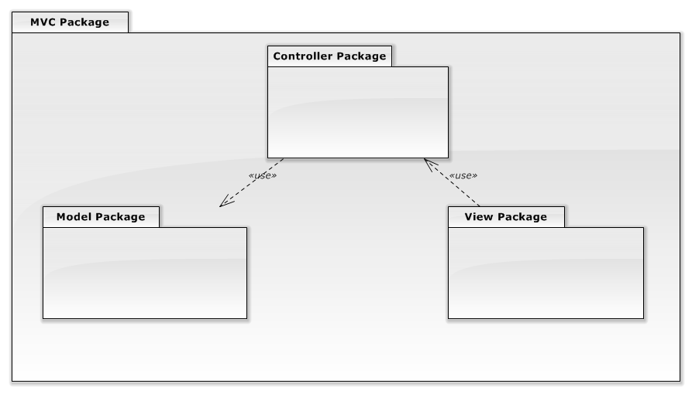

**Figure 4.4 - MVC Package diagram**

### **Model Package**

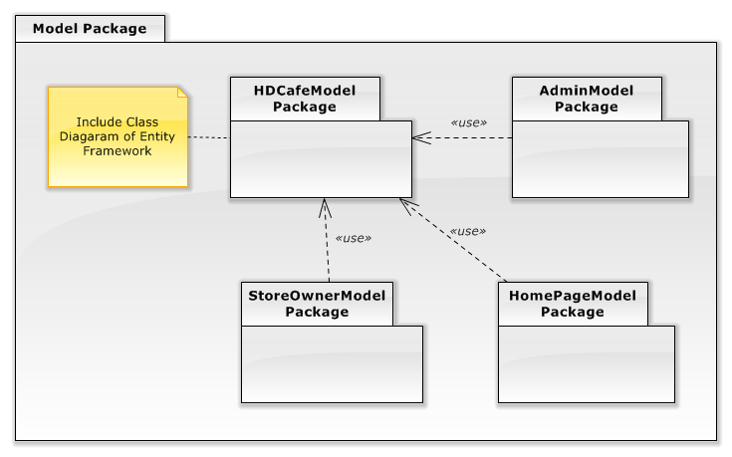

**Figure 4.4.1 - Model Package**

#### HDCafeModel Package

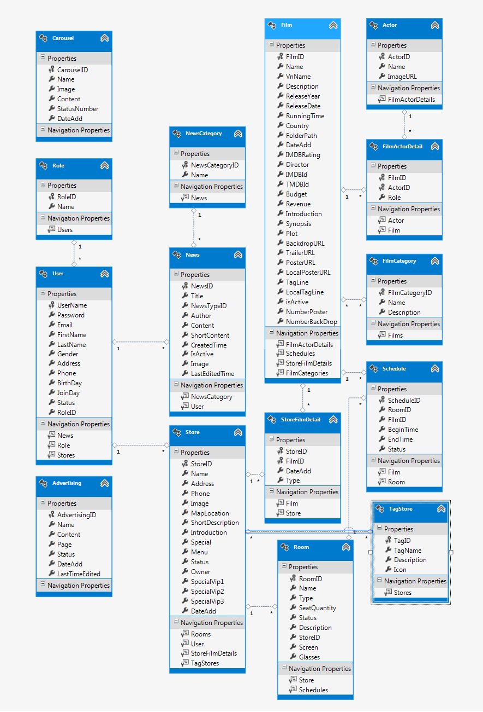

Figure 4.4.1.1 - HDCafeModel Package

*HDCafeModel is mapping with table in database. Its attributes will be explain in database design.*

#### AdminModel Package

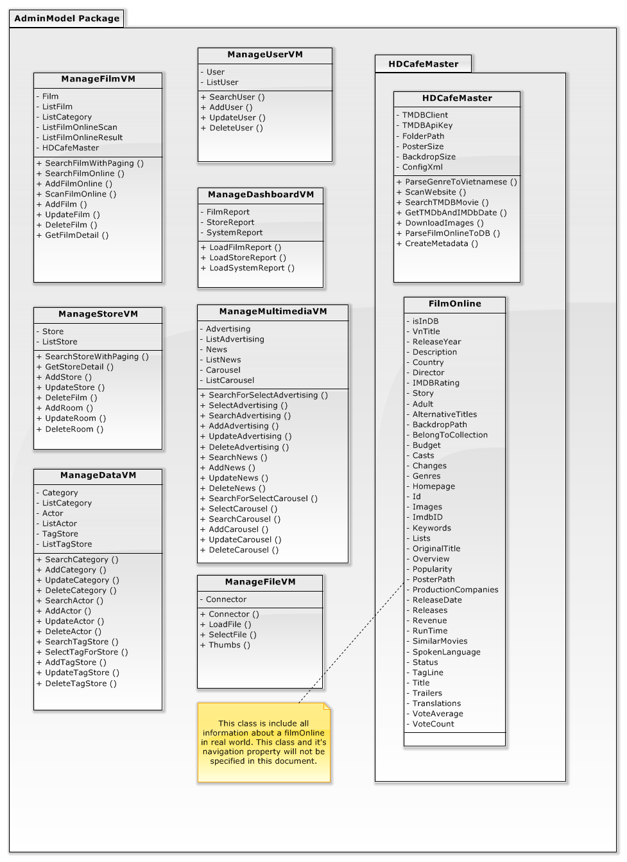

AdminModel Package

##### ManageFilmVM

###### Attributes

|  |  |  |
| --- | --- | --- |
| **Parameter/Return** | **Type** | **Description** |
| Film | Film | Film use for function Add, update in View. |
| ListFilm | List <Film> | List film use for display in table. |
| ListCategory | List <Category> | List category of film for user select when search or add, update. |
| ListFilmOnlineScan | List <FilmOnline> | The list FilmOnline after scan film on onother website |
| ListFilmOnlineResult | List <FilmOnline> | The list FilmOnline after search film online based on TMDB and IMDB data. |
| HDCafeMaster | HDCafeMaster | The class that have all function use for scan and parse film online to database |

###### Methods

* Public List<Film> SearchFilmWithPaging (int? page, string query, string [] category, string sortMethod, bool isActive): This method is used to search film with many conditions. Using smart search and order result with percent matching, it also searches English and Vietnamese.

|  |  |  |
| --- | --- | --- |
| **Parameter/Return** | **Type** | **Description** |
| page | Int? | Page that user want to navigate |
| query | string | Querystring |
| category | String[] | Array of category that user is selecting |
| sortMethod | String | Type of sort: newest, popular, ImdbRating. |
| isActive | bool | Film is active or deactive |
| Return | List<Film> | Return listfilm that matching with condition |

* Public List< FilmOnline > SearchFilmOnline (string title, int? year): This method is used to search film on Themoviedb.org. Using TMDB api key and scraper IMDB, then collect information and parse to FilmOnline

|  |  |  |
| --- | --- | --- |
| **Parameter/Return** | **Type** | **Description** |
| title | string | Name of title for searching |
| year | int | The releaseyear of title and it can be null. |
| Return | List <FilmOnline> | The list films online that matching with query. |

* Public bool AddFilmOnline (FilmOnline filmOnline): This method is used to parse a filmOnline to Film in system and insert it to Database.

|  |  |  |
| --- | --- | --- |
| **Parameter/Return** | **Type** | **Description** |
| filmOnline | FilmOnline | A film that have full attribute for a film. It is based on property of movie on TMDB and IMDB. |
| Return | bool | This method is successful or not |

* Public List<FilmOnline> ScanFilmOnline (string urlWebsite, int pageFrom, int pageTo): This method is used toscan VietNamese information in another website.

|  |  |  |
| --- | --- | --- |
| **Parameter/Return** | **Type** | **Description** |
| urlWebsite | String | URL of website need to scan vietnamese information. |
| pageFrom | Int | Page number want to start scan |
| pageTo | int | Page number will end scan. |
| Return | List <FilmOnline> | The list films online after scan, this list will have vietnamese information. |

* Public bool AddFilm (Film film): This method is used to add new film to databse.

|  |  |  |
| --- | --- | --- |
| **Parameter/Return** | **Type** | **Description** |
| Film | Film | A normal Film in Database. |
| Return | bool | This method is successful or not |

* Public bool UpdateFilm (Film film): This method is used to update film.

|  |  |  |
| --- | --- | --- |
| **Parameter/Return** | **Type** | **Description** |
| Film | Film | A normal Film in Database. |
| Return | bool | This method is successful or not |

* Public bool DeleteFilm (int id): This method is used to delete film in database, based on filmId.

|  |  |  |
| --- | --- | --- |
| **Parameter/Return** | **Type** | **Description** |
| Id | int | Id of the film want to delete |
| Return | bool | This method is successful or not |

* Public Film GetFilmDetail (int id): This method is used to get detail of a film, based on filmId.

|  |  |  |
| --- | --- | --- |
| **Parameter/Return** | **Type** | **Description** |
| Id | int | Id of the film wants to get detail. |
| Return | Film | Return a film that includes all information. |

##### ManageStoreVM

###### Attributes

|  |  |  |
| --- | --- | --- |
| **Parameter/Return** | **Type** | **Description** |
| Store | Store | Store use for function Add, update in View. |
| ListStore | List < Store > | List Store use for display in table. |

###### Methods

* Public List<Store> SearchStoreWithPaging (int? page, string query, string [] tag, string sortMethod, bool isActive): This method is used to search Store with many conditions. Using smart search and order result with percent matching, it also searches English and Vietnamese.

|  |  |  |
| --- | --- | --- |
| **Parameter/Return** | **Type** | **Description** |
| Page | Int | Page that user want to navigate |
| query | string | Querystring |
| category | String[] | Array of category that user is selecting |
| sortMethod | String | Sort method: newest, most popular, most film, room. |
| isActive | bool | Film is active or deactive |
| Return | List<Film> | Return listfilm that matching with condition |

* Public bool AddStore (Store store): This method is used to add new store to databse.

|  |  |  |
| --- | --- | --- |
| **Parameter/Return** | **Type** | **Description** |
| store | Store | A HD café store. |
| Return | bool | This method is successful or not |

* Public bool UpdateStore(Store store): This method is used to update store to databse

|  |  |  |
| --- | --- | --- |
| **Parameter/Return** | **Type** | **Description** |
| Store | Store | A HD café store. |
| Return | bool | This method is successful or not |

* Public bool DeleteStore (int id): This method is used to delete Store in database, based on StoreId.

|  |  |  |
| --- | --- | --- |
| **Parameter/Return** | **Type** | **Description** |
| Id | int | Id of the Store want to delete |
| Return | bool | This method is successful or not |

* Public Store GetStoreDetail (int id): This method is used toget detail of a store, based on storeId.

|  |  |  |
| --- | --- | --- |
| **Parameter/Return** | **Type** | **Description** |
| Id | int | Id of the Store wants to get detail. |
| Return | bool | This method is successful or not |

* Public bool AddRoom (Room room): This method is used to add new Room to a store.

|  |  |  |
| --- | --- | --- |
| **Parameter/Return** | **Type** | **Description** |
| room | Room | A room in a store. |
| Return | bool | This method is successful or not |

* Public bool UpdateRoom (Room room): This method is used to update room to databse

|  |  |  |
| --- | --- | --- |
| **Parameter/Return** | **Type** | **Description** |
| room | Room | A room in a store. |
| Return | bool | This method is successful or not |

* Public bool DeleteRoom (int id): This method is used to delete Room in database, based on RoomId.

|  |  |  |
| --- | --- | --- |
| **Parameter/Return** | **Type** | **Description** |
| Id | int | Id of the Category want to delete |
| Return | bool | This method is successful or not |

##### ManageFileVM

###### Attributes

|  |  |  |
| --- | --- | --- |
| **Parameter/Return** | **Type** | **Description** |
| Connector | Connector | This class is a connector of Elfinder.net with <http://elfinder.org/>. An open source that help manage file on server. |

###### Methods

* Public Connector Connector(string serverPath)

|  |  |  |
| --- | --- | --- |
| **Parameter/Return** | **Type** | **Description** |
| serverPath | string | Folder path that need to manage file.  Example: “~/Images”. |
| Connector | Connector | Initialization connector to elfinder library, mapping with folder on server. |

* Public Loadfile( HttpRequestBase Request): This will process connector to load file matching with request

|  |  |  |
| --- | --- | --- |
| **Parameter/Return** | **Type** | **Description** |
| Request | HttpRequestBase | Serves as the base class for classes that enable ASP.NET to read the HTTP values sent by a client during a Web request. |
| Return | Connector | Initialization connector to elfinder library, mapping with folder on server. |

* Public string SelectFile (string target): This will return location of file.

|  |  |  |
| --- | --- | --- |
| **Parameter/Return** | **Type** | **Description** |
| Target | string | Target file in elfinder |
| Return | string | Return full name of file in server. Example: hdcafevn.com/Images/films/ManofSteel.jpg |

* Public ActionResult Thumbs (HttpRequestBase Request, HttpResponseBase Response, string tmb): This creates a thumbs image to view small images on web.

|  |  |  |
| --- | --- | --- |
| **Parameter/Return** | **Type** | **Description** |
| Request | HttpRequestBase | Target file in elfinder |
| Response | HttpResponseBase | Return full name of file in server. Example: hdcafevn.com/Images/films/ManofSteel.jpg |
| tmb | String | The location of folder for thumbs. Default is “~folderImage/Thumails/” |
| Return | ActionResult | Return a ActionResult for controller. |

##### ManageMultimediaVM

###### Attributes

|  |  |  |
| --- | --- | --- |
| **Parameter/Return** | **Type** | **Description** |
| Advertising | Advertising | An avertising on website, may be images, flash, anything because it’s content allow Html. This instance use for Create, Update in View. |
| ListAdvertising | List <Advertising> | List Advertising use for display in table. |
| News | News | News on website, support information about Film, Store, Technical in HD for Viewer. This instance use for Create, Update in View. |
| ListNews | List <News> | List News use for display in table. |
| Carousel | Carousel | A large banner in homepage, it is an image and can content information about Film or Store automatic. This instance use for Create, Update in View. |
| ListCarousel | List <Carousel> | List Carousel use for display in table. |

###### Methods

* Public JsonResult SearchForSelectAdvertising (string query, int pageLimit, int page, string pageName): This method is used to search advertising and return json for **Select2** plugin.

|  |  |  |
| --- | --- | --- |
| **Parameter/Return** | **Type** | **Description** |
| query | string | String to search advertising by name. |
| pageLimit | Int | Limit elements advertising result in response. |
| page | int | Current page number of result. |
| pageName | string | The Page that need to load advertising. |
| Return | JsonResult | Return total number result and a collection advertising (id, name, and content). |

* Public JsonResult SelectAdvertising (int [] listAdvertisingId, string pageName): This method is used to save the list advertising and it order display on website.

|  |  |  |
| --- | --- | --- |
| **Parameter/Return** | **Type** | **Description** |
| listAdvertisingId | Int [] | Array of advertisinId are sorted. |
| pageName | Sting | The Page that want to save advertising. |
| Return | JsonResult | Return result of function for controller ( true / false ) |

* Public JsonResult SearchAdvertising(DatatableParam param): This method is used to load, search, sort, paging data, using plugin **Datatable.net**

|  |  |  |
| --- | --- | --- |
| **Parameter/Return** | **Type** | **Description** |
| param | DatatableParam | This is a class support for plugin datatable easy to play with.  This class include:   * String sEcho: Request sequence number sent by DataTable, same value must be returned in response. * String sSearch: Text used for filtering * Int iDisplayLength: Number of records that should be shown in table * int iDisplayStart: First record that should be shown(used for paging) * int iColumns: Number of columns in table * int iSortingCols: Number of columns that are used in sorting * string sColumns Comma separated list of column names |
| Return | JsonResult | Return sEcho, iTotalRecord, iTotalDisplayRecord ( default of datatable ) and data ( AdvertisingId, name, Content, Page, Status, DateAdd, LastTimeEditted) |

* Public bool AddAdvertising (Advertising advertising): This method is used to add new Advertising to databse.

|  |  |  |
| --- | --- | --- |
| **Parameter/Return** | **Type** | **Description** |
| advertising | Advertising | An avertising on website. |
| Return | bool | This method is successful or not |

* Public bool UpdateAdvertising (Advertising advertising): This method is used to update advertising to databse

|  |  |  |
| --- | --- | --- |
| **Parameter/Return** | **Type** | **Description** |
| advertising | Advertising | An avertising on website. |
| Return | bool | This method is successful or not |

* Public bool DeleteAdvertising (int id): This method is used to delete Advertising in database, based on AdvertisingId.

|  |  |  |
| --- | --- | --- |
| **Parameter/Return** | **Type** | **Description** |
| Id | int | Id of the Advertising want to delete |
| Return | bool | This method is successful or not |

* Public JsonResult SearchNews(jqueryDatatableParamModel param): This method is used to load, search, sort, paging data, using plugin **Datatable.net**

|  |  |  |
| --- | --- | --- |
| **Parameter/Return** | **Type** | **Description** |
| param | DatatableParam | This is a class support for plugin datatable easy to play with.  This class include:   * String sEcho: Request sequence number sent by DataTable, same value must be returned in response. * String sSearch: Text used for filtering * Int iDisplayLength: Number of records that should be shown in table * int iDisplayStart: First record that should be shown(used for paging) * int iColumns: Number of columns in table * int iSortingCols: Number of columns that are used in sorting * string sColumns Comma separated list of column names |
| Return | JsonResult | Return sEcho, iTotalRecord, iTotalDisplayRecord ( default of datatable ) and data ( NewsId, Image, Title, Newscategory, Author, CreateTime, IsActive) |

* Public bool AddNews (News news): This method is used to add new News to databse.

|  |  |  |
| --- | --- | --- |
| **Parameter/Return** | **Type** | **Description** |
| news | News | News on website. |
| Return | bool | This method is successful or not |

* Public bool UpdateNews (News news): This method is used to update News to databse

|  |  |  |
| --- | --- | --- |
| **Parameter/Return** | **Type** | **Description** |
| news | News | News on website. |
| Return | bool | This method is successful or not |

* Public bool DeleteNews (int id): This method is used to delete News in database, based on NewsId.

|  |  |  |
| --- | --- | --- |
| **Parameter/Return** | **Type** | **Description** |
| Id | int | Id of the News want to delete |
| Return | bool | This method is successful or not |

* Public JsonResult SearchForSelectCarousel (string query, int pageLimit, int page): This method is used to search Carousel and return json for **Select2** plugin.

|  |  |  |
| --- | --- | --- |
| **Parameter/Return** | **Type** | **Description** |
| query | string | String to search advertising by name. |
| pageLimit | Int | Limit elements advertising result in response. |
| page | int | Current page number of result. |
| Return | JsonResult | Return total number result and a collection Carousel (id, image). |

* Public JsonResult SelectCarousel (int [] listCarouselId): This method is used to save the list Carousel and it order display on HomePage.

|  |  |  |
| --- | --- | --- |
| **Parameter/Return** | **Type** | **Description** |
| listCarouselId | Int [] | Array of CarouselId are sorted. |
| Return | JsonResult | Return result of function for controller ( true / false ) |

* Public JsonResult SearchCarousel (DatatableParam param): This method is used to load, search, sort, paging data, using plugin **Datatable.net**

|  |  |  |
| --- | --- | --- |
| **Parameter/Return** | **Type** | **Description** |
| param | DatatableParam | This is a class support for plugin datatable easy to play with.  This class include:   * String sEcho: Request sequence number sent by DataTable, same value must be returned in response. * String sSearch: Text used for filtering * Int iDisplayLength: Number of records that should be shown in table * int iDisplayStart: First record that should be shown(used for paging) * int iColumns: Number of columns in table * int iSortingCols: Number of columns that are used in sorting * string sColumns Comma separated list of column names |
| Return | JsonResult | Return sEcho, iTotalRecord, iTotalDisplayRecord ( default of datatable ) and data ( CarouselId, name, Image, DateAdd) |

* Public bool AddCarousel (Carousel carousel): This method is used to add new Advertising to databse.

|  |  |  |
| --- | --- | --- |
| **Parameter/Return** | **Type** | **Description** |
| carousel | Carousel | A Carousel on website. |
| Return | bool | This method is successful or not |

* Public bool UpdateCarousel (Carousel carousel): This method is used to update advertising to databse

|  |  |  |
| --- | --- | --- |
| **Parameter/Return** | **Type** | **Description** |
| carousel | Carousel | A Carousel on website. |
| Return | bool | This method is successful or not |

* Public bool DeleteCarouse (int id): This method is used to delete Carouse in database, based on CarouseId.

|  |  |  |
| --- | --- | --- |
| **Parameter/Return** | **Type** | **Description** |
| Id | int | Id of the Carouse want to delete |
| Return | bool | This method is successful or not |

##### ManageDataVM

###### Attributes

|  |  |  |
| --- | --- | --- |
| **Parameter/Return** | **Type** | **Description** |
| Category | Category | Film Category. Example: Action, Sport, Thriller….  This instance is use for Create, Update in View. |
| List Category | List <Category> | List Category use for display in table. |
| Actor | Actor | The person who act in a film. This instance use for Create, Update in View. |
| ListActor | List <Actor> | List Actor use for display in table. |
| TagStore | TagStore | A tag for an store, this is present the feature for each Store. This instance use for Create, Update in View. |
| List TagStore | List <TagStore> | List TagStore use for display in table. |

###### Methods

* Public JsonResult SearchCategory(DatatableParam param): This method is used to load, search, sort, paging data, using plugin **Datatable.net**

|  |  |  |
| --- | --- | --- |
| **Parameter/Return** | **Type** | **Description** |
| param | DatatableParam | This is a class support for plugin datatable easy to play with.  This class include:   * String sEcho: Request sequence number sent by DataTable, same value must be returned in response. * String sSearch: Text used for filtering * Int iDisplayLength: Number of records that should be shown in table * int iDisplayStart: First record that should be shown(used for paging) * int iColumns: Number of columns in table * int iSortingCols: Number of columns that are used in sorting * string sColumns Comma separated list of column names |
| Return | JsonResult | Return sEcho, iTotalRecord, iTotalDisplayRecord ( default of datatable ) and data ( CategoryId, CategoryName, Total Film on each Category) |

* Public bool AddCategory (Category category): This method is used to add new Advertising to databse.

|  |  |  |
| --- | --- | --- |
| **Parameter/Return** | **Type** | **Description** |
| category | Category | A category film. |
| Return | bool | This method is successful or not |

* Public bool UpdateCategory (Category category): This method is used to update category to databse

|  |  |  |
| --- | --- | --- |
| **Parameter/Return** | **Type** | **Description** |
| category | Category | A category film. |
| Return | bool | This method is successful or not |

* Public bool DeleteCategory (int id): This method is used to delete Category in database, based on CategoryId.

|  |  |  |
| --- | --- | --- |
| **Parameter/Return** | **Type** | **Description** |
| Id | int | Id of the Category want to delete |
| Return | bool | This method is successful or not |

* Public JsonResult SearchActor(DatatableParam param): This method is used to load, search, sort, paging data, using plugin **Datatable.net**

|  |  |  |
| --- | --- | --- |
| **Parameter/Return** | **Type** | **Description** |
| param | DatatableParam | This is a class support for plugin datatable easy to play with.  This class include:   * String sEcho: Request sequence number sent by DataTable, same value must be returned in response. * String sSearch: Text used for filtering * Int iDisplayLength: Number of records that should be shown in table * int iDisplayStart: First record that should be shown(used for paging) * int iColumns: Number of columns in table * int iSortingCols: Number of columns that are used in sorting * string sColumns Comma separated list of column names |
| Return | JsonResult | Return sEcho, iTotalRecord, iTotalDisplayRecord ( default of datatable ) and data (ActorId, name, ImageURL) |

* Public bool AddActor (Actor actor): This method is used to add new Actor to databse.

|  |  |  |
| --- | --- | --- |
| **Parameter/Return** | **Type** | **Description** |
| actor | Actor | An Actor that act in film |
| Return | bool | This method is successful or not |

* Public bool UpdateActor (Actor actor): This method is used to update Actor to databse

|  |  |  |
| --- | --- | --- |
| **Parameter/Return** | **Type** | **Description** |
| actor | Actor | An Actor that act in film |
| Return | bool | This method is successful or not |

* Public bool DeleteAdvertising (int id): This method is used to delete Advertising in database, based on AdvertisingId.

|  |  |  |
| --- | --- | --- |
| **Parameter/Return** | **Type** | **Description** |
| Id | int | Id of the Advertising want to delete |
| Return | bool | This method is successful or not |

* Public JsonResult SearchTagStore (DatatableParam param): This method is used to load, search, sort, paging data, using plugin **Datatable.net**

|  |  |  |
| --- | --- | --- |
| **Parameter/Return** | **Type** | **Description** |
| param | DatatableParam | This is a class support for plugin datatable easy to play with.  This class include:   * String sEcho: Request sequence number sent by DataTable, same value must be returned in response. * String sSearch: Text used for filtering * Int iDisplayLength: Number of records that should be shown in table * int iDisplayStart: First record that should be shown(used for paging) * int iColumns: Number of columns in table * int iSortingCols: Number of columns that are used in sorting * string sColumns Comma separated list of column names |
| Return | JsonResult | Return sEcho, iTotalRecord, iTotalDisplayRecord ( default of datatable ) and data (TagStoreId, TagName, Icon) |

* Public bool AddTagStore (TagStore tagStore): This method is used to add new TagStore to databse.

|  |  |  |
| --- | --- | --- |
| **Parameter/Return** | **Type** | **Description** |
| tagStore | TagStore | An tag for HD Café Store |
| Return | bool | This method is successful or not |

* Public bool UpdateTagStore (TagStore tagStore): This method is used to update TagStore to databse

|  |  |  |
| --- | --- | --- |
| **Parameter/Return** | **Type** | **Description** |
| tagStore | TagStore | An tag for HD Café Store |
| Return | bool | This method is successful or not |

* Public bool DeleteTagStore (int id): This method is used to delete TagStore in database, based on TagStoreId.

|  |  |  |
| --- | --- | --- |
| **Parameter/Return** | **Type** | **Description** |
| Id | int | Id of the TagStore want to delete |
| Return | bool | This method is successful or not |

##### ManageDashboardVM

###### Attributes

|  |  |  |
| --- | --- | --- |
| **Parameter/Return** | **Type** | **Description** |
| FilmReport | FilmReport | This class include :   * Total film in database * Total film added in day, week, and month. * Total Film is using most in schedule |
| StoreReport | StoreReport | This class include :   * Total store in database * Total store added in day, week, and month. * Tracking View of Store |
| SystemReport | SystemReport | This class include :   * Tracking view of Website in day, week, and month. |

###### Methods

* Public JsonResult LoadFilmReport (date from, date to): This method is used to load report of Film in a specific time.

|  |  |  |
| --- | --- | --- |
| **Parameter/Return** | **Type** | **Description** |
| from | date | Date begin to get report |
| to | date | Date end to get report |
| Return | JsonResult | Return data ( total, averageday, averageWeek, averageMonth, filmusedCount) |

* Public JsonResult LoadStoreReport (date from, date to): This method is used to load report of Store in a specific time.

|  |  |  |
| --- | --- | --- |
| **Parameter/Return** | **Type** | **Description** |
| from | date | Date begin to get report |
| to | date | Date end to get report |
| Return | JsonResult | Return array Stores ( totalfilmInStore, averageday, averageWeek, averageMonth, view, comment, like) |

* Public JsonResult LoadSystemReport (date from, date to): This method is used to load report of System in a specific time.

|  |  |  |
| --- | --- | --- |
| **Parameter/Return** | **Type** | **Description** |
| from | date | Date begin to get report |
| to | date | Date end to get report |
| Return | JsonResult | Return data ( totalView, totalLike, totalComment, averageViewDay, averageViewWeek, averageViewMonth ) |

##### ManageUserVM

###### Attributes

|  |  |  |
| --- | --- | --- |
| **Parameter/Return** | **Type** | **Description** |
| User | User | The people who use this system: Admin, StoreOwner  This instance is use for Create, Update in View. |
| List User | List < User > | List Category use for display in table. |

###### Methods

* Public JsonResult SearchUser (DatatableParam param): This method is used to load, search, sort, paging data, using plugin **Datatable.net**

|  |  |  |
| --- | --- | --- |
| **Parameter/Return** | **Type** | **Description** |
| param | DatatableParam | This is a class support for plugin datatable easy to play with.  This class include:   * String sEcho: Request sequence number sent by DataTable, same value must be returned in response. * String sSearch: Text used for filtering * Int iDisplayLength: Number of records that should be shown in table * int iDisplayStart: First record that should be shown(used for paging) * int iColumns: Number of columns in table * int iSortingCols: Number of columns that are used in sorting * string sColumns Comma separated list of column names |
| Return | JsonResult | Return sEcho, iTotalRecord, iTotalDisplayRecord ( default of datatable ) and data ( FullName, Address, Phone, Email, Status, RoleName ) |

* Public bool AddUser (User user): This method is used to add new User to databse.

|  |  |  |
| --- | --- | --- |
| **Parameter/Return** | **Type** | **Description** |
| user | User | The people who use this system: Admin, StoreOwner. |
| Return | bool | This method is successful or not |

* Public bool UpdateUser (User user): This method is used to update User to databse

|  |  |  |
| --- | --- | --- |
| **Parameter/Return** | **Type** | **Description** |
| user | User | A category film. |
| Return | bool | This method is successful or not |

* Public bool DeleteUser (int id): This method is used to delete User in database, based on UserId.

|  |  |  |
| --- | --- | --- |
| **Parameter/Return** | **Type** | **Description** |
| id | int | Id of the User want to delete |
| Return | bool | This method is successful or not |

##### HDCafeMaster

###### Attributes

|  |  |  |
| --- | --- | --- |
| **Parameter/Return** | **Type** | **Description** |
| TMDbClient | TMDbClient | The warpper of **TMDB API** for .net. This class using apikey for send request to website Themoviedb.org and receive data, then parse into class that matching with result. We use this result for parse into FilmOnline. |
| TMDbApiKey | String | Apikey of Themoviedb.org. It is free with limited 30 requests/ second. |
| FolderPath | String | A folder on server use for download images of FilmOnline. |
| PosterSize | String | The size of poster if user chooses down images. It name is convention of Themoviedb.org: Example: original, w45, w92, w154, w185, w300. |
| BackDropSize | String | The size of backdrop if user chooses down images. It name is convention of Themoviedb.org: Example: original, w300, w780, w1280. |
| ConfigXml | FileInfo | Get the default config of wrapper for themoviedb.org: BaseURL, SecureURL, convention of size poster, size backdrop. |

###### Methods

* Public int ParseGenreToVietNamese (int tmdbGenreId): This method is used to parse genre from English to Vietnamese. This method is hard-code based on mapping tmdbgenreId with FilmCategory in Database.

|  |  |  |
| --- | --- | --- |
| **Parameter/Return** | **Type** | **Description** |
| tmdbGenreId | int | The GenreID of Themoviedb.org. |
| Return | int | The FilmCategoryID of Hdcafe Database. |

* Public List<FilmOnline> Scanwebsite (string urlWebsite, int pageFrom, int pageTo): This method is used toscan VietNamese information in another website. Using **HtmlAgility Pack** to get document of website and write **xpath** query to navigate information.

|  |  |  |
| --- | --- | --- |
| **Parameter/Return** | **Type** | **Description** |
| urlWebsite | String | URL of website need to scan vietnamese information. |
| pageFrom | Int | Page number want to start scan |
| pageTo | int | Page number will end scan. |
| Return | List <FilmOnline> | The list films online after scan, this list will have vietnamese information. |

* Public List< FilmOnline > SearchTMDBMovie (string title, int? year): This method is used to search film on Themoviedb.org. Using TMDB API key to send request to website Themoviedb.org and receive Movie data.

|  |  |  |
| --- | --- | --- |
| **Parameter/Return** | **Type** | **Description** |
| title | string | Name of title for searching |
| year | int | The releaseyear of title and it can be null. |
| Return | List <FilmOnline> | The list films online that matching with query. This FilmOnline is only having basic information of TMDB. |

* Public bool GetTMDbAndIMDbDate (ref FilmOnline filmOnline): This method is used toupdate full data for a basic filmOnline result in function SearchTMDBMovie () by send more request to TMDB. The TMDb will include ImdbId, so we can continous update data FilmOnline with IMDb data through non offical IMDb API (its API is still beta and not public).

|  |  |  |
| --- | --- | --- |
| **Parameter/Return** | **Type** | **Description** |
| filmOnline | FilmOnline | A FilmOnline that need update more data from TMDB and IMDB. |
| Return | bool | This method is successful or not. |

* Public void DownloadImages (Images images, string folderPath): This method is used todownload a list of images (backdrop, poster) of a film that in database and save to server. All the process of this method is used tobe writing detail in log and do not need return.

|  |  |  |
| --- | --- | --- |
| **Parameter/Return** | **Type** | **Description** |
| images | Images | Name of title for searching. |
| folderPath | string | The releaseyear of title and it can be null. |

* Public bool ParseFilmOnlineToDB (FilmOnline filmOnline): This method is used to mapping between FilmOnline and Film in Database, and then adds new Film to Database.

|  |  |  |
| --- | --- | --- |
| **Parameter/Return** | **Type** | **Description** |
| filmOnline | FilmOnline | Name of title for searching. |
| Return | bool | This method is successful or not. |

* Public bool CreateMetaData (FilmOnline filmOnline, string folderPath, bool isOverwrite): This method is used toparse FilmOnline to a movie.xml a stardard of **Browser Media** metadata. This movies.xml combine with convention of DownloadImages function with purpose improve interface of Window media center in Windows7,

|  |  |  |
| --- | --- | --- |
| **Parameter/Return** | **Type** | **Description** |
| filmOnline | FilmOnline | Name of title for searching. |
| folderPath | string | Folder that save metadata |
| isOverwrite | bool | Is overwrite the file or folder that duplicate |
| Return | bool | This method is successful or not. |

#### StoreOwnerModel Package

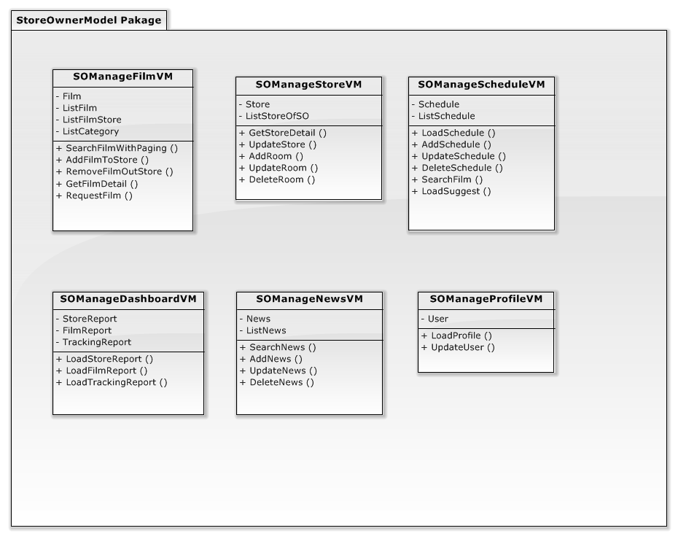

StoreOwnerModel Package

##### SOManageFilmVM

###### Attributes

|  |  |  |
| --- | --- | --- |
| **Parameter/Return** | **Type** | **Description** |
| Film | Film | A film in database. This instance uses for function Add, update in View. |
| ListFilm | List <Film> | List film in database use for display in table. |
| ListFilmStore | List <Film> | List film of store. |
| ListCategory | List <Category> | List category of film for user select when search or add, update. |

###### Methods

* Public List<Film> SearchFilmWithPaging (int? page, string query, string [] category, string sortMethod bool isActive): This method is used to search film with many conditions. Using smart search and order result with percent matching, it also searches English and Vietnamese.

|  |  |  |
| --- | --- | --- |
| **Parameter/Return** | **Type** | **Description** |
| page | Int? | Page that user want to navigate |
| query | string | Querystring |
| category | String[] | Array of category that user is selecting |
| sortMethod | String | Type of sort: newest, popular, ImdbRating. |
| isActive | bool | Film is active or deactive |
| Return | List<Film> | Return listfilm that matching with condition |

* Public bool AddFilmToStore (int id): This method is used to add a film to the store.

|  |  |  |
| --- | --- | --- |
| **Parameter/Return** | **Type** | **Description** |
| id | Int | Id of the film. |
| Return | bool | This method is successful or not. |

* Public bool RemoveFilmOutStore (int id): This method is used to remove a film in store.

|  |  |  |
| --- | --- | --- |
| **Parameter/Return** | **Type** | **Description** |
| id | int | Id of the film. |
| Return | bool | This method is successful or not |

* Public Film GetFilmDetail (int id): This method is used to get detail of a film, based on filmId.

|  |  |  |
| --- | --- | --- |
| **Parameter/Return** | **Type** | **Description** |
| id | int | Id of the film. |
| Return | Film | Return a film that includes all information. |

* Public bool RequestFilm (string title, string description): This method is used to request a film that do not in database.

|  |  |  |
| --- | --- | --- |
| **Parameter/Return** | **Type** | **Description** |
| title | string | Title of the film. |
| description | string | The description of the request. It can provide more information for admin. |
| Return | bool | This method is successful or not. |

##### SOManageStoreVM

###### Attributes

|  |  |  |
| --- | --- | --- |
| **Parameter/Return** | **Type** | **Description** |
| Store | Store | The current store that user selected. |
| ListStore | List < Store > | List Store that storeOwner has. |

###### Methods

* Public bool UpdateStore(Store store): This method is used to update store to databse

|  |  |  |
| --- | --- | --- |
| **Parameter/Return** | **Type** | **Description** |
| Store | Store | A HD café store. |
| Return | bool | This method is successful or not |

* Public Store GetStoreDetail (int storeId, string owner): This method is used to get detail of a store of a storeowner.

|  |  |  |
| --- | --- | --- |
| **Parameter/Return** | **Type** | **Description** |
| storeId | int | Id of the Store wants to get detail. |
| owner | string | Username of the owner. |
| Return | bool | This method is successful or not |

* Public bool AddRoom (Room room): This method is used to add new Room to a store.

|  |  |  |
| --- | --- | --- |
| **Parameter/Return** | **Type** | **Description** |
| room | Room | A room in a store. |
| Return | bool | This method is successful or not |

* Public bool UpdateRoom (Room room): This method is used to update room to databse

|  |  |  |
| --- | --- | --- |
| **Parameter/Return** | **Type** | **Description** |
| room | Room | A room in a store. |
| Return | bool | This method is successful or not |

* Public bool DeleteRoom (int id): This method is used to delete Room in database, based on RoomId.

|  |  |  |
| --- | --- | --- |
| **Parameter/Return** | **Type** | **Description** |
| Id | int | Id of the Category want to delete |
| Return | bool | This method is successful or not |

##### SOManageScheduleVM

###### Attributes

|  |  |  |
| --- | --- | --- |
| **Parameter/Return** | **Type** | **Description** |
| Schedule | Schedule | A block times in a room that showing film with beign time and end time. |
| ListSchedule | List <Schedule> | A List that includes many schedule in a specific time or condition. |

###### Methods

* Public List<Schedule> GetStoreDetail (int storeId, string owner): This method is used to get detail of a store of a storeowner.

|  |  |  |
| --- | --- | --- |
| **Parameter/Return** | **Type** | **Description** |
| storeId | int | Id of the Store wants to get detail. |
| owner | string | Username of the owner. |
| Return | bool | This method is successful or not |

* Public bool AddRoom (Room room): This method is used to add new Room to a store.

|  |  |  |
| --- | --- | --- |
| **Parameter/Return** | **Type** | **Description** |
| room | Room | A room in a store. |
| Return | bool | This method is successful or not |

* Public bool UpdateRoom (Room room): This method is used to update room to databse

|  |  |  |
| --- | --- | --- |
| **Parameter/Return** | **Type** | **Description** |
| room | Room | A room in a store. |
| Return | bool | This method is successful or not |

* Public bool DeleteRoom (int id): This method is used to delete Room in database, based on RoomId.

|  |  |  |
| --- | --- | --- |
| **Parameter/Return** | **Type** | **Description** |
| Id | int | Id of the Category want to delete |
| Return | bool | This method is successful or not |

##### SOManageDashboardVM

###### Attributes

|  |  |  |
| --- | --- | --- |
| **Parameter/Return** | **Type** | **Description** |
| FilmReport | FilmReport | This class include :   * Total film in store * Total film added to store in day, week, and month. * Total Film of store is using most in schedule |
| StoreReport | StoreReport | This class include :   * Total schedule in each room. * Total comment. * Total like. |
| TrackingViewReport | TrackingViewReport | This class include :   * Tracking view of store in day, week, and month in a specific time. |

###### Methods

* Public JsonResult LoadFilmReport (date from, date to): This method is used to load report of Film in a specific time.

|  |  |  |
| --- | --- | --- |
| **Parameter/Return** | **Type** | **Description** |
| from | date | Date begin to get report |
| to | date | Date end to get report |
| Return | JsonResult | Return data ( total, averageday, averageWeek, averageMonth, filmusedCount) |

* Public JsonResult LoadStoreReport (date from, date to): This method is used to load report of Store in a specific time.

|  |  |  |
| --- | --- | --- |
| **Parameter/Return** | **Type** | **Description** |
| from | date | Date begin to get report |
| to | date | Date end to get report |
| Return | JsonResult | Return array Stores (schedules,view, comment, like) |

* Public JsonResult LoadTrackingReport (date from, date to): This method is used to load report of tracking view in a specific time. This method is intergrate with google analytics.

|  |  |  |
| --- | --- | --- |
| **Parameter/Return** | **Type** | **Description** |
| from | date | Date begin to get report |
| to | date | Date end to get report |
| Return | JsonResult | Return data ( totalView, averageViewDay, averageViewWeek, averageViewMonth ) |

##### SOManageNewsVM

###### Attributes

|  |  |  |
| --- | --- | --- |
| **Parameter/Return** | **Type** | **Description** |
| News | News | News on website, support information about Film, Store, Technical in HD for Viewer. This instance use for Create, Update in View. |
| ListNews | List <News> | List News use for display in table. |

###### Methods

* Public JsonResult SearchNews(jqueryDatatableParamModel param): This method is used to load, search, sort, paging data, using plugin **Datatable.net**

|  |  |  |
| --- | --- | --- |
| **Parameter/Return** | **Type** | **Description** |
| param | DatatableParam | This is a class support for plugin datatable easy to play with.  This class include:   * String sEcho: Request sequence number sent by DataTable, same value must be returned in response. * String sSearch: Text used for filtering * Int iDisplayLength: Number of records that should be shown in table * int iDisplayStart: First record that should be shown(used for paging) * int iColumns: Number of columns in table * int iSortingCols: Number of columns that are used in sorting * string sColumns Comma separated list of column names |
| Return | JsonResult | Return sEcho, iTotalRecord, iTotalDisplayRecord ( default of datatable ) and data ( NewsId, Image, Title, Newscategory, Author, CreateTime, IsActive) |

* Public bool AddNews (News news): This method is used to add new News to databse.

|  |  |  |
| --- | --- | --- |
| **Parameter/Return** | **Type** | **Description** |
| news | News | News on website. |
| Return | bool | This method is successful or not |

* Public bool UpdateNews (News news): This method is used to update News to databse

|  |  |  |
| --- | --- | --- |
| **Parameter/Return** | **Type** | **Description** |
| news | News | News on website. |
| Return | bool | This method is successful or not |

* Public bool DeleteNews (int id): This method is used to deactive news of store owner, it can not delete news.

|  |  |  |
| --- | --- | --- |
| **Parameter/Return** | **Type** | **Description** |
| Id | int | Id of the News want to deactive |
| Return | bool | This method is successful or not |

##### SOManageProfileVM

###### Attributes

|  |  |  |
| --- | --- | --- |
| **Parameter/Return** | **Type** | **Description** |
| News | News | News on website, support information about Film, Store, Technical in HD for Viewer. This instance use for Create, Update in View. |
| ListNews | List <News> | List News use for display in table. |

###### Methods

* Public User LoadProfile (string userName): This method is used to load information of this user.

|  |  |  |
| --- | --- | --- |
| **Parameter/Return** | **Type** | **Description** |
| userName | User | A StoreOwner in system. |
| Return | User | A User contains all information. |

* Public bool UpdateUser (User user): This method is used to update News to databse

|  |  |  |
| --- | --- | --- |
| **Parameter/Return** | **Type** | **Description** |
| user | User | A StoreOwner in system. This paramater contain information is modified. |
| Return | bool | This method is successful or not |

#### HomeModel Package

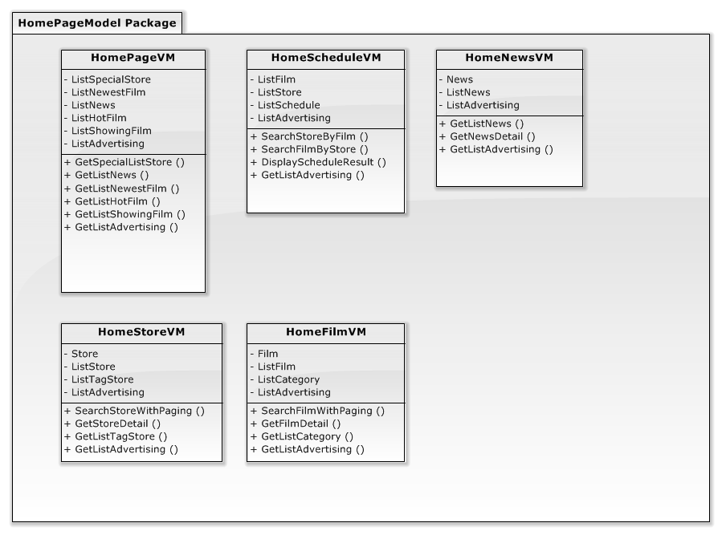

Figure xx: HomeModel Package

##### HomePageVM

###### Attributes

|  |  |  |
| --- | --- | --- |
| **Parameter/Return** | **Type** | **Description** |
| ListSpecialStore | List <Store> | List of stores that will display on homepage. Contain six stores. |
| ListNews | List <Film> | Films are added to database recently. |
| ListNewestFilm | List<News> | This list news will be display on homepage. |
| ListHotFilm | List<Film> | Films are showed most in all stores. |
| ListShowingFilm | List<Film> | Films will show in day. |
| ListAdvertising | List  <Advertising> | List advertising will be display on homepage. |

###### Methods

* Public List<Store> GetListSpecialStore (): This method is used to get stores that are impressive.

|  |  |  |
| --- | --- | --- |
| **Parameter/Return** | **Type** | **Description** |
| Return | List<Store> | Return stores. |

* Public List<News> GetListNews (): This method is used to get news for displaying in homepage.

|  |  |  |
| --- | --- | --- |
| **Parameter/Return** | **Type** | **Description** |
| Return | List< News > | Return news. |

* Public List<Film> GetListNewestFilm (): This method is used to get films are added recently in database.

|  |  |  |
| --- | --- | --- |
| **Parameter/Return** | **Type** | **Description** |
| Return | List<Film> | Return films are showed most in all stores. |

* Public List<Film> GetListHotFilm (): This method is used to get films are showed most in all stores.

|  |  |  |
| --- | --- | --- |
| **Parameter/Return** | **Type** | **Description** |
| Return | List<Film> | Return films are showed most in all stores. |

* Public List<Film> GetListShowingFilm (): This method is used to get films will show in day.

|  |  |  |
| --- | --- | --- |
| **Parameter/Return** | **Type** | **Description** |
| Return | List<Film> | Return films will show in day. |

* Public List< Advertising> GetListAdvertising (): This method is used to get advertising in HomePage.

|  |  |  |
| --- | --- | --- |
| **Parameter/Return** | **Type** | **Description** |
| Return | List <Advertising> | Return advertising used to display in HomePage |

##### HomeFilmVM

###### Attributes

|  |  |  |
| --- | --- | --- |
| **Parameter/Return** | **Type** | **Description** |
| Film | Film | List of stores that will display on homepage. Contain six stores. |
| ListFilm | List <Film> | Films are added to database recently. |
| ListCategory | List <News> | This list news will be display on homepage. |
| ListAdvertising | List <Advertising> | List advertising will be display on film page. |

###### Methods

* Public List<Film> SearchFilmWithPaging (int? page, string query, string [] category, string sortMethod, bool isActive): This method is used to search film with many conditions. Using smart search and order result with percent matching, it also searches English and Vietnamese.

|  |  |  |
| --- | --- | --- |
| **Parameter/Return** | **Type** | **Description** |
| page | Int? | Page that user want to navigate |
| query | string | Querystring |
| category | String[] | Array of category that user is selecting |
| sortMethod | String | Type of sort: newest, popular, ImdbRating. |
| isActive | bool | Film is active or deactive |
| Return | List<Film> | Return listfilm that matching with condition |

* Public Film GetFilmDetail (int id): This method is used to get detail of a film, based on filmId.

|  |  |  |
| --- | --- | --- |
| **Parameter/Return** | **Type** | **Description** |
| id | int | Id of the film. |
| Return | Film | Return a film that includes all information. |

* Public List< Category> GetListCategory (): This method is used to get list category of film.

|  |  |  |
| --- | --- | --- |
| **Parameter/Return** | **Type** | **Description** |
| Return | List <Category> | Return list category of film in database |

* Public List< Advertising> GetListAdvertising (): This method is used to get advertising in FilmPage.

|  |  |  |
| --- | --- | --- |
| **Parameter/Return** | **Type** | **Description** |
| Return | List <Advertising> | Return advertising used to display in FilmPage |

##### HomeStoreVM

###### Attributes

|  |  |  |
| --- | --- | --- |
| **Parameter/Return** | **Type** | **Description** |
| Store | Store | List of stores that will display on homepage. Contain six stores. |
| ListStore | List < Store > | Films are added to database recently. |
| ListTagStore | List <TagStore> | This list news will be display on homepage. |
| ListAdvertising | List <Advertising> | List advertising will be display on Store page. |

###### Methods

* Public List<Film> SearchStoreWithPaging (int? page, string query, string [] tagStore, string sortMethod, bool isActive): This method is used to search film with many conditions. Using smart search and order result with percent matching, it also searches English and Vietnamese.

|  |  |  |
| --- | --- | --- |
| **Parameter/Return** | **Type** | **Description** |
| page | Int? | Page that user want to navigate |
| query | string | Querystring |
| tagStore | String[] | Array of tagStore that user is selecting |
| sortMethod | String | Type of sort: newest, popular, ImdbRating. |
| isActive | bool | Film is active or deactive |
| Return | List<Film> | Return listfilm that matching with condition |

* Public Film GetStoreDetail (int id): This method is used to get detail of a Store, based on StoreId.

|  |  |  |
| --- | --- | --- |
| **Parameter/Return** | **Type** | **Description** |
| id | int | Id of the Store. |
| Return | Film | Return a Storethat includes all information. |

* Public List< TagStore> GetListTagStore (): This method is used to get list TagStore of Store.

|  |  |  |
| --- | --- | --- |
| **Parameter/Return** | **Type** | **Description** |
| Return | List <TagStore> | Return list category of film in database |

* Public List <Advertising> GetListAdvertising (): This method is used to get advertising in store page.

|  |  |  |
| --- | --- | --- |
| **Parameter/Return** | **Type** | **Description** |
| Return | List <Advertising> | Return advertising used to display in StorePage |

##### HomeScheduleVM

###### Attributes

|  |  |  |
| --- | --- | --- |
| **Parameter/Return** | **Type** | **Description** |
| ListFilm | List <Film> | List result of films after search schedule by store. |
| ListStore | List <Store> | List result of stores after search schedule by films. |
| ListSchedule | List <Schedule> | This list news will be display on homepage. |
| ListAdvertising | List <Advertising> | List advertising will be display on SchedulePage |

###### Methods

* Public List<Store> SearchStoreByFilm (int filmId): This method is used to get stores that have schedules with filmId.

|  |  |  |
| --- | --- | --- |
| **Parameter/Return** | **Type** | **Description** |
| filmId | int | Id of the film guest wants to search. |
| Return | List< Store > | Return stores and included schedule in it. |

* Public List<Film> SearchFilmByStore (int storeId): This method is used to get films that have schedule in these stores.

|  |  |  |
| --- | --- | --- |
| **Parameter/Return** | **Type** | **Description** |
| storeId | int | Id of the film guest wants to search. |
| Return | List <Film> | Return films and included schedule in it. |

* Public List<Schedule> DisplayScheduleResult (int filmId, int storeId): This method is used to get schedule based on filmId and storeId.

|  |  |  |
| --- | --- | --- |
| **Parameter/Return** | **Type** | **Description** |
| filmId | int | Id of the film. |
| storeId | int | Id of the store. |
| Return | List<Schedule> | Return schedules that matching with filmId and storeId. |

* Public List <Advertising> GetListAdvertising (): This method is used to get advertising in SchedulePage.

|  |  |  |
| --- | --- | --- |
| **Parameter/Return** | **Type** | **Description** |
| Return | List <Advertising> | Return advertising used to display in SchedulePage |

##### HomeNewsVM

###### Attributes

|  |  |  |
| --- | --- | --- |
| **Parameter/Return** | **Type** | **Description** |
| News | News | Newly received or noteworthy information.This instance used to view newsdetail. |
| ListNews | List <News> | List news display on NewsPage. |
| ListAdvertising | List <Advertising> | List advertising will be display on NewsPage. |

###### Methods

* Public List<News> GetListNews (date from, date to): This method is used to get list news to display on NewsPage.

|  |  |  |
| --- | --- | --- |
| **Parameter/Return** | **Type** | **Description** |
| from | date | The date want to begin load news |
| to | date | The date want to end load news |
| Return | List<News> | Return list news in a specific time. |

* Public List <Advertising> GetListAdvertising (): This method is used to get advertising in NewsPage.

|  |  |  |
| --- | --- | --- |
| **Parameter/Return** | **Type** | **Description** |
| Return | List <Advertising> | Return advertising used to display in NewsPage |

### Controller Package

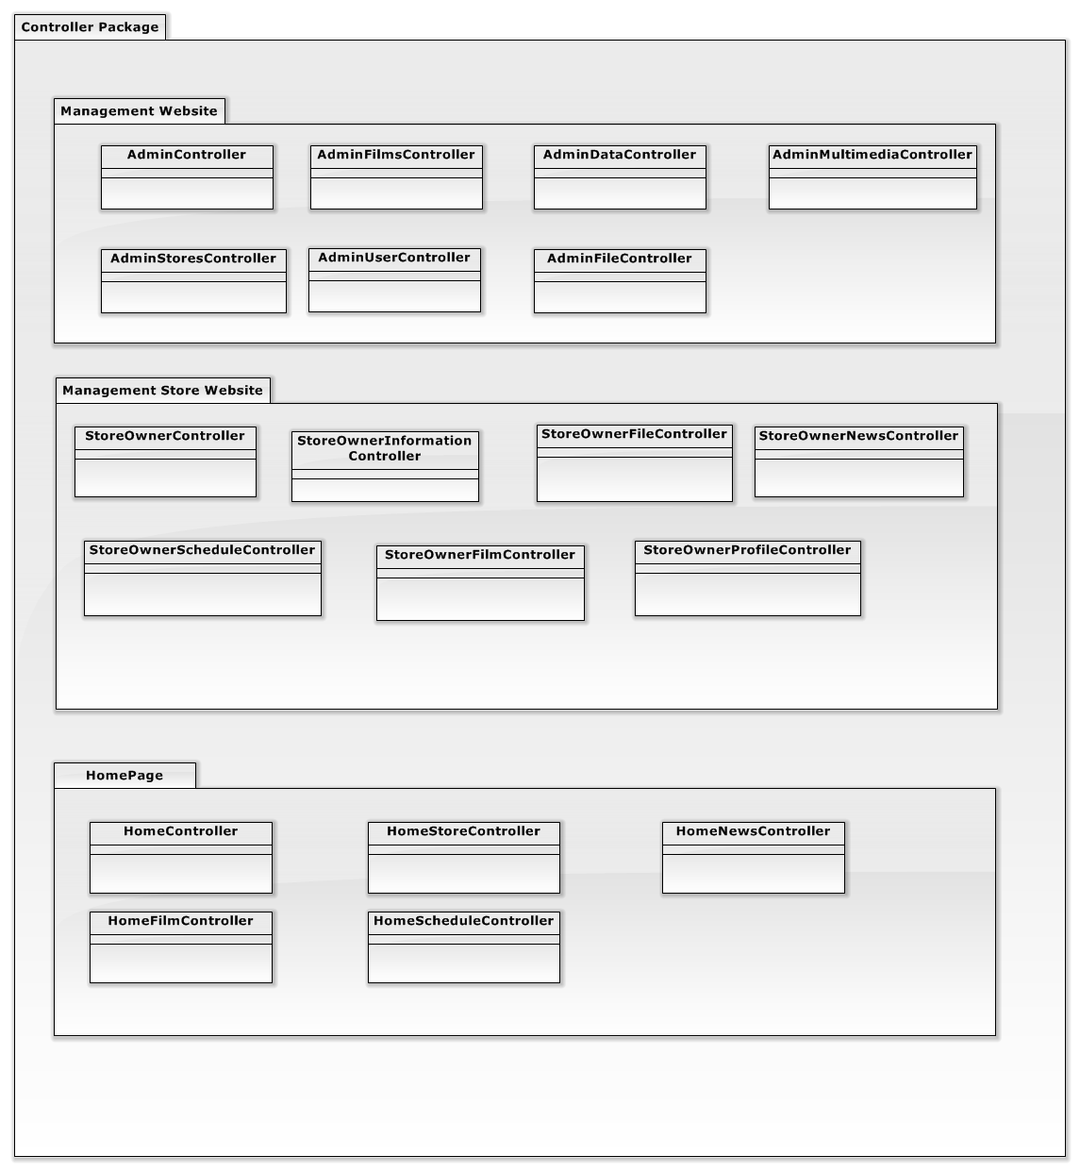

#### Management Website

##### AdminController

|  |  |  |
| --- | --- | --- |
| **Function** | **Type** | **Description** |
| 1.Index() | Action Result | View dashboard page |
| 2.ManageFilm() | Action Result | Load all film and display to browser |
| 3.ManageStore() | Action Result | Load all store and display to browser |
| 4.ManageUser() | Action Result | Load all user and display to browser |
| 5.ManageFile() | Action Result | Load all file in server and display to browser |
| 6.ManageMultiMedia() | Action Result | Load all information about News, Advertising, Carousel and display to browser |
| 7.ManageDatabase() | Action Result | Load all information about Category, Actor, Tag and display to browser |

##### AdminFilmController

|  |  |  |
| --- | --- | --- |
| **Function** | **Type** | **Description** |
| 1. ManualAddFilm() | Action Result | AddFilm that user input in form |
| 2.ViewFilmDetail () | Action Result | View all information about film |
| 3.EditFilmDetail () | Action Result | Edit information of film |
| 4.SearchFilm() | Action Result | Search film and display result |
| 5.SearchFilmOnline () | Action Result | Search film on internet and display result |
| 6.AddFilmOnline() | Action Result | Fill full information of the film and add to DB |
| 7.ScanFilmOnline() | Action Result | Scan information about film in another website |
| 8.DeactiveFilm() | Action Result | Deactive film not use. |
| 9.ActiveFilm() | Action Result | Active film to use |
| 10.DeleteFilm() | Action Result | Delete film in list deactive. |

##### AdminStoreController

|  |  |  |
| --- | --- | --- |
| **Function** | **Type** | **Description** |
| 1.SearchStore() | Action Result | Search Stores available on system by variety ways of search conditions |
| 2.AddStore () | Action Result | Add a new store that user input data on form modal to Database and update new list stores |
| 3.EditStoreBasic() | Action Result | Edit basic information of Store (Name, address, introduction,…) |
| 4.EditImageStore () | Action Result | Edit image (or avatar) of store will be displayed on home |
| 5.EditSpecial () | Action Result | Edit special contents of a store ( |
| 6.ChangeLocation() | Action Result | Edit location of store on google map API |
| 7.DeactiveStore() | Action Result | Make a store in list inactive store for not displaying temporarily |
| 8.AddRoom() | Action Result | Add a new room of HD/3D for a definite store |
| 9.EditRoom() | Action Result | Edit information of a room of a definite store |
| 10.DeleteRoom() | Action Result | Delete room of a definite store |

##### AdminFileController

|  |  |  |
| --- | --- | --- |
| **Function** | **Type** | **Description** |
| 1.FileManager() | Action Result | Responsibility for action on file on Elfinder |
| 2.CheckHealth() | Action Result | Responsibility for consistent between film and file on folder |

##### AdminMultimediaController

|  |  |  |
| --- | --- | --- |
| **Function** | **Type** | **Description** |
| 1.LoadNews() | Action Result | Load all news available in Database and display |
| 2.AddNews() | Action Result | Add news into database |
| 3.EditNews () | Action Result | Edit information of news and update Database |
| 4.DeleteNews() | Action Result | Delete a definite news |
| 5.LoadCarousel() | Action Result | Load list carousels in Database |
| 6.AddCarousel () | Action Result | Add new carousel into Database |
| 7.EditCarousel () | Action Result | Edit carousel and update Database |
| 8.DeleteCarousel () | Action Result | Delete carousel and update database |
| 9.LoadAdvertising() | Action Result | Load list advertising available in Database |
| 10.AddAdvertising () | Action Result | Add new advertising into database |
| 11.EditAdvertising () | Action Result | Edit advertising and update database |
| 12.DeleteAdvertising () | Action Result | Delete advertising and update database |
| 13.SelectCarousel() | Action Result | Select carousel and save into list selected carousel that load from database |
| 14.SelectNews() | Action Result | Select news and display on corresponding page |
| 15.SelectAdvertising | Action Result | Select advertising and save into list selected advertising that load from database |

##### AdminDataController

|  |  |  |
| --- | --- | --- |
| **Function** | **Type** | **Description** |
| 1.LoadCategory() | Action Result | Load categories of film and display on browser |
| 2.AddCategory() | Action Result | Add new film’s category into Database |
| 3.EditCategory() | Action Result | Edit film’s category available |
| 4.DeleteCategory() | Action Result | Delete film’s category |
| 5.LoadActor() | Action Result | Load actors available on database |
| 6.AddActor() | Action Result | Add new actor into Database |
| 7.EditActor() | Action Result | Edit actor available |
| 8.DeleteActor() | Action Result | Delete actor |
| 9.LoadTag() | Action Result | Load all tags and display on browser |
| 10.AddTag() | Action Result | Add new tag into Database |
| 11.EditTag() | Action Result | Edit tag and update Database |
| 12.DeleteTag() | Action Result | Delete tag and update Database |
| 13.SelectTagForStore() | Action Result | Select tag available for definite store |

##### AdminUserController

|  |  |  |
| --- | --- | --- |
| **Function** | **Type** | **Description** |
| 1.LoadUser() | Action Result | Load all users and display on manage user page |
| 2.AddUser () | Action Result | Add new user that input data on form modal |
| 3.EditUser() | Action Result | Edit definite user in data table of users |
| 4.DeactiveUser() | Action Result | Make user inactive state |

#### Management Store Website

##### StoreOwnerController

|  |  |  |
| --- | --- | --- |
| **Function** | **Type** | **Description** |
| 1.Index() | Action Result | View dashboard page |
| 2.ManageFilm() | Action Result | Load all film and display to browser |
| 3.ManageStore() | Action Result | Load all store and display to browser |
| 4.ManageFile() | Action Result | Load all file in server and display to browser |
| 5.ManageSchedule() | Action Result | Load all schedule and display to browser |

##### StoreOwnerFilmController

|  |  |  |
| --- | --- | --- |
| **Function** | **Type** | **Description** |
| 1.SearchFilm () | Action Result | Search film available on current store by variety ways of searching condition |
| 2.AddFilmToStore () | Action Result | Add a film to current store |
| 3.ViewFilmDetail() | Action Result | View a definite film details |
| 4.AddFilmToSchedule () | Action Result | Add a film into schedule of current store |
| 5.RemoveFilmStore() | Action Result | Remove a definite film out of current store |

##### StoreOwnerManageStoreController

|  |  |  |
| --- | --- | --- |
| **Function** | **Type** | **Description** |
| 1.EditStoreBasic() | Action Result | Edit basic information of a current store (name, address, introduction, phone,… ) |
| 2.EditImage() | Action Result | Edit image (or avatar) of current store |
| 3.EditSpecial | Action Result | Edit special information of current store |
| 4.ChangeLocation() | Action Result | Edit location of current store on google map |
| 5.AddRoom() | Action Result | Add new room that user input data into current store |
| 6.EditRoom() | Action Result | Edit a definite room of current store |
| 7.DeleteRoom() | Action Result | Delete a definite room of current store |

##### StoreOwnerScheduleController

|  |  |  |
| --- | --- | --- |
| **Function** | **Type** | **Description** |
| 1.AddSchedule() | Action Result | Add film schedule of current store and update display on page |
| 2.EditSchedule () | Action Result | Edit film schedule of current store and update display on page |
| 3.DeleteSchedule () | Action Result | Delete a definite film schedule of current store and update page |

##### StoreOwnerFileController

|  |  |  |
| --- | --- | --- |
| **Function** | **Type** | **Description** |
| 1.FileManager() | Action Result | Responsibility for action on file on Elfinder |

##### StoreOwnerNewsController

|  |  |  |
| --- | --- | --- |
| **Function** | **Type** | **Description** |
| 1.AddNews() | Action Result | Add a news that user input into Database and which page and status of news |
| 2.EditNews () | Action Result | Edit a definite news that available on data table which load from database |
| 3.DeleteNews () | Action Result | Delete a definite news and update database |

##### StoreOwnerProfileController

|  |  |  |
| --- | --- | --- |
| **Function** | **Type** | **Description** |
| 1.EditInformation() | Action Result | Edit information of current store owner (user) |
| 2.ChangePassword() | Action Result | Change password of current store owner (user) |

#### HomePage

##### HomeController

|  |  |  |
| --- | --- | --- |
| **Function** | **Type** | **Description** |
| 1.Index() | Action Result | View homepage |
| 2.Film() | Action Result | Load all film and display to browser |
| 3.Store() | Action Result | Load all store and display to browser |
| 4.Schedule() | Action Result | Display form for User to search Schedule |
| 5.News() | Action Result | Load News and display to browser |
| 6.Login() | Action Result | Login into System |

##### HomeFilmController

|  |  |  |
| --- | --- | --- |
| **Function** | **Type** | **Description** |
| 1.SearchFilm() | Action Result | Search film available by variety ways of searching condition |
| 2.ViewFilmDetail() | Action Result | View a definite film details information |
| 3.ViewScheduleOfFilm() | Action Result | View schedule of a definite film |

##### HomeStoreController

|  |  |  |
| --- | --- | --- |
| **Function** | **Type** | **Description** |
| 1.SearchStore() | Action Result | Search store available on page by name and tags |
| 2.ViewStoreDetail() | Action Result | View store details of a definite store |
| 3.ViewStore3D() | Action Result | View store spaces in 3D-formatted image |

##### HomeScheduleController

|  |  |  |
| --- | --- | --- |
| **Function** | **Type** | **Description** |
| 1.SearchStoreByFilm() | Action Result | Search Store that has film on schedule |
| 2.SearchFilmByStore() | Action Result | Search film that store are showing on schedule |
| 3.DisplaySchedule() | Action Result | Display available schedule on page |

##### HomeNewsController

|  |  |  |
| --- | --- | --- |
| **Function** | **Type** | **Description** |
| 1.ViewNewsDetail() | Action Result | View details information of a news listed on page |
| 2.NewsFilter() | Action Result | Filter news by news type |

### View Package

#### ManagementView

##### Dashboard

##### ManageFilm

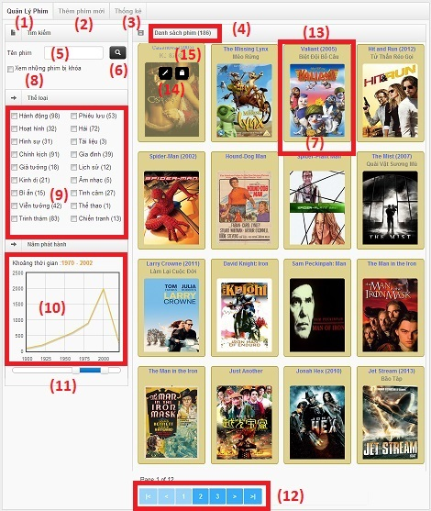

**Data Fields Definition – Admin – ManageFilm**

|  |  |  |  |  |  |  |
| --- | --- | --- | --- | --- | --- | --- |
| **Field name** | **Description** | **ReadOnly** | **Mandatory** | **Control**  **Type** | **Data**  **Type** | **Length** |
| (4)"Number of films" label | Label contain the number of films in list | Y | N | Label | integer | >=0 |
| (5) “Search text” field | Field contain the search text | N | N | Textbox | String | >=0; <=50 |
| (10)"Number of films " chart | Chart about the number of film by year | Y | N | Chart | - | - |
| (13) “Item-Film” field | Field contain a Film's info(Film's name and film's vnName, film's picture) | Y | N | - | Film | - |

##### AddFilm Online

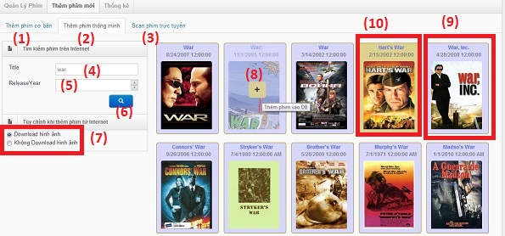

**Data Fields Definition – Admin-AddFilmOnline page**

|  |  |  |  |  |  |  |
| --- | --- | --- | --- | --- | --- | --- |
| **Field name** | **Description** | **ReadOnly** | **Mandatory** | **Control**  **Type** | **Data**  **Type** | **Length** |
| (4) "Title "textbox | Field contain the title text | N | N | Textbox | String | >=0; <=50 |
| (5) "Release Year" Dropdowlist | Field contain a film's release year | N | N | Dropdo-wlist | Integer | > 0 |
| (7)"Picture download" combo box | Field contain a combo box about download picture | N | Y | Combo box | Bool | N/A |
| (9)"Item-film not in the system" field | Field contain a film's info of the film that not exist in the system | Y | N | - | Film | - |
| (10)"Item-film already in the system" field | Field contain a film's info of the film that already exist in the system | Y | N | - | Film | - |

**Buttons / Hyper Links – Admin- AddFilmOnline Page**

|  |  |  |  |  |
| --- | --- | --- | --- | --- |
| **Function** | **Description** | **Available**  **Criteria** | **Validation** | **Outcome** |
| (1)"Add Film Manual" tab | Clicks to go to add film manual page | Always available | - | Shows the "AddManualFilm" page |
| (2) “Add Film Online” tab | Clicks to go to add film online page | Always available | - | Shows the "AddFilmOnline" page |
| (3)“Scan Film Online” tab | Clicks to go to scan film online page | Always available | - | Shows the "ScanFilmOnline" page |
| (6) "Search" button | Clicks to search film | Always available | - | Shows the specific films |
| (8) " Add" button | Clicks to add film into system's database | Move the mouse into film's zone | - | Add film to database |

##### ScanFilm Online

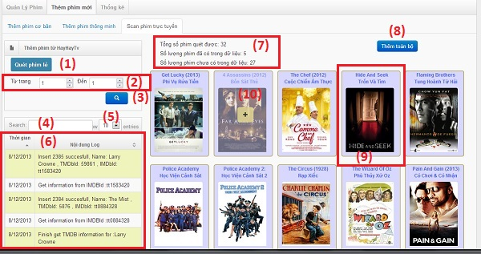

**Data Fields Definition – Admin-ScanFilmOnline page**

|  |  |  |  |  |  |  |
| --- | --- | --- | --- | --- | --- | --- |
| **Field name** | **Description** | **ReadOnly** | **Mandatory** | **Control**  **Type** | **Data**  **Type** | **Length** |
| (1) "Scan film" label | Label about scan film | Y | - | Label | String | - |
| (2)"Page" numeric input field | Field contain a numeric input that for the admin to choose the page's scan | N | Y | Numeric input | Integer | > 0 |
| (4)"Search log" text box | Field contain a search log's text | N | N | Textbox | String | >=0,  <=50 |
| (5)"Number of log" drop down list | Field contain a drop down list about number of log searched | N | Y | Drop down list | Integer | - |
| (6)"Log" data table field | Field contain a log's datatable with time and content of the logs | Y | - | Datatable | Log | - |
| (7)"Film's statistic" field | Field contain a statistic of the film : total films scanned, films that already in the database, films that do not exists in the database | Y | - | Label | integer | >=0 |
| (9)"Item-Film" field | Field that contains the film's information( name, Vietnamese name, picture) | Y | - | - | Film |  |

**Buttons / Hyper Links – Admin- ScanFilmOnline Page**

|  |  |  |  |  |
| --- | --- | --- | --- | --- |
| **Function** | **Description** | **Available**  **Criteria** | **Validation** | **Outcome** |
| (3)"Scan" button | Clicks to scan specific films | Always available | - | Shows the specific films scanned |
| (8) “Add all film ” button | Clicks to add all scanned films into database | Always available | - | Add all films available into system's database |
| (10) "Add film" button | Clicks to add film to database | When move the mouse into film's zone | - | Add film into system's database |

##### ManageStore

##### StoreDetail

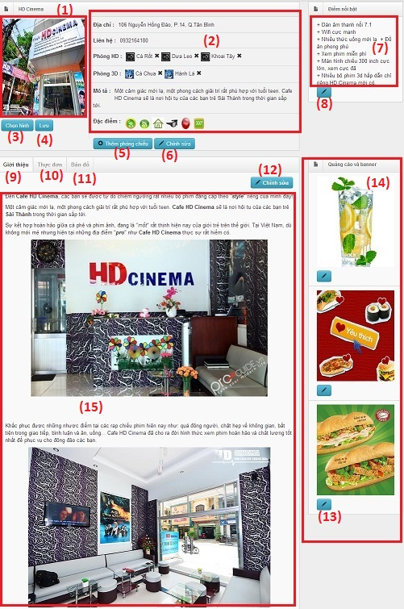

**Data Fields Definition – Admin- StoreDetail page**

|  |  |  |  |  |  |  |
| --- | --- | --- | --- | --- | --- | --- |
| **Field name** | **Description** | **ReadOnly** | **Mandatory** | **Control**  **Type** | **Data**  **Type** | **Length** |
| (1) “Store's avatar ” field | Field contain the store's avatar | Y | N | - | Picture | - |
| (2) “Store's information” field | Field contain a store's information | Y | N | - | - | - |
| (7)"Store's special" field | Field contain a store's special | Y | N | - | Text | - |
| (14)"Store advertising" field | Field contain a store's advertising | Y | N | - | Picture | - |
| (15)"Store introduction/ menu/ comment/ map" field | Field contain a store's introduction/menu/ comment/map | Y | N | - | - | - |

**Buttons / Hyper Links – Admin- StoreDetail Page**

|  |  |  |  |  |
| --- | --- | --- | --- | --- |
| **Function** | **Description** | **Available**  **Criteria** | **Validation** | **Outcome** |
| (3) "Choose avatar" button | Clicks to choose avatar | Always available | - | Shows the picture storage of store |
| (4) "Save avatar" button | Clicks to save avatar of the store | Always available | - | Saves the avatar of the store |
| (5) "Add room" button | Clicks to add room | Always available | - | Adds room of the store |
| (6)"Edit information" button | Clicks to edit store's information | Always available | - | Shows the edit store information modal |
| (8)"Edit special" button | Clicks to edit store's special | Always available | - | Shows the edit special modal |
| (9)"Introduction" tab | Clicks to go to store's introduction tab | Always available | - | Shows store's introduction field |
| (10)"Menu" tab | Clicks to go to store's menu tab | Always available | - | Shows store's menu field |
| (11)"map" tab | Clicks to go to store's map tab | Always available | - | Shows the map with store's location |
| (12)"Edit introduction" button | Clicks to edit store's introduction | Always available | - | Shows the edit store introduction modal |

##### ManageUser

##### ManageFile

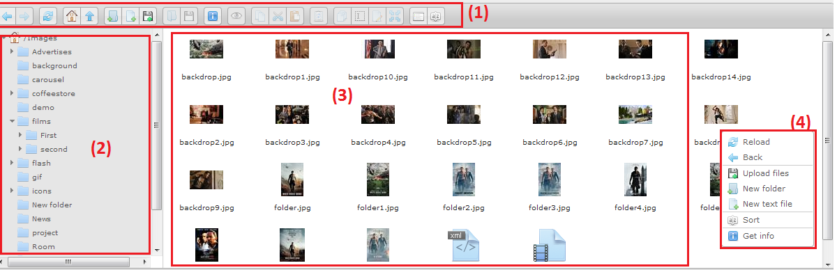

**Buttons / Hyper Links – Admin – ManageFile Page**

|  |  |  |  |  |
| --- | --- | --- | --- | --- |
| **Function** | **Description** | **Available**  **Criteria** | **Validation** | **Outcome** |
| (1) Menu toolbar of Elfinder | Contain all commands of elfinder. | Always available | - | Send the command to elfinder |
| (2) File tree in server | Display all folder that Admin mapping to elfinder | Always available | - | Display file and sub-folder. |
| (3) FileName and thumbnails of file in server. | Display information about file | Always available | - | Display information about this file. |
| (4) Right click content menu | Contain commands in this folder. | Right click white space |  | Send the command to elfinder. |

##### ManageNews

##### Manage Advertising

##### Manage Carousel

##### Manage Category

##### Manage Actor

##### Manage TagStore

#### Management StoreView

##### SODashboard

##### SOManageFilm

##### SOFilmDetail

##### SOManageStore

##### SOManageSchedule

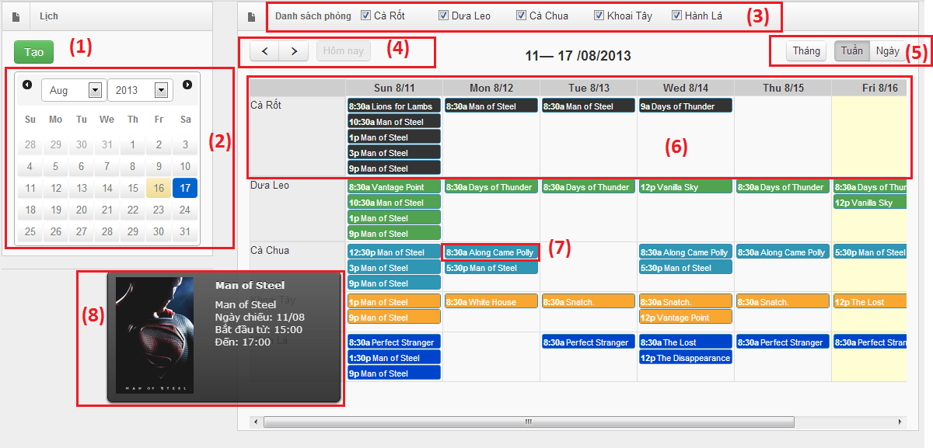

**Data Fields Definition – Store Owner- ManageSchedule page**

|  |  |  |  |  |  |  |
| --- | --- | --- | --- | --- | --- | --- |
| **Field name** | **Description** | **ReadOnly** | **Mandatory** | **Control**  **Type** | **Data**  **Type** | **Length** |
| (6)"Room’s schedule" field | Field contain room’s schedule | - | Y | - | - | - |
| (8) Tooltip of each event | Display more information about event | N/A | - | - | HTML | - |

**Buttons / Hyper Links – Store Owner- ManageSchedule Page**

|  |  |  |  |  |
| --- | --- | --- | --- | --- |
| **Function** | **Description** | **Available**  **Criteria** | **Validation** | **Outcome** |
| (1) "Create " button | Clicks to create an event of schedule | Always available | N/A | Shows the add event modal |
| (2) " Calendar " field | Field contain the small calendar | Always available | N/A | Gotodate in big calendar |
| (3)"Store's room" checkbox | Check to choose a room's schedule | Always available | N/A | Shows the schedule of the specific room |
| (4) “Datetime” Navigation | Click to previous day/week/month based on type View. | Always available | N/A | Display the calendar with time navigation. |
| (5) "ChangeView" button | Change the view day/week/month of the big calendar. | Always available | N/A | Shows the schedule by month/week/day |
| (7) Whitespace in big calendar | A white space in calendar | Always available | N/A | Show the add schedule form. |

##### SOAddSchedule

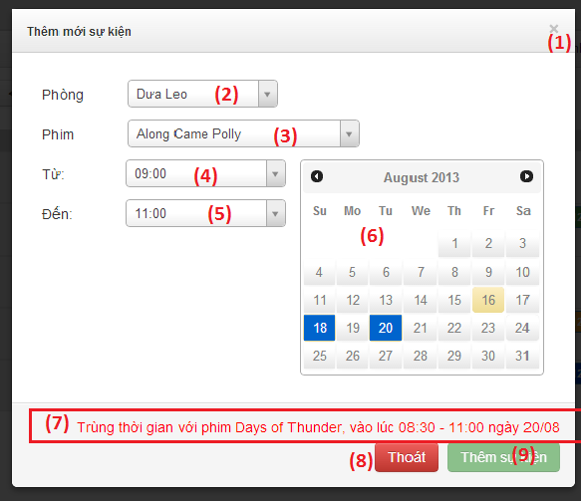

**Data Fields Definition – Store Owner- AddSchedule page**

|  |  |  |  |  |  |  |
| --- | --- | --- | --- | --- | --- | --- |
| **Field name** | **Description** | **ReadOnly** | **Mandatory** | **Control**  **Type** | **Data**  **Type** | **Length** |
| (7) Validation message | Notify store owner to know conflict when create schedule. | Y | - | label | - | - |

**Buttons / Hyper Links – Store Owner- AddSchedule Page**

|  |  |  |  |  |
| --- | --- | --- | --- | --- |
| **Function** | **Description** | **Available**  **Criteria** | **Validation** | **Outcome** |
| (1) "Exit " icon | Clicks to return to store's manage schedule page | Always available | - | Shows the "ManageSchedule" page |
| (2) \*Room\* Select | Select room for this schedule | Always available | - | Display select2 for select room.  ValidationEvent() |
| (3) \*Film\* select | Select film for this schedule | Always available | - | Display select2 for search film can show in this room. |
| (4) BeginTime | Select begintime for this schedule | Always available | 8:00-23:30 | Display select2 for select begin time.  ValidationEvent() |
| (5) EndTime | Select endtime for this schedule | Always available | 8:00-23:30  EndTime<BeginTime | Display select2 for select end time.  ValidationEvent() |
| (6) Multidate picker | Click to select days want to use this schedule. | Always available | - | ValidationEvent() |
| (8) "Exit " button | Clicks to return to store's manage schedule page | Always available | - | Shows the "ManageSchedule" page |
| (9)"Add schedule " button | Clicks to add an event of schedule | Always available | - | close the popup, display message and render event if success. |

##### SOManageFile

##### SOManageNews

#### HomePageView

##### HomePage

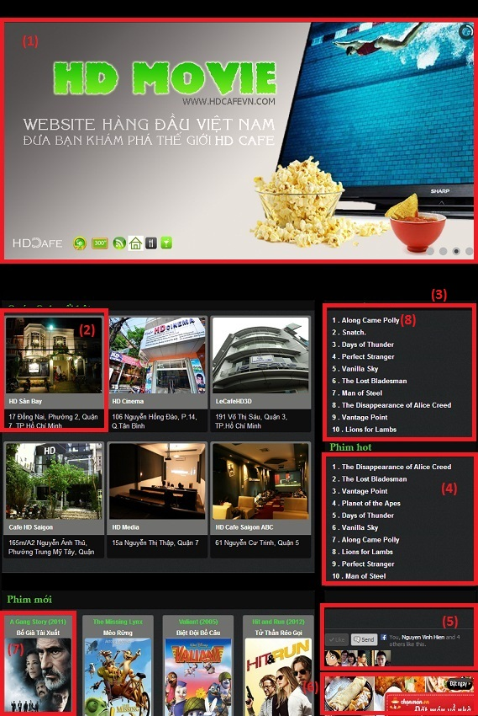

**Data Fields Definition – Home – Index Page**

|  |  |  |  |  |  |  |
| --- | --- | --- | --- | --- | --- | --- |
| **Field name** | **Description** | **ReadOnly** | **Mandatory** | **Control**  **Type** | **Data**  **Type** | **Length** |
| (1) “Banner” field | Field contain the banner of home page | Y | N | - | Image | - |
| (2) “Item-Store” field | Field contain the store that have most like | Y | N | - | Store | - |
| (3) “Film-showing” field | Field contain the film that is going to show at a current time | Y | N | - | String | - |
| (4) “Film Hot” field | Field contain the film that have most schedule | Y | N | - | String | - |
| (5) “Plug-in Facebook” field | Field contain the facebook’s plug-in | Y | N | - | - | - |
| (6) “Advertising” field | Field contain the advertising | Y | N | - | Html | - |
| (7) “Item-Film New” field | Field contain the new film | Y | N | - | Film | - |

**Buttons / Hyper Links – Home – Index Page**

|  |  |  |  |  |
| --- | --- | --- | --- | --- |
| **Function** | **Description** | **Available**  **Criteria** | **Validation** | **Outcome** |
| (8) “Film details” hyper link | Clicks to go to “Film details” page | Always available | - | Show the film details |

##### News

##### Films

##### FilmDetail

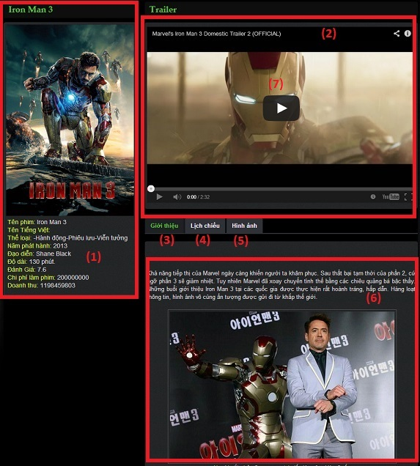

**Data Fields Definition – Home-FilmDetail page**

|  |  |  |  |  |  |  |
| --- | --- | --- | --- | --- | --- | --- |
| **Field name** | **Description** | **ReadOnly** | **Mandatory** | **Control**  **Type** | **Data**  **Type** | **Length** |
| (1) "Film information" field | Field contain the film's info | Y | N | - | - | - |
| (2) "Trailer" Field | Field contain a film's trailer | - | N | - | - | - |
| (6)"Film introduction/ schedule/picture" field | Field contain an introduction/schedule/picture of film | Y | N | - | - | - |

**Buttons / Hyper Links – Home-FilmDetail Page**

|  |  |  |  |  |
| --- | --- | --- | --- | --- |
| **Function** | **Description** | **Available**  **Criteria** | **Validation** | **Outcome** |
| (3) "Introduction" tab | Clicks to go to introduction of film | Always available | - | Shows the introduction of film |
| (4) "Schedule" tab | Clicks to go to schedule of film | Always available | - | Shows the schedule of film |
| (5) "Pictures" tab | Clicks to go to pictures of film | Always available | - | Shows the pictures of film |
| (7)"Play" button | Clicks to play the film's trailer | Always available unless the trailer is playing | - | Shows the film's trailer |

##### Stores

##### Schedule

##### StoreDetail

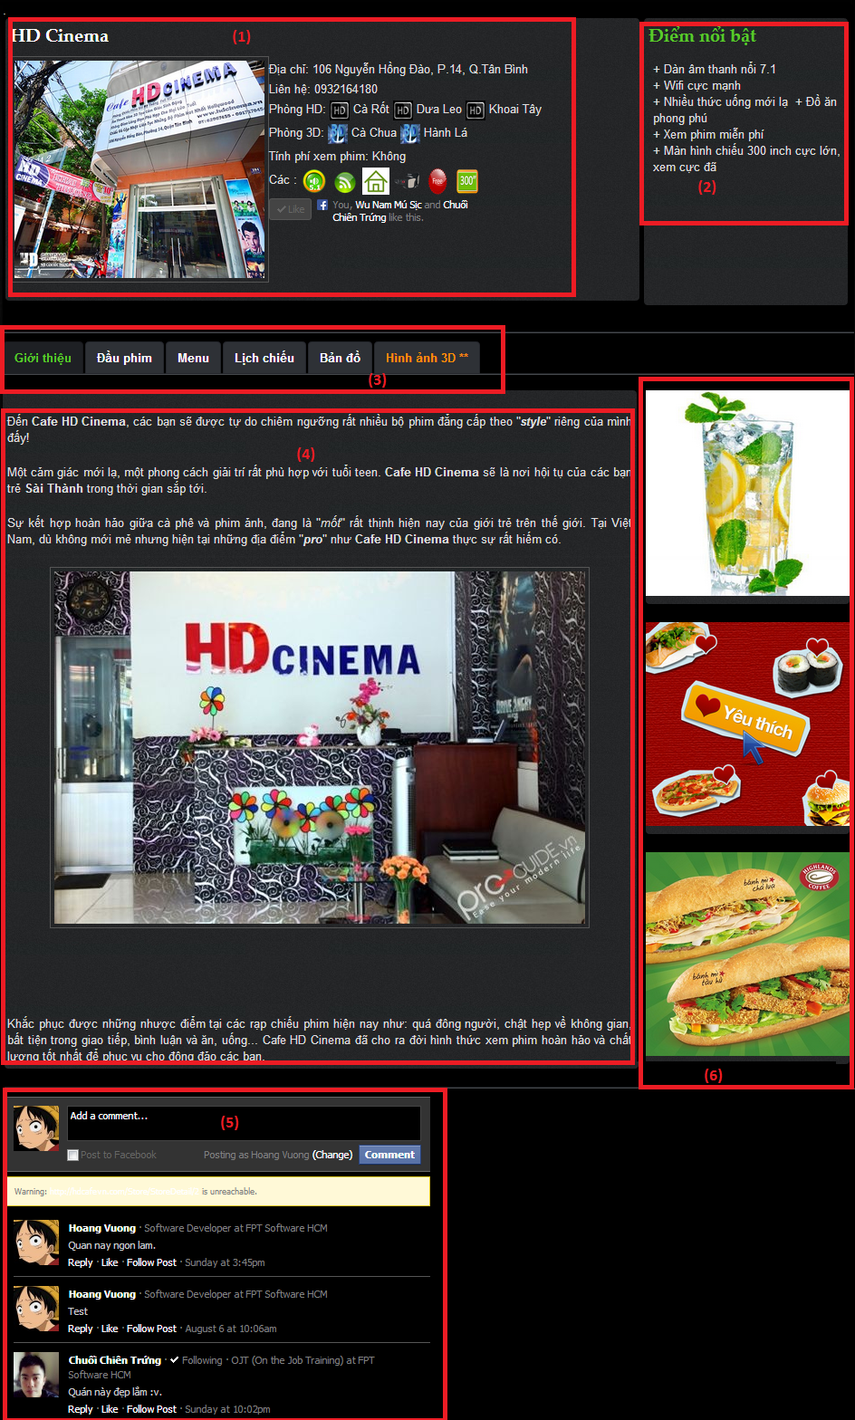

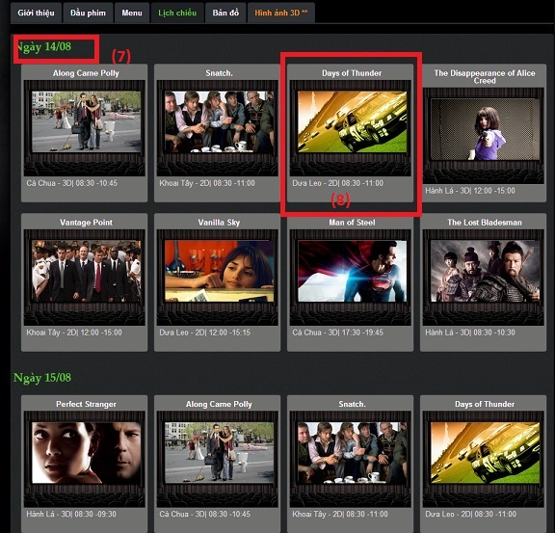

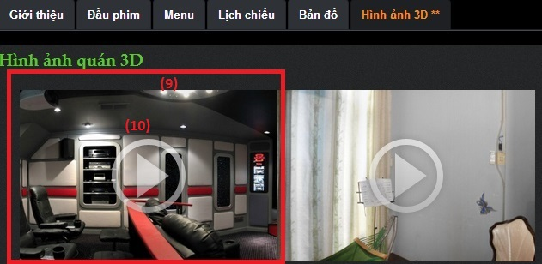

**Data Fields Definition – Home-StoreDetail page**

|  |  |  |  |  |  |  |
| --- | --- | --- | --- | --- | --- | --- |
| **Field name** | **Description** | **ReadOnly** | **Mandatory** | **Control**  **Type** | **Data**  **Type** | **Length** |
| (1) “Store's information” field | Field contain a store's information | Y | N | - | - | - |
| (2)"Store's special" field | Field contain a store's special | Y | N | - | Text | - |
| (4)"Store introduction/film/menu/ schedule/ map/ 3Dpicture " field | Field contain a store's introduction/film/menu/ schedule/ map/ 3Dpicture | Y | N | - | - | - |
| (5) "Comment" field | Field contain a comment of the guest about the store | N | N | - | - | - |
| (6) "Advertising" field | Field contains the banner of advertising | Y | N | - | - | - |
| (7)"Date" field | Field contain a day time of schedule | Y | N | - | Text | - |
| (8)"Item-schedule" field | Field contain a schedule's information (film's name, room, type of room, date time begin, date time end) | Y | N | - | Schedule | - |
| (9)"Item-picture" field | Field contain a store's 3D pictures) | Y | N | - | Picture | - |

**Buttons / Hyper Links – Home-StoreDetail Page**

|  |  |  |  |  |
| --- | --- | --- | --- | --- |
| **Function** | **Description** | **Available**  **Criteria** | **Validation** | **Outcome** |
| (3) " introduction/film/menu/ schedule/ map/ 3Dpicture " tab | Clicks to go to introduction/film/menu/ schedule/ map/ 3Dpicture tab | Always available | - | Shows the introduction/film/ menu/ schedule/ map/ 3Dpicture tab |
| (5) "Comment" field | Type a comment and Clicks submit to comment about store | Always available | - | Comment about store |
| (10)"Picture play" button | Clicks to play a 360 degree picture's show | Always available | - | Shows the 360 degree picture |

## Sequence Diagram

### Scan Film Online

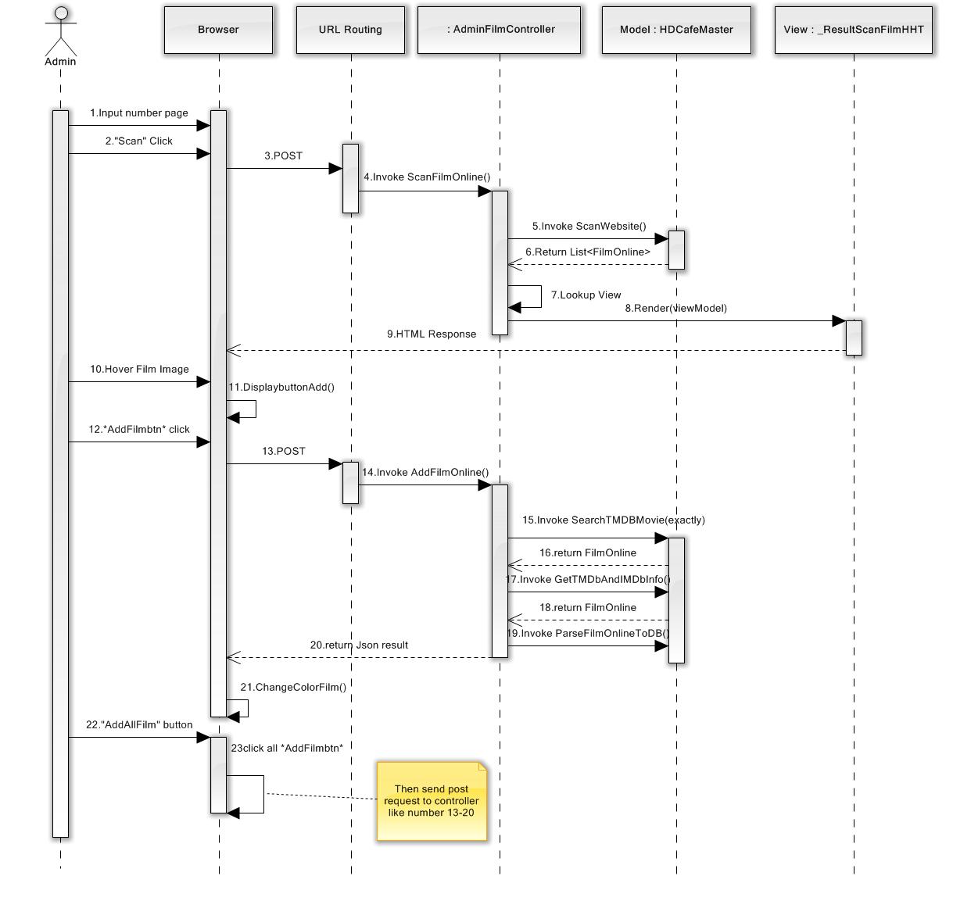

Figure 4.5.1 – Scan Film Online Sequence diagram

### Edit Store Information

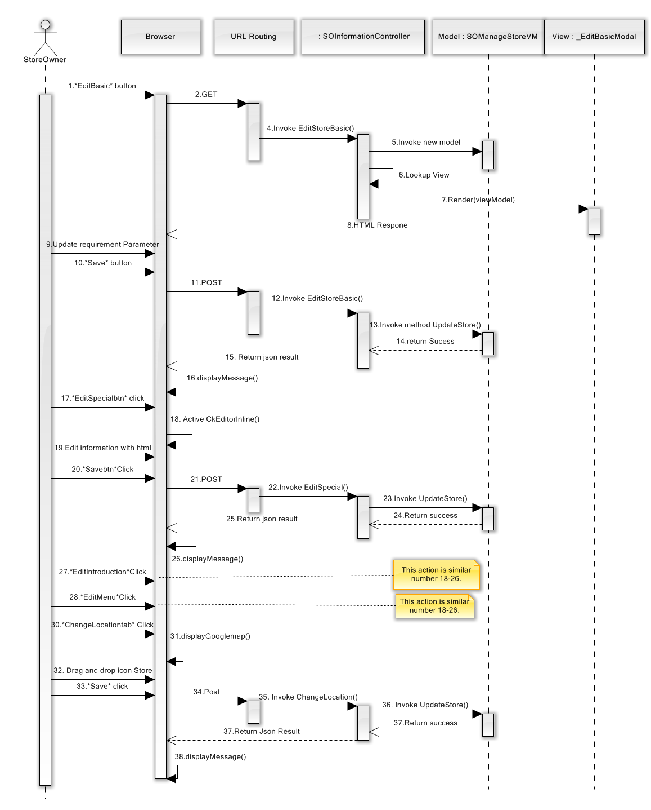

Figure 4.5.2 – Edit Store Information Sequence Diagram

### Change Carousel on Website

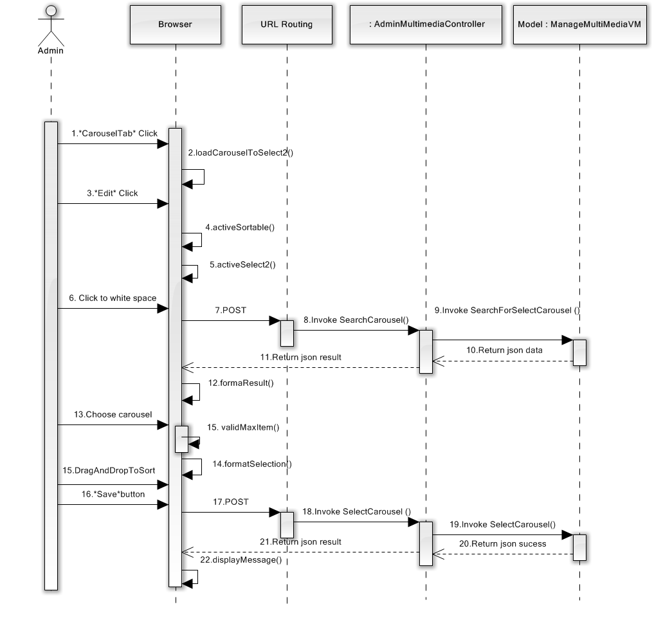

Figure 4.5.3 – Change Carousel on Website Sequence Diagram

### Add New Schedule

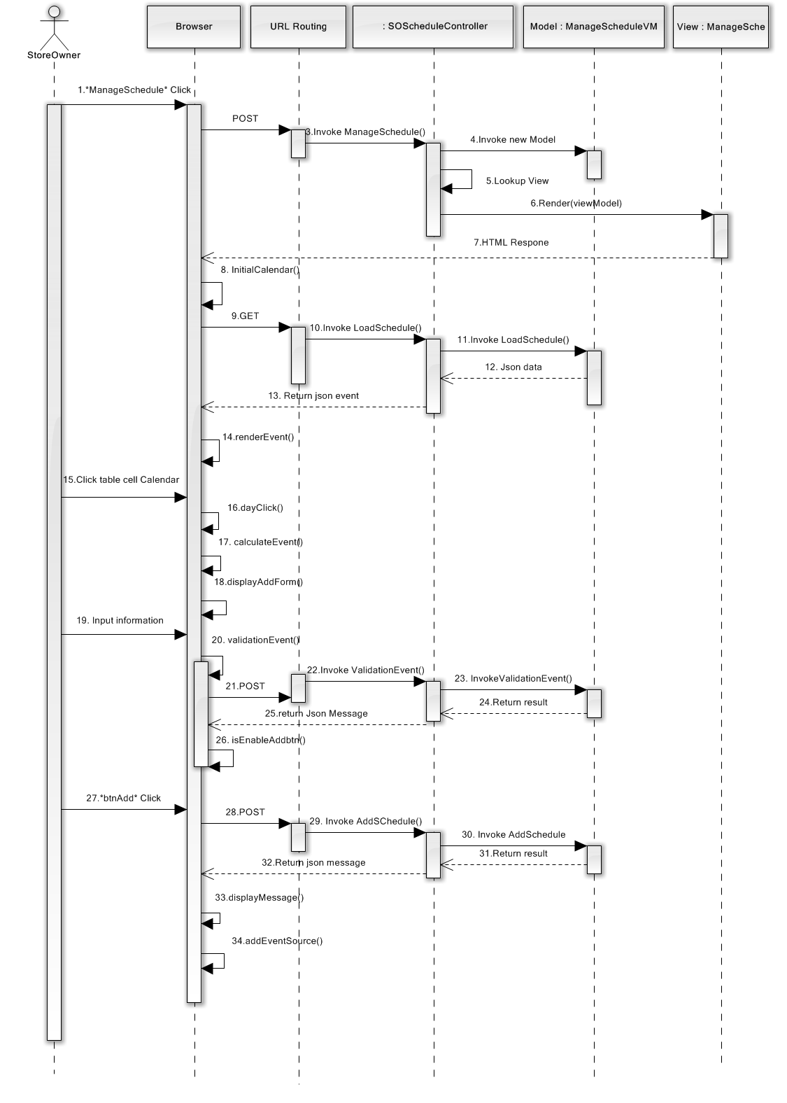

Figure 4.5.4 – Add New Schedule Sequence Diagram

# Software Test Documentation

## Introduction

### System Overview

This document describes the approach and methodologies used by the testing group to plan, organize and manage the testing of this system. It describes implementation details of test cases or technical details of how the product features should work.

The 3D and HD Cafe system allows users to perform the following actions:

* Create schedule of store : add events, delete events, search events
* Add film to store
* View schedule, film's list, film's detail, store's list. store's detail
* Search film, store and schedule
* Update film's detail and store's detail
* Manage data: add, edit or inactive user, film, store.

### Test Approach

* The testing for this project will consist of Unit, System and Acceptance test levels. It is hoped that there will be as less problem as possible in project.
* Unit Testing will be done by the developers and will be approved by the implementing team leader. All unit test information will be managed by developers and it must be showed when team required.
* System Testing will be performed by tester with assistance from the individual developers as required.
* Acceptance Testing will be performed by all the member of team. The acceptance test will be done for a period of 2 weeks after completion of the System test process. Programs will enter into Acceptance test after all critical and major defects have been corrected. A program may have one major defect as long as it does not obstruct testing of the program. Prior to final completion of acceptance testing all open critical and major defects must be corrected.

## Test Plan

### Feature To Be Tested

#### <Guest> ViewSchedule

* Test all functions in “View Schedule” include: View new's list, new's title, view information of the new.

#### <Guest> SearchFilm

* Test all functions in “Search Films” include: Search film by name, search film by category

#### <Guest> SearchStore

* Test all functions in “Search Store” include: Search store by name, Search store by type of film ( 3D or HD)

#### <Guest> SearchScheduleByFilm

* Test all functions in “Search Schedule By Film” include: Search schedule by film

#### <Guest> SearchScheduleByStore

* Test all functions in “Search Schedule By Store” include: Search schedule by store

#### <StoreOwner> ViewSchedule

* Test these functions in viewing information and some related functions of schedule include: add/ remove schedule, display schedule of rooms …

#### <StoreOwner> AddFilmToStore

* Test activity add film to store normally

#### <StoreOwner> EditSchedule

* Test all function in EditSchedule by store’s owner includes: validation of begin time and end time, validation of conflict with other event, search film.

#### <StoreOwner> AddSchedule

* Test all function in AddSchedule by store’s owner includes: validation of begin time and end time, validation of conflict with other event, search film.

#### <Admin> ViewFile

* Test functions in “View File” includes: upload file, create file, rename, move file on server.

#### <Admin> AddUser

* Test working of Add a User function include correctly displaying of basic information: Username, password, email, gender, DoB, address, phone, role. Test status and displaying of user after creating on Data table on “ManageUser” page.

#### <Admin> AddStore

* Test working of Add a Store function include correctly displaying of basic information: Store Name, Address, Phone, Dedicated Image, Description, Owner. Test status and displaying of new store after creating in List active store on “Cửa hàng” page.

#### <Admin> AddRoom

* Test working of Add a Room function when edit a store include correctly displaying of basic information: Room name, type of showroom (2D, 3D), quality and features of showroom (glasses, screen, drink). Test status and displaying correctly (2D, 3D) in List room display on “EditStore” page.

#### <Admin> EditSlideCarousel

* Test functions in “EditSlideCarousel” includes: add carousel to slide, change order of carousels.

#### <Admin> SearchFilm

* Test search film function in following type: search active film, search inactive film, search by categories, input keywords (“Tên phim”)

### Feature Not To Be Tested

* Add/Edit/Delete functions are similar test plan above.
* Performance Testing

## Test Case

### <Guest> ViewSchedule

|  |  |  |  |  |  |  |  |
| --- | --- | --- | --- | --- | --- | --- | --- |
| **ID** | **Test Case Description** | **Test Case Procedure** | **Expected Output** | **Inter-test case Dependence** | **Result** | **Test Date** | **Note** |
|  | List roles |  |  |  |  |  |  |
|  | Steps  1. Go to Home Page | | | | | | |
| VSC1 | View Schedule Page | Click on "Lịch Chiếu" tab at home page | Schedule page will be displayed |  | Passed | 25/07/2013 |  |
| VSC2 | View Find By Store tab | Click on "Tìm the quán" tab | " Chọn quán" Dropdownlist will be displayed | VSC1 | Passed | 25/07/2013 |  |
| VSC3 | View Find By Film tab | Click on "Tìm theo film" tab | "Chọn phim" Dropdownlist will be displayed | VSC2 | Passed | 25/07/2013 |  |

### <Guest> SearchFilm

|  |  |  |  |  |  |  |  |
| --- | --- | --- | --- | --- | --- | --- | --- |
| **ID** | **Test Case Description** | **Test Case Procedure** | **Expected Output** | **Inter-test case Dependence** | **Result** | **Test Date** | **Note** |
|  | List roles |  |  |  |  |  |  |
|  | Steps  1. Go to Home Page  2. Click on " PhimHD" tab | | | | | | |
| SF1 | Search Film by Name | 1. Input search string into search textbox  2. Click on "Search" icon | Films with the name contain search string will be displayed |  | Passed | 25/07/2013 |  |
| SF2 | Search Film by Category | Checkin a " Hành Động" checkbox | Films that have a category " Hành Động" is displayed |  | Passed | 25/07/2013 |  |
| SF3 | Search Film By Category | Checkin a " Hành Động" checkbox again | All Films will be displayed | SF2 | Passed | 25/07/2013 |  |

### <Guest> SearchStore

|  |  |  |  |  |  |  |  |
| --- | --- | --- | --- | --- | --- | --- | --- |
| **ID** | **Test Case Description** | **Test Case Procedure** | **Expected Output** | **Inter-test case Dependence** | **Result** | **Test Date** | **Note** |
|  | List roles |  |  |  |  |  |  |
|  | Steps  1. Go to Home Page  2. Click on " HDCafe" tab | | | | | | |
| SS1 | Search Store by Name | 1. Input search string into search textbox  2. Click on "Search" icon | Stores with the name contain search string will be displayed |  | Passed | 25/07/2013 |  |
| SS2 | Search Store by Type | Checkin a "3D" checkbox | Stores that have 3D room is displayed |  | Passed | 25/07/2013 |  |
| SS3 | Search Film By Type | Checkin a "HD" checkbox | Stores that have HD room is displayed |  | Passed | 25/07/2013 |  |

### <Guest> SearchScheduleByFilm

|  |  |  |  |  |  |  |  |
| --- | --- | --- | --- | --- | --- | --- | --- |
| **ID** | **Test Case Description** | **Test Case Procedure** | **Expected Output** | **Inter-test case Dependence** | **Result** | **Test Date** | **Note** |
|  | List roles |  |  |  |  |  |  |
|  | Steps  1. Go to Home Page  2. Click on " Lịch Chiếu" tab | | | | | | |
| SSCBF1 | Search Schedule By Film | 1. Click on " Chọn phim" Dropdownlist  2. input a search string into textbox  3. Choose a film to search schedule | Schedule of that film will be displayed correctly |  | Passed | 25/07/2013 |  |
| SSCBF2 | Search Schedule By Film | 1. Click on " Chọn phim" Dropdownlist  2. input a search string into textbox  3. Choose a film to search schedule | The schedule of that film will be displayed correctly and  The schedule at the film that already have displayed in SSCBF1 will be no longer displayed | SSCBF1 | Passed | 25/07/2013 |  |

### <Guest> SearchScheduleByStore

|  |  |  |  |  |  |  |  |
| --- | --- | --- | --- | --- | --- | --- | --- |
| **ID** | **Test Case Description** | **Test Case Procedure** | **Expected Output** | **Inter-test case Dependence** | **Result** | **Test Date** | **Note** |
|  | List roles |  |  |  |  |  |  |
|  | Steps  1. Go to Home Page  2. Click on " Lịch Chiếu" tab  3. Click on "Tìm theo quán" tab | | | | | | |
| SSCBS1 | Search Schedule By Store | 1. Click on " Chọn Quán" Dropdownlist  2. input a search string into textbox  3. Choose a store to search schedule | Schedule of that store will be displayed correctly |  | Passed | 25/07/2013 |  |
| SSCBS2 | Search Schedule By Film | 1. Click on " Chọn quán" Dropdownlist  2. input a search string into textbox  3. Choose a store to search schedule | The schedule of that store will be displayed correctly and  The schedule at the store that already have displayed in SSCBS1 will be no longer displayed, the | SSCBS1 | Passed | 25/07/2013 |  |

### <StoreOwner> ViewSchedule

|  |  |  |  |  |  |  |  |
| --- | --- | --- | --- | --- | --- | --- | --- |
| **ID** | **Test Case Description** | **Test Case Procedure** | **Expected Output** | **Inter-test case Dependence** | **Result** | **Test Date** | **Note** |
|  | List roles |  |  |  |  |  |  |
|  | Steps 1. Login the system with User role. | | | | | | |
| SVS1 | Display schedule of store | Click on “Lịch chiếu” icon | Screen display schedule with rooms |  | Passed | 26/07/2013 |  |
| SVS2 | Display schedule of room | 1. Click on “Lịch chiếu” icon.  2. Select “Cà rốt” check box | Schedule of “Cà rốt” room is displayed normally |  | Passed | 26/07/2013 |  |
| SVS3 | View schedule by week | Click on “Tuần” icon | Schedule is displayed by week | SVS1 | Passed | 26/07/2013 |  |
| SVS4 | Add schedule | 1. Click on Calenda  2. Input information and save. | Schedule is added normally | SVS1 | Passed | 26/07/2013 |  |

### <StoreOwner> AddFilmToStore

|  |  |  |  |  |  |  |  |
| --- | --- | --- | --- | --- | --- | --- | --- |
| **ID** | **Test Case Description** | **Test Case Procedure** | **Expected Output** | **Inter-test case Dependence** | **Result** | **Test Date** | **Note** |
|  | List roles |  |  |  |  |  |  |
|  | Steps 1. Login the system with User role. | | | | | | |
| SAFTS1 | Add film to store | 1. Click on “Phim ảnh” icon  2. Select “Ngoài quán” check box 3. Click on “Thêm phim vào quán” icon | Film is added to store normally |  | Passed | 26/07/2013 |  |

### < StoreOwner > EditSchedule

|  |  |  |  |  |  |  |  |
| --- | --- | --- | --- | --- | --- | --- | --- |
| **ID** | **Test Case Description** | **Test Case Procedure** | **Expected Output** | **Inter-test case Dependence** | **Result** | **Test Date** | **Note** |
|  | List roles |  |  |  |  |  |  |
|  | Steps 1. Login the system with Store Owner role. | | | | | | |
| SOES1 | Store Owner views Schedule | Store Owner click “ManageSchedule” on Menu. | Screen display a small calendar on the left and big calendar that include event on the right. |  | Passed | 25/07/2013 |  |
| SOES2 | Store Owner changes day of Schedule from small calendar | Store Owner click on any date of small calendar | Big calendar will change to same day and display correct event in that day. | SOES1 | Passed | 25/07/2013 |  |
| SOES3 | Store Owner change day of Schedule from big calendar | Store Owner click button “<” or “>” to move next or previous day on big calendar | Big calendar will change event in that day. | SOES1 | Passed | 25/07/2013 |  |
| SOES4 | Store Owner changes view of event by Room. | Store Owner check to checkbox in list room. | Big calendar will display only event if Room is checked. | SOES1 | Passed | 25/07/2013 |  |
| SOES5 | Store Owner edits a event | Store Owner click to an event in big Calendar.  Store Owner change information that valid and click “save” | Display a label notifies that edit successfully.  Big calendar will change the event based on edit of Store Owner. | SOES1 | Passed | 25/07/2013 |  |
| SOES6 | Store Owner edits an event with unvalid time. | Store Owner click to an event in big Calendar.  Store Owner set time end less than time begin. | Display a label notifies “Event can be end before it start”, and disable button “Save”. | SOES1 | Passed | 25/07/2013 |  |
| SOES7 | Store Owner edits an event with conflict | Store Owner click to an event in big Calendar.  Store Owner set time that conflict with other event. Time end and begin may be duplicate with other event. | Display a label notifies “The event duplicatte time with event …. From … to …..”, and disable button “Save”. | SOES1 | Passed | 25/07/2013 |  |

### < StoreOwner > AddSchedule

|  |  |  |  |  |  |  |  |
| --- | --- | --- | --- | --- | --- | --- | --- |
| **ID** | **Test Case Description** | **Test Case Procedure** | **Expected Output** | **Inter-test case Dependence** | **Result** | **Test Date** | **Note** |
|  | List roles |  |  |  |  |  |  |
|  | Steps 1. Login the system with Store Owner role. | | | | | | |
| SOAS1 | Store Owner views Schedule | Store Owner click “ManageSchedule” on Menu. | Screen display a small calendar on the left and big calendar that include event on the right. |  | Passed | 25/07/2013 |  |
| SOAS5 | Store Owner adds a event | Store Owner click to button “Add” or a white spce in big calendar.  Store Owner change information that valid and click “save” | Display a label notifies that add successfully.  Big calendar will change the event based on edit of Store Owner. | SOAS1 | Passed | 25/07/2013 |  |
| SOAS6 | Store Owner adds an event with unvalid time. | Store Owner click to button “Add” or a white spce in big calendar.  Store Owner set time end less than time begin. | Display a label notifies “Event can be end before it start”, and disable button “Save”. | SOAS1 | Passed | 25/07/2013 |  |
| SOAS7 | Store Owner adds an event with conflict | Store Owner click to button “Add” or a white spce in big calendar.  Store Owner set time that conflict with other event. Time end and begin may be duplicate with other event. | Display a label notifies “The event duplicatte time with event …. From … to …..”, and disable button “Save”. | SOAS1 | Passed | 25/07/2013 |  |

### < Admin > ViewFile

|  |  |  |  |  |  |  |  |
| --- | --- | --- | --- | --- | --- | --- | --- |
| **ID** | **Test Case Description** | **Test Case Procedure** | **Expected Output** | **Inter-test case Dependence** | **Result** | **Test Date** | **Note** |
|  | List roles |  |  |  |  |  |  |
|  | Steps 1. Login the system with Admin role. | | | | | | |
| AVF1 | Admin view File on server | Admin click “ManageFile” on Menu. | Screen display all folder that Admin have with their account. |  | Passed | 25/07/2013 |  |
| AVF2 | Admin upload file | Admin right click on space of windows or click on upload file symbol on menuBar of tool.  -The borwser display windows choose file  -User choose file and click upload | File will display correct on folder that User choose with file’s User. | AVF1 | Passed | 25/07/2013 |  |
| AVF3 | Admin rename file | Admin chooses a file and clicks rename on toolbar or rightclick and choose rename.  StoreOwner type new name for file. | File will have new name. | AVF1 | Passed | 25/07/2013 |  |
| AVF4 | Admin rename file with duplicate | Admin chooses a file and clicks rename on toolbar or rightclick and choose rename.  StoreOwner type a same name with other file. | File will not allow having duplicate name. | AVF1 | Passed | 25/07/2013 |  |

### < Admin > AddUser

|  |  |  |  |  |  |  |  |
| --- | --- | --- | --- | --- | --- | --- | --- |
| **ID** | **Test Case Description** | **Test Case Procedure** | **Expected Output** | **Inter-test case Dependence** | **Result** | **Test Date** | **Note** |
|  | List roles |  |  |  |  |  |  |
|  | Steps 1. Login with Admin role account  2. Go to “Người dùng” page | | | | | | |
| AU1 | Check display of User information Data table | At “Người dùng” page, check displaying of user information in Data table | Data table display user information with following column:  “Tên người dùng”, “Họ và tên”, “Địa chỉ”, “Điện thoại liên lạc”, “Địa chỉ email”, “Trạng thái”, “Vai trò”, Edit column |  | Passed | 27/07/2013 |  |
| AU2 | Check working when click “Thêm người dùng” button | At “Người dùng” page, click on “Thêm người dùng” button | AddUser modal popup has been displayed with following basic information:  “Tên đăng nhập (\*)” – Textbox  “Mật khẩu (\*)” – Textbox  “Họ và tên đệm” – Textbox  “Tên” – Textbox  “Địa chỉ” – Textbox  “Email” – Textbox  “Giới tính” – SelectList (“Nam” , “Nữ)  “Điện thoại” – Textbox  “Phân quyền” – SelectList (“Chủ quán”, “Admin”) |  | Passed | 27/07/2013 |  |
| AU3 | Check working when submit AddUser modal with validation | At AddUser modal popup, input corresponding information:  “Tên đăng nhập (\*)” – (leave empty)  “Mật khẩu (\*)” – (leave empty)  “Họ và tên đệm” – “NamNQ2”  “Tên” – “Nam22”  “Địa chỉ” – “AbCxxz”  “Email” – “Namyahoo.com”  “Điện thoại” – “090598asda”  Click on “Lưu” button | AddUser modal will display validation error message corresponding:  “Vui lòng nhập tên đăng nhập”  “Vui lòng nhập mật khẩu”  “Địa chỉ email hợp lệ có dạng “xxx@x.x”  “Gồm 10 hoặc 11 số , bắt đầu bằng 09xxxxxxxx, 01xxxxxxxxx” |  | Passed | 27/07/2013 |  |
| AU4 | Check working when submit AddUser modal | At AddUser modal popup, input corresponding information:  “Tên đăng nhập (\*)” – “Testuser1”  “Mật khẩu (\*)” – “12345678”  “Họ và tên đệm” – “NamNQ2”  “Tên” – “Nam22”  “Địa chỉ” – “AbCxxz”  “Email” – “Nam@yahoo.com”  “Điện thoại” – “0905988292”  Click on “Lưu” button | User “Testuser1” has been added and displayed correctly information on Data Table | AU2 | Passed | 27/07/2013 |  |
| AU5 | Check working when reset AddUser modal inputted data | At AddUser modal popup, input corresponding information:  “Tên đăng nhập (\*)” – “Testuser”  “Mật khẩu (\*)” – “123456”  “Họ và tên đệm” – “NamNQ”  “Tên” – “Nam”  “Địa chỉ” – “AbC”  “Email” – “AAAAAAAAAAAAA”  “Điện thoại” – “0905988292”  Click on “Làm lại” button | Inputted data has been undone into empty (first state when AddUser modal show up). | AU2 | Passed | 27/07/2012 |  |

### < Admin > AddStore

|  |  |  |  |  |  |  |  |
| --- | --- | --- | --- | --- | --- | --- | --- |
| **ID** | **Test Case Description** | **Test Case Procedure** | **Expected Output** | **Inter-test case Dependence** | **Result** | **Test Date** | **Note** |
|  | List roles |  |  |  |  |  |  |
|  | Steps 1. Login with Admin role account  2. Go to “Cửa hàng” page | | | | | | |
| AS1 | Check working of “Thêm Quán” button | At “Cửa hàng” page, click to “Thêm Quán” button | AddStore modal popup display successful with needed information:  “Tên quán” – Textbox  “Địa chỉ” – Textbox  “Mô tả” – Textbox  “Hình đại diện” – FileUpload  “Điện thoại” – Textbox  “Trạng thái” – SelectList  “Chủ quán” – AutocompleteBox |  | Passed | 27/07/2013 |  |
| AS2 | Check working when submit AddStore modal with validation | At AddStore modal popup, input corresponding information:  “Tên Quán” – (leave empty)  “Điện thoại” – “ABC”  Click on “Lưu” button | AddStore modal popup display validation message of “Tên quán” : “Vui lòng nhập tên quán”.  AddStore modal popup display validation message of “Điện thoại”: “Bao gồm 10 hoặc 11 số, bắt đầu bằng 09xxxxxxxx, 01xxxxxxxxx,…” | AS1 | Passed | 27/07/2013 |  |
| AS3 | Check working when submit AddStore modal | At AddStore modal popup, input corresponding information:  “Tên quán” – “TestStore”  “Địa chỉ” – “TestAddress”  “Mô tả” – “Description here”  “Hình đại diện” – (leave)  “Điện thoại” – “01228524791”  “Trạng thái” – “Active”  “Chủ quán” – “VuongHTT”  Click on “Lưu” button | New Store with corresponding information has been displayed correctly with blue background-color on the first list active store. Default Image is displayed correctly | AS1 | Passed | 27/07/2013 |  |
| AS4 | Check working when reset AddStore modal inputted data | At AddStore modal popup, input corresponding information:  “Tên quán” – “TestStore2”  “Địa chỉ” – “TestAddress2”  “Mô tả” – “Description overthere”  “Hình đại diện” – (leave)  “Điện thoại” – “01228524791”  “Trạng thái” – “Active”  “Chủ quán” – “NamNQ”  Click on “Làm lại” button | Inputted data has been undone into empty (first state when AddStore modal show up). | AS1 | Passed | 27/07/2012 |  |

### < Admin > AddRoom

|  |  |  |  |  |  |  |  |
| --- | --- | --- | --- | --- | --- | --- | --- |
| **ID** | **Test Case Description** | **Test Case Procedure** | **Expected Output** | **Inter-test case Dependence** | **Result** | **Test Date** | **Note** |
|  | List roles |  |  |  |  |  |  |
|  | Steps 1. Login with Admin role account  2. Go to “Cửa hàng” page  3. Click to “HD Cinema” Store to redirect to EditStore page | | | | | | |
| AR1 | Check working of “Thêm phòng chiếu” button | At EditStore page, click to “Thêm phòng chiếu” button | AddRoom modal popup display successful with needed information:  “Tên quán” – “HD Cinema” (readonly)  “Tên phòng chiếu” – Textbox  “Loại phòng” – SelectList (“2D”, “3D”)  “Số lượng chỗ” – DropList<int>  “Thiết bị chiếu” – Textbox  “Loại Kính 3D” – Textbox  “Mô Tả” – Textbox |  | Passed | 27/07/2013 |  |
| AR2 | Check working when submit AddRoom modal with validation | At AddRoom modal popup, input corresponding information:  “Tên phòng chiếu” – (leave empty)  Click on “Lưu” button | AddStore modal popup display validation message of “Tên quán”: “Vui lòng nhập tên phòng chiếu”. | AR1 | Passed | 27/07/2013 |  |
| AR3 | Check working when submit AddRoom modal | At AddRoom modal popup, input corresponding information:  “Tên quán” – “HD Cinema” (readonly)  “Tên phòng chiếu” – “TestRoom”  “Loại phòng” – “2D”  “Số lượng chỗ” – “30”  “Thiết bị chiếu” – “VIP”  “Loại Kính 3D” – “Lycan”  Click on “Lưu” button  Repeat step for  “Tên phòng chiếu” – “Test3D”  “Loại phòng” – “3D” | New Room with corresponding information (TestRoom) has been displayed correctly list active room on EditStore page. Image for 2D room type is displayed correctly  New Room with corresponding information (Test3D) has been displayed correctly list active room on EditStore page. Image for 3D room type is displayed correctly | AR1 | Passed | 27/07/2013 |  |
| AR4 | Check working when reset AddRoom modal inputted data | At AddRoom modal popup, input corresponding information:  “Tên quán” – “HD Cinema” (readonly)  “Tên phòng chiếu” – “TestRoom2”  “Loại phòng” – “2D”  “Số lượng chỗ” – “12”  “Thiết bị chiếu” – “VIP2”  “Loại Kính 3D” – “Lycan2”  Click on “Làm lại” button | Inputted data has been undone into empty (first state when AddRoom modal show up). | AR1 | Passed | 27/07/2012 |  |

### < Admin > EditSlideCarousel

|  |  |  |  |  |  |  |  |
| --- | --- | --- | --- | --- | --- | --- | --- |
| **ID** | **Test Case Description** | **Test Case Procedure** | **Expected Output** | **Inter-test case Dependence** | **Result** | **Test Date** | **Note** |
|  | List roles |  |  |  |  |  |  |
|  | Steps 1. Login the system with Admin role. | | | | | | |
| AEC1 | Admin view current Carousels Slide | Admin click “ManageDB” on Menu and choose tab “Carousel” | Screen display all image carousel that using on Website. |  | Passed | 25/07/2013 |  |
| AEC2 | Admin Edit order of Carousels Slide | Admin click “Edit”. Using mouse move image to new position.  Admin click “Save”. | Display label notify that save successfully.  Website will use new Carousels slide after Admin click Save. | AEC1 | Passed | 25/07/2013 |  |
| AEC3 | Admin add new slide to Carousels Slide | Admin click “Edit”.  Type text to search Carousel, and click to choose new Carousel  Admin click “Save”. | New image will add to Carousels slide.  Website will use new Carousels slide after Admin click Save. | AEC1 | Passed | 25/07/2013 |  |
| AEC4 | Admin delete slide from Carousels Slide | Admin click “Edit”.  Click to button “x” near Image.  Admin click “Save”. | New image will remove from Carousels slide.  Website will use new Carousels slide after Admin click Save. | AEC1 | Passed | 25/07/2013 |  |

### <Admin> SearchFilm

|  |  |  |  |  |  |  |  |
| --- | --- | --- | --- | --- | --- | --- | --- |
| **ID** | **Test Case Description** | **Test Case Procedure** | **Expected Output** | **Inter-test case Dependence** | **Result** | **Test Date** | **Note** |
|  | List roles |  |  |  |  |  |  |
|  | Steps 1. Login with Admin role account  2. Go to “Phim Ảnh” page | | | | | | |
| SF1 | Check working of Search Active/Inactive film | At “Phim Ảnh” page, click to check “Inactive Film” box  Uncheck “Inactive Film” box | List Inactive film are displayed correctly in the left content  List active film are displayed correctly in the left content when uncheck |  | Passed | 27/07/2013 |  |
| SF2 | Check search by keywords input | At “Phim Ảnh” page, input “man” keywords. Click on search button | List active films have words match “man” in “Tên phim” are displayed correctly |  | Passed | 27/07/2013 |  |
| SF3 | Check search by categories | At “Phim Ảnh” page, check on these categories:  “Hành động”  “Kinh dị”  “Tình cảm” | List active films have “Thể loại” which match “Hành động”, “Kinh dị” or “Tình cảm” are displayed correctly |  | Passed | 27/07/2013 |  |

## Checklist

### Checklist of Validation

|  |  |  |  |  |
| --- | --- | --- | --- | --- |
| Question | | Yes | No | N/A |
| 1 | Does a failure of validation on every field cause a sensible user error symbol? | x |  |  |
| 2 | Is the user required to fix entries which have failed validation tests? |  |  | X |
| 3 | Have any fields got multiple validation rules and if so are all rules being applied? | x |  |  |
| 4 | If the user enters an invalid value and clicks on the insert button is the invalid entry identified and highlighted correctly with an error symbol? | x |  |  |
| 5 | Is validation consistently applied at screen level unless specifically required at field level? | x |  |  |
| 6 | For all numeric fields check whether negative numbers can and should be able to be entered. |  | x |  |
| 7 | For all numeric fields check the minimum and maximum values and also some mid-range values allowable? |  | x |  |
| 8 | For all character/alphanumeric fields check the field to ensure that there is a character limit specified and that this limit is exactly correct for the specified database size? | X |  |  |
| 9 | Do all mandatory fields require user input? | x |  |  |
| 10 | If any of the database columns do not allow null values then the corresponding screen fields must be mandatory. (If any field which initially was mandatory has become optional then check whether null values are allowed in this field.) | x |  |  |

### Submission Checklist

|  |  |  |  |  |
| --- | --- | --- | --- | --- |
| Question | | Yes | No | N/A |
| TABLES AND FIGURES | | | | |
| 1 | Does every table column, including the stub column, have a heading? | x |  |  |
| 2 | Are all tables referred to in text? | x |  |  |
| 3 | Are the elements in the figures large enough to remain legible after the figure has been reduced to the width of a journal column or page? |  |  | X |
| 4 | Is lettering in a figure no smaller than 8 points and no larger than 14 points? |  | x |  |
| 5 | Are the figures being submitted in a file format acceptable to the publisher? |  |  | X |
| 6 | Has the figure been prepared at a resolution sufficient to produce a high-quality image? |  |  | X |
| 7 | Are all figures numbered consecutively with Arabic numerals? |  | x |  |
| 8 | Are all figures and tables mentioned in the text and numbered in the order in which they are mentioned? | x |  |  |
| REFERENCES | | | | |
| 1 | Are references cited both in text and in the reference list? |  |  | X |
| 2 | Do the text citations and reference list entries agree both in spelling and in date? |  |  | X |
| 3 | Are journal titles in the reference list spelled out fully? |  | x |  |
| 4 | Are the references (both in the parenthetical text citations and in the reference list) ordered alphabetically by the authors’ surnames? |  | x |  |
| 5 | Are inclusive page numbers for all articles or chapters in books provided in the reference list? |  | x |  |
| 6 | Are references to studies included in your meta-analysis preceded by an asterisk? |  | x |  |
| FORMAT | | | | |
| 1 | Have you checked the journal’s website for instructions to authors regarding specific formatting requirements for submission? |  | x |  |
| 2 | Is the entire manuscript—including quotations, references, author note, content footnotes, and figure captions—double-spaced? Is the manuscript neatly prepared? |  | x |  |
| 3 | Are the margins at least 1 in. (2.54 cm)? |  |  | X |
| 4 | Are the title pages, abstracts, references, appendices, content footnotes, tables, and figures on separate pages (with only one table or figure per page)? Are the figure captions on the same page as the figures? Are manuscript elements ordered in sequence, with the text pages between the abstract and the references? |  |  | X |
| 5 | Are all pages numbered in sequence, starting with the title page? | x |  |  |
| PARAGRAPHS AND HEADINGS | | | | |
| 1 | Is each paragraph longer than a single sentence but not longer than one manuscript page? |  |  | X |
| 2 | Do the levels of headings accurately reflect the organization of the paper? | x |  |  |
| 3 | Do all headings of the same level appear in the same format? | x |  |  |

# Software User’s Manual

## Installation Guide

### Hosting and domain

* In this guide, we use free hosting Somee.com and buy a domain hdcafevn.com of matbao.com

### Upload project and database to web server

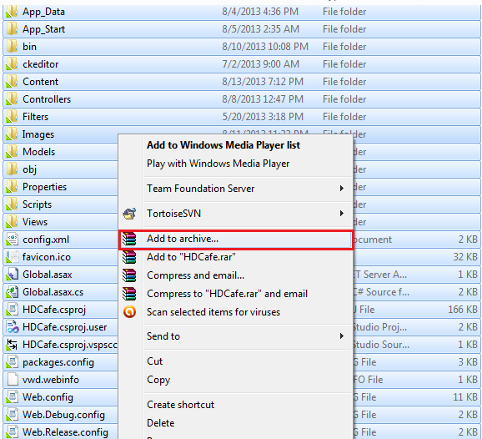

**Step1: Archive you website to ProjectName.zip**

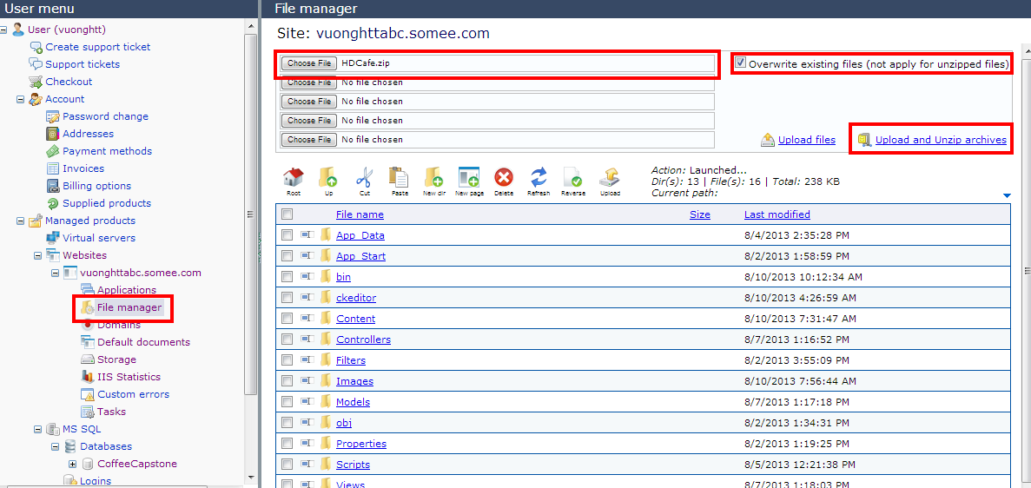

**Step2: Upload Projectname.zip to server.**

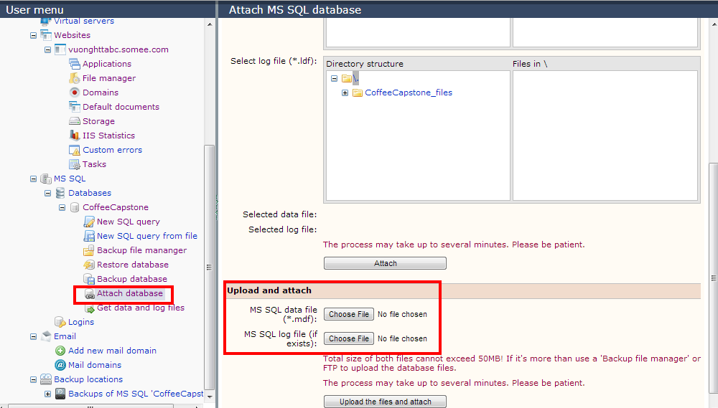

**Step3: Upload database to server.**

### Config Web.config

**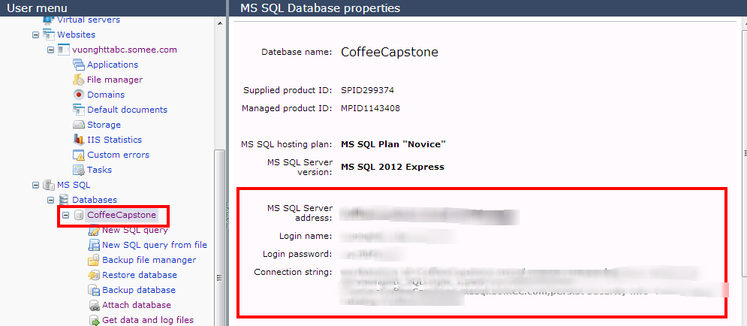**

**Step1: Get information of database in server.**

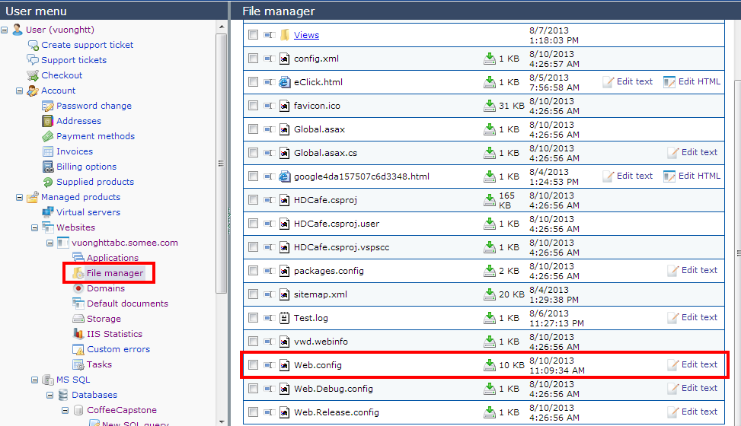

**Step2: Edit Web.config in server.**

### Config domain and host

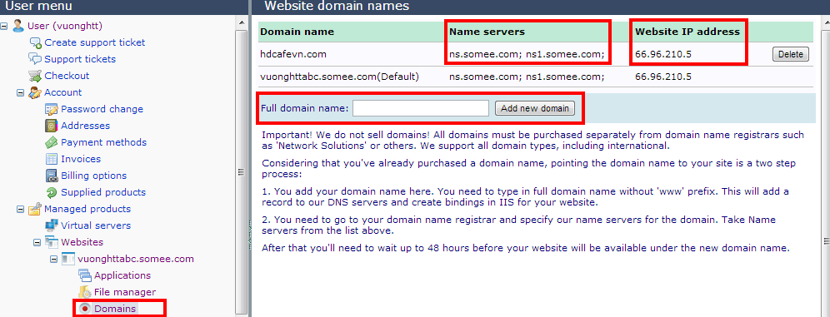

**Step1: Add your domain name to host.**

**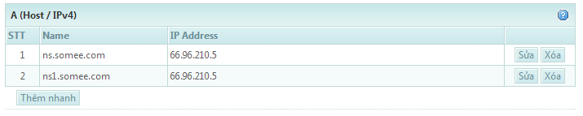**

**This screen is Control Panel DNS of matbao.net**

**Step2: Specify name servers for the domain.**

### Wait 48 hours and enter our domain name in browser

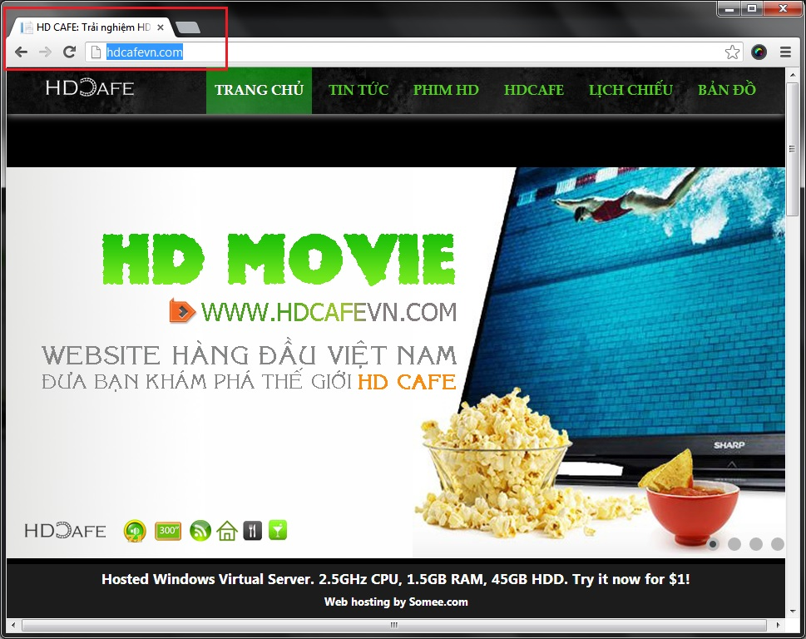

### Config website with google analytics

Optional

### Config website with Facebook API

Optional

### Development in hosting

If you want to continue develop project, you should use this setting for upload your project.

#### Step1: Open your website in Visual Studio

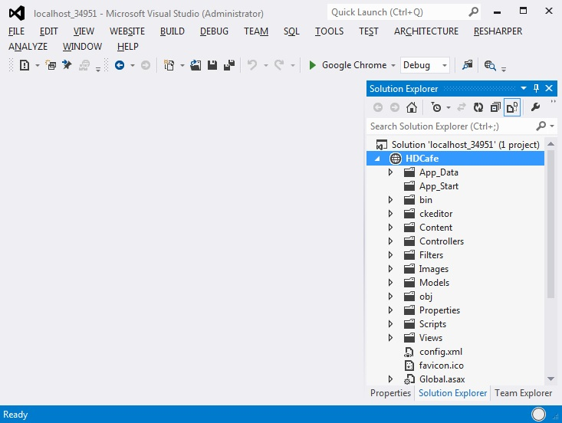

#### Step2: Copy your website to remote site.

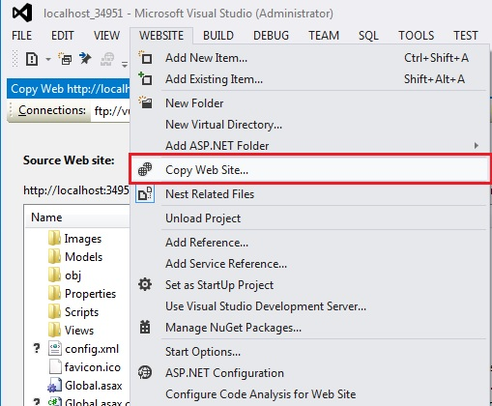

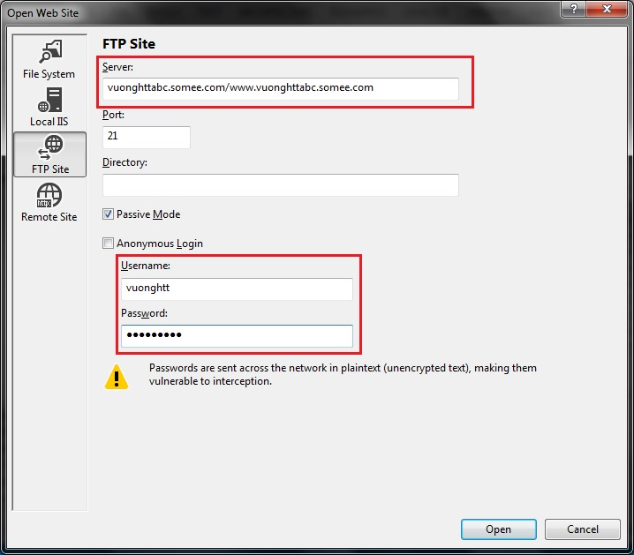

#### Step3: Copy/ Synchronize between your source website and remote website.

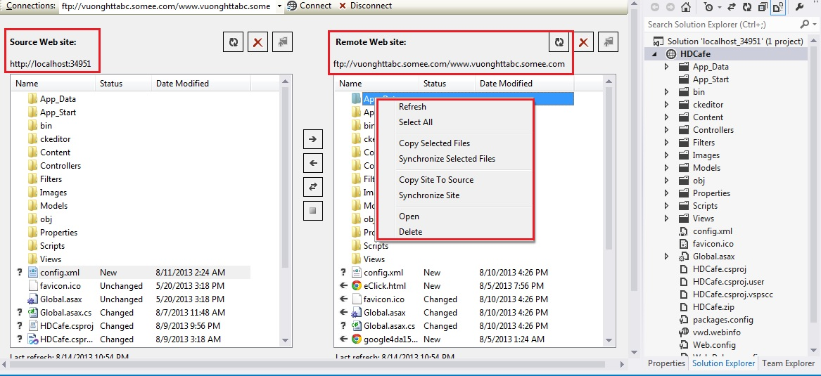

## User’s Guide

### Admin’s Guide

#### How to add film online

#### How to scan film online

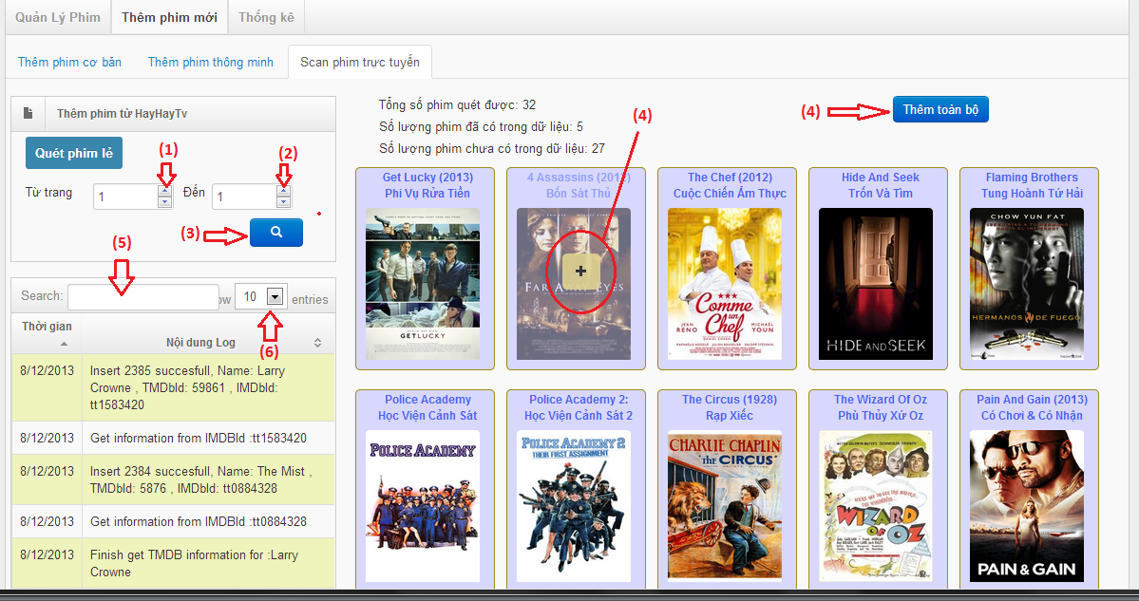

Scan Film online (Manage Film page) screen

|  |  |
| --- | --- |
| **Step** | **Description** |
| (1) | Choose the first page you want to scan film from hayhaytv.com website |
| (2) | Choose the end page you want to scan film from hayhaytv.com website |
| (3) | Click "Search" icon to scan film from the first page to the end page that you choose in step (1) and step(2) from hayhaytv.com website |
| (4) | Move the mouse into any film-item that you want to add and click "Add" button to add that film into database ( Or you can click " Add all film" button to add all the film available inti database) |
| (5) | Fill the information that you want to search for the log |
| (6) | Choose the number of entries of log you want to display on the log's datatable |

#### How to change slide in website

#### How to change advertising in website

#### How to manage file on server

### Store Owner’s Guide

#### How to change information of store

#### How to add film to store

#### How to manage schedule

#### How to add event in schedule

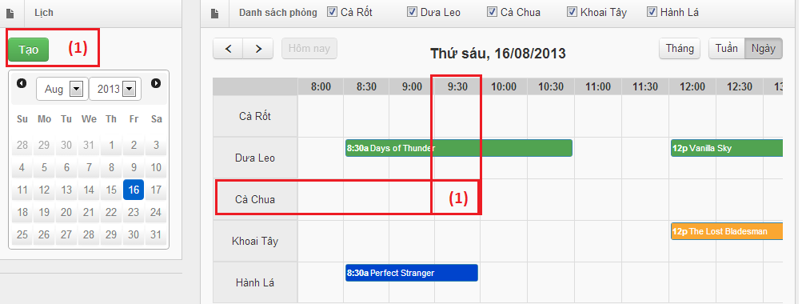

|  |  |
| --- | --- |
| **Step** | **Description** |
| (1) | Click “Add” button in the left screen. This is the basic create event for a schedule. |
| (1) | Click on the table cell that meets room and begintime requirement. This way is fastest to create an event. |

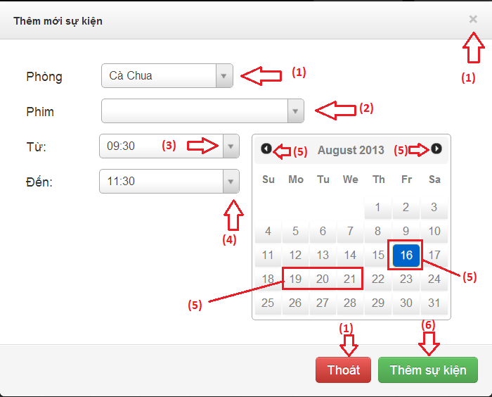

Add New Event in schedule screen

|  |  |
| --- | --- |
| **Step** | **Description** |
| (1) | Choose the room of the store that the event will belong to  (Click "Exit" icon to close the "Add schedule" screen and back to "ManageSchedule" screen)  (Click "Thoát" button to close the "Add schedule" screen and back to "Manage Schedule" screen) |
| (2) | Fill the name of the film into textbox and then choose one film |
| (3) | Choose the begin time of the event |
| (4) | Choose the end time of the event |
| (5) | Click on any day on calendar to choose more days. This event will be duplicated in multi days.  (Click on "Previous month" icon, previous month's calendar is displayed and then choose any day)  (Click on "Next month" icon, next month's calendar is displayed and then choose any day) |
| (6) | Click "Thêm sự kiện" button to add an event with the detail you filled in step (1), (2), (3), (4). |

#### How to manage film on server

### Guest’s Guide

#### How to view information of a store

#### How to view information of a film

#### How to search schedule